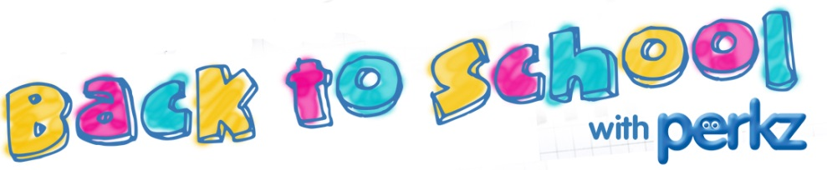

Get the kids back to school and enjoy the new football season for less with Perkz.
Term Time Essentials - Save 6 to 25%
From pencils to PCs save up to 25% at Hewlett Packard, up to 12% at Apple and 10% at Dell. There’s 8% off at WH Smith and 6% at PC World plus some great additional discounts on selected products.
School Uniform – Save 5 to 15%
Dress kids for less with 10% off at BHS, 8.5% at Debenhams, 6% at M+S and 5% at ASDA. Save 10 to 15% on footwear at Schuh, Trainer Station and tReds.
Play Football – Save 7 to 20%
Get in the game and save 10% at Kitbag, 7% at Sports Direct and 20% at Reebok.
Watch Football - Save 6 to 40%
TVs to suit all tastes with 25 to 40% off at Sharp and 6% at Currys.
Summer Memories - Save 10 to 25%
Get 40 free prints and 10% of every order thereafter with Truprint or create a photo book of summer memories and save 25% with Albelli.
August Prizes
Win the new MacBook Air from Apple and £100 of sports kit from Kitbag. Log in to www.perkz.com and click on the Competitions Section for details.
How to Register
If you haven’t registered for Perkz yet it’s easy. Simply follow the step by step guide below:
Step 1: Go to www.perkz.com and click on the message “If you are a first time user click here”.
Step 2: You will be asked for your Company Code. This is UNIMAN. When you’ve completed the registration section click “Submit”.
Step 3: You will then receive an email inviting you to click on the link provided to complete the registration process. This will come from service@perkz.com so make sure this is in your email address book to avoid potential spam filtering.
Step 4: You can now login to Perkz to take advantage of all the special offers and start saving money straight away.
Contact Us
You can contact Perkz at service@perkz.com and keeping up to date with Perkz offers is easy, just follow on Twitter @perkz_eb . You can also select to receive a monthly email as part of the registration process or by going to the ‘My Profile’ section of the Perkz website www.perkz.com.
So, enjoy your Perkz this August.
The Perkz Team.
