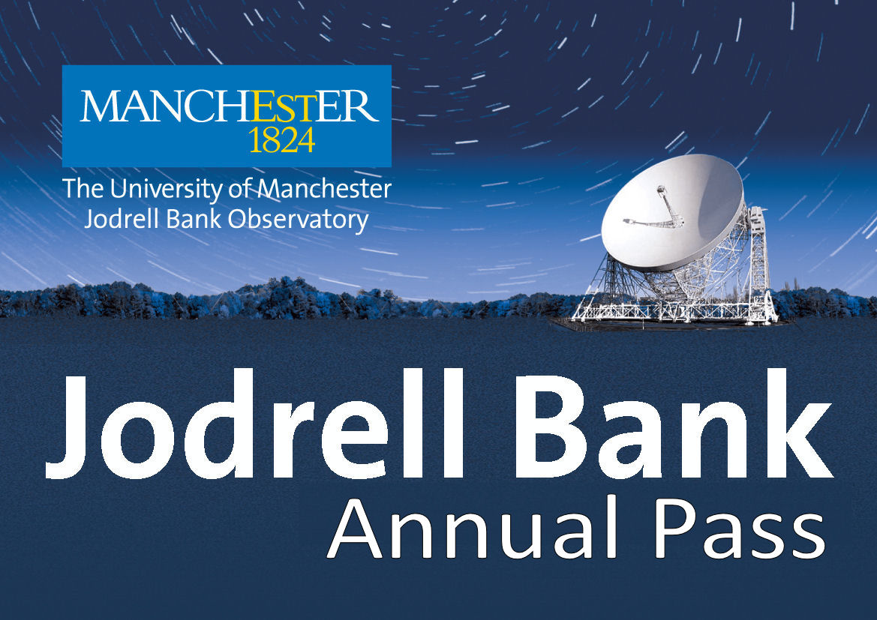

Are you an existing Annual Pass holder? - Yes Please provide

card number:

Are there any amendments to your personal details?

- No Please enter full names (and ages of children 16 and under ) of additional applicants

If you have purchased the Annual Pass as a gift please enter the giftee's details below (full name, address, email address)

Card will be sent directly to the recipient

PLEASE EMAIL THIS COMPLETED FORM TO: amanda.labella@manchester.ac.uk

