Social Media Guidance for University of Manchester Staff


Author/Enquiries: Marieke Mollitt, 58269

Date/version: Version 4 / March 2013

Summary: This guidance aims to assist any colleagues within the University who are utilising social media sites for the purpose of student recruitment and admissions

Contents: 1. General information about social media
2. Why participate in the use of social media?
3. Points to consider when using social media
4. Social media utilised by Recruitment and Admissions
5. Setting up your social media – user guide
6. Promoting your social media
7. Useful links

1. General information about social media

Within the past five years, social media has become one of the most widely-used methods for people to keep in contact, interact, and share information. What began as simply another way to easily stay in touch with friends has now evolved to a mass method for large corporations to converse with consumers, advertise, and learn more about their audiences in this reciprocal process. It is therefore essential to understand how The University of Manchester should use this entity. Wikipedia defines social media as:
“The means of interactions among people in which they create, share, and exchange information and ideas in virtual communities and networks”.

1.2. Top 10 social media sites (worldwide) – March 2013

- www.facebook.com
- www.twitter.com
- www.linkedin.com
- www.pintrest.com
- www.myspace.com
- www.googleplus.com
- www.DeviantArt.com
- www.LiveJournal.com
- www.tagged.com
- www.orkut.com
Other popular sites include:

www.youtube.com
www.ning.com
www.bebo.com
www.tumblr.com
www.flickr.com
www.stumbleupon.com
www.delicious.com
www.digg.com
www.reddit.xom

1.3. Main types of Social Media

- Social networks, e.g. Facebook, LinkedIn
- Bookmarking sites e.g. Delicious, Stumbleupon
- Social news e.g. Digg, Reddit
- Media sharing e.g. YouTube, Flickr
- Microblogging e.g. Twitter
- Blogs and forums e.g. wordpress

(Source – Outthink group)

1.4. Ways in which social media can be used by organisations / businesses

The ways in which organisations can use social media fall into two main categories:

1. By using it as a platform for engagement and interaction
2. Through advertising (which is highly targeted and often cheap in comparison to print)

2. Why participate in the use of social media?

2.1 The use of social media is widespread - technology is developing and improving at a faster rate than ever before, and critically, people are embracing it not only socially, but in how they search for information of any kind.

2.2 Social media is the future of communications - people want instant information that is more honest, interactive and involves debate and critique rather than one static, authoritative voice. There are now social media links within the majority of websites, allowing people to share and signpost using their social media accounts.

2.3 Our competitors are using it – many higher education institutions are using social media, and in the main, with great success. In the past the use of social media was associated with newer universities, but now the majority of institutions such as Oxford, Cambridge, other Russell Group universities, and reputable American universities use social media.

2.4 Efficient and effective – in comparison to costly advertising campaigns and print communications, the use of social media to communicate to mass audiences can provide an excellent return on investment. Social media sites such as Facebook, YouTube and Twitter are free. The costs associated are that of staff time for set up and maintenance and training.

2.5 We need to reach as many people, in as many ways as possible – using social media is not intended to replace more traditional methods to communicate with potential students, but to supplement these channels and ensure we are reaching our target audiences. Rather than be seen as a way of collecting ‘followers’, or increasing application numbers, the use of social media is a complimentary way of answering queries, and importantly, on a mass basis which should save staff time.

2.6 It is accessed anywhere, anytime – people of all demographics now access social media on mobile devices such as phones and tablets. This method of receiving information is only set to become more widespread. Audiences are therefore more accessible at anytime.

2.7 Things to avoid
- Embarking upon the utilisation of social media without clear objectives outlining why it is being used and what is hoped will be achieved (see section 3.2);
- Failing to monitor the use of pages to ensure that they are useful and fulfilling objectives – see section 3.3 for more detail.
- Using social media with the intention of collecting followers or solely to have an impressive range of new media products;
- Failing to maintain pages and content regularly

3. Points to consider when using social media

3.1 Decide from the beginning what your level of engagement will be

Social media can be used solely to put across important pieces of information and news stories, like The University of Cambridge. This option is useful if you have limited resources but would like to communicate important information to audiences quickly and cheaply. However, it is worth noting that someone should take responsibility for removing inappropriate posts such as advertising, swearing and anything offensive.

In addition, you can utilise it as a method of answering enquiries, therefore creating a two-way communication, in a similar way to our Admissions Facebook page, or within the private sector, Next (an excellent example of enquiry response). This means that you either open up your wall for comments, or you just allow followers to comment on any of your status updates, ensuring you monitor the wall so that you can respond as needed. If you choose to use a page in this way, then it can work very well, but will obviously require monitoring and more time and effort to maintain. However, it may result in fewer email and telephone queries if you are answering questions to more than one person at once (see point 3.3).

Whichever option you choose, you need to ensure that you are consistent with your approach, avoiding only managing queries periodically, or posting irregular / infrequent updates.

It is also advised to set up your Facebook page as a ‘like’ page (formerly a ‘fan’ page) rather than a group, as then your name and personal profile are in no way affiliated with your university page.

3.2 Have clear objectives as to why you’re using it and what you hope to achieve.

These may include:
-To provide current and interesting news and information to target audiences that is varied and dynamic, and to maintain this to ensure they are reactive, relevant and up-to-date.
-To allow social media, specifically Facebook and Twitter, to act as part of an enquiry management system
-To meet the changing needs of our target audience
-To ensure that we are competing with other higher institutions in terms of reacting to the need for interesting and useful social media sites
-To speak in a casual and approachable voice which is befitting of social media, whilst preserving our prestigious reputation as a world-leading university.

3.3 Monitor the uptake and success against objectives to help plan for the future and highlight successes / failures

-Monitoring volume of emails and phone calls vs social media. If it is possible for you to keep count of the number of phone call and email enquiries you usually receive, as well as any queries that come through social media, you can then see whether the former increase and the latter decreases over time. Such a pattern would be reflective of the fact that answering questions to enquiries that are present on social media sites for all to see can answer numerous peoples’ questions are once.
-Followers- although checking how many Twitter and Facebook followers an account has can be useful, it should not be a sole focus as people can easily become a fan or follower of something and subsequently only utilise it once.
-Research- Carrying out quantitative and/or qualitative research to assess how successful each of social media sites can help greatly with future development. This could include focus groups, questionnaires and surveys.
-Anecdotal feedback (comments on Facebook, word of mouth). As well as planned research, anecdotal feedback can be very useful. This may arise from potential current students, staff and other institutions for example, and could come through a range of sources, including comments on the social media sites themselves. It may be worth keeping a record of any positive or negative comments, as well as any reactions from you or other users where applicable, to form part of this research.

3.4 Make sure that those who will be involved in maintaining your pages are properly briefed

-Anyone who writes on your social media pages is representing the University and your team /School. They therefore should be briefed as to the kind of language that they should use, the purpose of the page so they can adapt their tone accordingly.
-It may be an idea to create a Code of Practice within your team that can be shared with each colleague who is made an admin on the page. This will ensure clarity of what their role is (just answering queries, or posting updates for example) how they should respond and within what timeframe, and what posts should be removed. Having a policy in place will facilitate quicker reactions when needed.

4. Social media utilised by Recruitment and Admissions within The University of Manchester

The following information may provide you with ideas of different types of social media that your team or school might like to use as part or all of your campaign.

4.1 Facebook

In September 2010, a University of Manchester Admissions page was created. The page gives information and news about admissions, as well as from the wider University and also acts as another strand of our enquiry management. The Communications and Marketing Team within the Directorate for the Student Experience is responsible for all the content, as well as monitoring these sites and answering any queries as they would with emails etc. Both central teams and Schools are encouraged to send information for inclusion on the page. The page has been extremely popular, with over 8,100 followers two years after launching and enquirers being happy with the speed and quality of responses to their questions.
In August 2012, the page had 8,100 followers.

4.2 Twitter

The Twitter feed usually reflects the Facebook status updates, but is adapted to ensure it is within the 140 character limit. It often signposts to a relevant website where more information can be found. As with the Facebook page, staff across the University are encouraged to supply updates to keep the feed varied and topical. Any enquires received are handled in the same way as highlighted in the previous Facebook section.
In August 2012, the page had 1,872 followers.

4.3 YouTube

The University of Manchester has a YouTube channel which is jointly maintained by the University Marketing Team and the DSE Communications and Marketing Team. It houses our institutional videos, as well as some provided by Schools, and other relevant videos, such as special lectures from Professor Brian Cox. Schools and teams across the university can submit videos for the page by sending them to john.walker@manchester.ac.uk.

4.4 Student blogs

Admissions are utilising both undergraduate and postgraduate student blogs, both of which are proving to be very popular,
Undergraduate
Two undergraduate students, Kat Pugh (Music) and David Perry (Medicine) were our undergraduate student bloggers for 2010/11, reflecting mainly on non-academic aspects of their student lives in Manchester. These have proved to be extremely popular with over 13,790 views between their launch in October 2011 and August 2011.

In September 2011 we recruited Eleanor who was starting her first year in Speech and Language Therapy. Her blogs documented the process of her leaving home and moving to University Halls of Residence, and then her first year at Manchester. Eleanor’s blogs proved to be extremely popular, with 27,800 views between September 2011 and August 2012. Her blogs can be seen here.

For 2011/12 we agreed with Eleanor that she continue to blog for us for 2012/13, due to the popularity of her blogs, and so that audiences could read about the transition from first year through to second year, when she is moving into a shared house with friends. We have also recruited a second blogger, a first year English Language and Literature Student, Adam Fearn, who has again written about his experiences of moving to university.
Postgraduate
Becca Day-Preston acted as our PG blogger from February 2011 – July 2012 and her lively and entertaining blogs have attracted many readers with 8,820 visits since starting.
We have recently recruited another PG blogger to write for the 2012/13 academic year. Peter Llewellyn who is a Biochemistry MA student. His blogs can be found here.

4.5 Ning
Ning is a platform that allows users to create and customise their own site, so that it caters to their specific needs. It allows integration of numerous other sites including Facebook, Twitter, YouTube, Vimeo and Google Plus. While there is a cost implication for this package, it is relatively low (see below). Many large companies, music bands and sports clubs use Ning. If you select the option when setting up the page for it to be private, then those who use the site need to be invited by an administrator, making it a private space, for example, just for offer holders (see 5.4).

The look and feel of the site can be completely customised so that it looks like an extension of Schools’ webpages. It would allow offer holders space to chat between themselves - although administrators hold the rights to remove any unsuitable content, or answer questions when deemed appropriate. Chat can take place via one-to-one messaging, ‘main room’ messaging (live chat but with more than one person) or in forums. Users of the site have their own profile, similar to Facebook, so they have an online identity within the site.
The functionality and areas of the site can be completely customised (the extent depending on the package chosen, see below), so that there can be areas for each individual programme within a School, which applicants would find very useful. A good example of this type of setup is demonstrated by Languages, Linguistics and Cultures (LLC), who have successfully run a Ning site for over two years. There is an area for each programme, so interaction can occur between those with very similar subject interests.
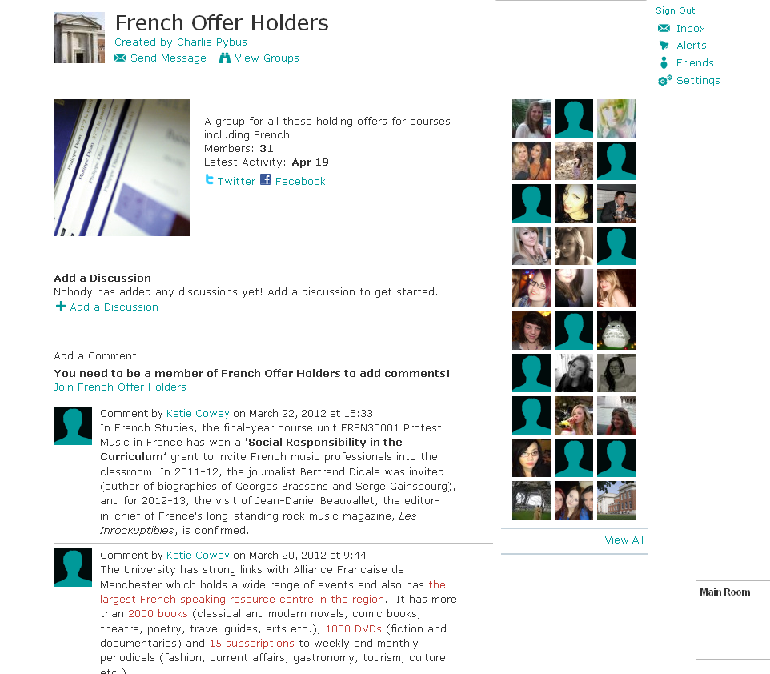
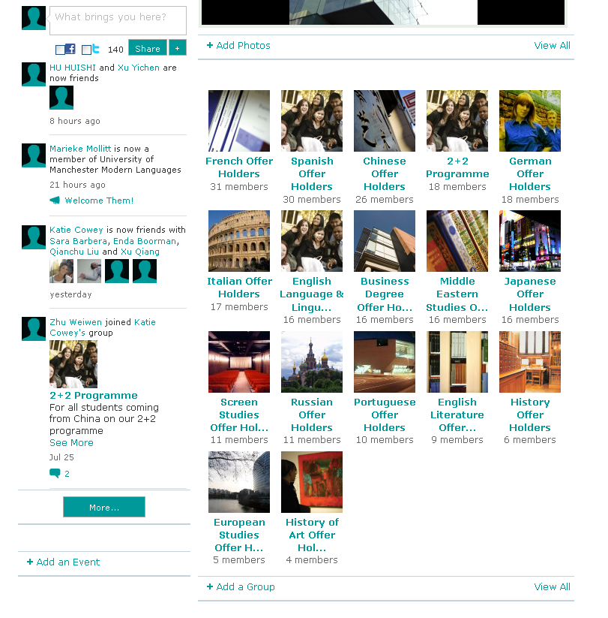

The site also allows for the sharing of photos and videos, and the use of forums, instant messaging and the posting of events.

Ning packages
There are three levels of user package: mini, plus, and pro. Ning describes them as follows:
Mini - For Small Groups - The simplest and fastest way to set up a social network for your classroom, community group, small non-profit or family. £2.95 monthly/£19.95 per year.
Plus - Advanced Features -The tools and features you need to customize your Ning Network with greater design flexibility and control over your members’ experience. £16.95 monthly /£169.50 per year
Pro - Built for Scale - The ideal solution for building a custom social experience with premium add-ons, integration options, and more bandwidth and storage. £39.95 monthly/£390.95 per year

Full information about what each plan offers can be seen at http://uk.ning.com/compareplans.
You can also have a 30-day free trail of Plus and Pro packages, if you’d like to try before committing.
Whereas mini would not be suitable for university use, LLC do use the ‘plus’ rather than the ‘pro’ package, to great success. It would therefore be at the discretion of Schools which package they chose to use. The website contains demos to help you make your decision - http://uk.ning.com/about/product/ .

Information about setting up your Ning page can be found in section 5.3.

4.6 Bespoke University sites – Welcome Week site

In 2012 the Welcome Week site was launched, aimed at all new students coming to The University of Manchester. As well as giving key information, step-by-step guides and a series of images, videos and maps, the site allowed applicants to meet virtually before arriving at Manchester, by connecting with their Facebook log in. This was a great success and will be repeated in 2013.

5. Setting up and using your social media – user guide

The below steps have been created to help you set up different social media pages, and then some of the main points to consider for the upkeep and maintenance. Please note, there is no help provided with YouTube, as the University-wide YouTube channel is available for all to utilise via the University Marketing Team.
5.1 Setting up a Facebook page
In order to set up a Facebook page/group you must already have a personal Facebook page to link the page to. If you do not have one, you could set one up just for work purposes that isn’t used personally, and linked only to your work email address.
Within Facebook, you can create either a ‘group’ or a ‘like’ page. Groups can be useful for where you want only want to invite certain people to join the group, a good example being offer holders. However, as administrator of a group, your profile will be visible instead of hidden. A way of avoiding crossover between personal and work information would be to set up a profile for work purposes only, that doesn’t hold any personal information. It is worth noting that unlike a group page, even though you are setting up a like page via your personal account, the two are in no way externally affiliated so no one will be able to contact you after looking at your like page.
The pros and cons of these can be seen in the table below.
 | Pros | Cons
‘Like’ page | - No affiliation between administrator and page  - Can comment as page rather than as yourself  - Has a perception has being more professional / reputable  - Access to apps  - Access to analytics  - Better access to Facebook ads  - Custom landing pages / tabs available  - People can easily find, and have access to your page  - ‘Pages’ app on mobile devices such as iPhones allows easy updates on the go.  - Can create vanity URLs | - Can’t invite specific members  - Cannot restrict membership unless person is deleted once ‘liked’  - Cannot send mass private messages  - Group conversations only take place on apps such as forums / notes
Group | - Can invite / only accept requests from specific members  - Allows group conversations  - Each member can post updates  - Members receive notifications by default when any member posts in the group  - Can send mass messages to members  - Useful for smaller groups | - Cannot access page unless invited / accepted (although this may be necessary for privacy reasons)  - Not as suitable for larger groups  - Cannot create vanity URLs  - Cannot perform targeted updates

Setting up a ‘Like’ page
Like page set up

- Once logged in, there is an option in the top right-hand side of your homepage (underneath your settings bar) which says ‘+create a page’. Click here and this will load up page-type options, of which you need to select ‘Company, organisation or institution’
- It will then give you options of the type of organisation – select ‘University’. Below this is the option for you to type in the Company name, for example ‘The University of Manchester English Literature Offer Holders 2013’. You must then agree to the terms and conditions.
- You will then be taken through several steps, where you can choose a profile photo (you may wish to use the University logo, or a university building photo, perhaps from your School), write some general information and select your web address-for example www.facebook.com/admissionsuom .
- Your page will now be set up, and you will be prompted to undergo actions that will improve your page – invite fans, add a cover photo, photo albums, videos and much more.
- You can set up different tabs and personalise these, for example photos, forums, notes etc.
- You can also go back and populate your timeline to show major milestones for your School
‘Like’ page settings

There are many different settings you can choose to protect your page and make it run the way you want it to. These can be found within the ‘edit settings’ button at the top and include:

- ‘Update info’ allows you to insert information such as telephone numbers, location and links to social media
- ‘Manage permissions’ is important, as it lets you set a minimum age for viewing your page, a profanity blocklist (the Admissions page is set to medium) and whether you’d like to open up your wall so that followers can write status updates, or just comment on ones you’ve posted (we recommend the latter). This is also where you would delete your page if needed.
- ‘Admin roles’ – here you can pick other people to be admins on your page (whereby there are different levels of admins) – you can have as many as you like, and a minimum of one. If you are all given the same level of rights then there is no one ‘owner’ of the page.
- ‘Manage notifications’ – here you can select whether you are emailed every time someone posts on your wall. We’d recommend against this as you would likely be inundated!

Using and maintaining your ‘Like’ page

Once you have set up your page and are posting information, and checking for posts, the following tips may be helpful:

- Ensure that you ‘Post as page’ – when you are in your page, ensure that you have set it to ‘post as page’ rather than post as yourself (your personal profile). If you do this, then when you post a status update / comment, it will appear as the page’s name with the page’s profile photo. The option to switch back and forth between posting as your page or yourself is at the top under the main Facebook toolbar.
- Notifications –Whereas you are notified on your personal account via the globe at the top of the screen when you any comments on your wall, any notifications for your like page appear instead appear within an admin panel at the top of the page. Notifications also appear in the left column next to the name of your personal page.
- Deleting posts – if you need to delete any comments, then you need to hover over the comment and click on the cross that appears. You can either just delete the comment, or delete and ban the user if they have been offensive or repeatedly posed inappropriate content.
It is not recommended that you delete a comment simply because it is negative – social media is all about transparency and freedom of speech. However, if a post contains swearing, prejudice, personal details, or anything you think is offensive and inappropriate, you may wish to take it down. Advice can be sought from the University’s PR team if you are unsure of how to handle a response to a contentious post.

Setting up a Facebook group
- To set up a Facebook group, go on to your profile and on the left hand side underneath any groups you may already be part of, there is a ‘create group’ option
- The options will then appear for you to create a group name, select members to invite (although you can add or remove any at any time after the page is set up) and also chose whether you want the group to be open, closed or secret. Presuming that you are setting up a page rather than a group because you only want certain people to be able to view it, then you will probably choose secret; this means that you have to be invited to be part of the group and that it is not searchable unless you are in the group.
- Once the group is set up, you can customise it much in the same way as a like page, with tabs containing photos, events, etc.
- Unlike on a like page where you can limit the wall so only you can post updates, within a group anyone can write on the wall.

5.2 Setting up a Twitter feed

Setting up a Twitter feed is quite a lot more simple than a Facebook page!

- Visit www.twitter.com where there will be a sign up box. Enter your full name, email address, and create a password.
- The next screen allows you to chose a user name, for example ‘AdmissionsUoM’
- You will then be taken to a ‘Twitter Teacher’ page that will help you to get started: informing you of the 140 character limit, suggesting people you may wish to follow (you can also search for people here), and upload an image and bio. Your page will then be set up.
- After set up you can then continue to add people to follow and start to tweet. The more you publicise your page, for example via your other social media, autosignature, or in publications, the more followers you will get.
- You can customise your page by adding a background image / logo to represent your brand.

5.3 Setting up blogs on WordPress

It is very easy to set up a blog on Wordpress. If you are familiar with Microsoft Word, then much of the functionality and toolbars will already be familiar.

- Visit www.wordpress.com
- Here you will be asked to create a blog address – e.g www.manchesterstudentblogs.wordpress.com , and add your email address, a password etc. You will be given an option to upgrade here so that you pay for the blog – you may wish to do this, but the free option does include a good degree of personalisation and functionality.
- The next page will ask you to create a profile with your name and information about yourself (so your School / programme in our case).
- Once you have verified the account via the email address you supplied, the blog become live. You can then customise your page via the ‘site admin’ area. The dashboard is where you can keep track of what blogs you’ve posted and when, look at readership stats, comments and much more. There is also a video in this area to help you understand how to use wordpress.
- At the lower left hand side of the dashboard you can customise the appearance of your page with images, colours and different layouts.
- When you post a blog, you can categorise it, for example if you blog about different courses you can put them in different categories and then just view that category and its stats separately. You can also add tags so that people can search for blogs relevant to them via these tag words.
- It’s a good idea to advertise your blogs via other social media, and through your School webpage. Applicants love hearing honest accounts in the first person from both staff and students and it can supplement and complement the more factual information within your site.

5.4 Setting up a Ning page

The guidelines to setting up a Ning page will greatly differ between which package you choose to buy; mini, plus or pro (see 4.5). There are also clear guidance videos for whichever package you choose. The below guidance shows the steps of the setting-up process which are relevant to all three types; the further customisation for each account type will then be guided through by Ning.

You can also have a 30-day free trial of Plus and Pro packages, if you’d like to try before committing.

- Visit http://uk.ning.com/
- Input your name, email address and a password.
- At the next page, you choose from the 3 level of accounts, and your ning page’s name. You also input payment information.
- Next, you can choose whether your page is private or public. If you are using Ning for offer holders, or a certain cohort of current students, then choosing private will allow you just to select those people and invite them.
- This page also allows you to start customising your page, in terms of appearance and the functions you have on it – e.g. an events tab, forums. You can remove or add features easily so that is exactly how you want it to be.
- You can also invite members from this page to create your network.
- There are many menu options on your dashboard for you to familiarise yourself with, including statistics of page visits, integration with a range of other social media, privacy settings, appearance of the page, and message broadcasting.
- The dashboard shows any notifications from users and Ning itself when you are logged in.

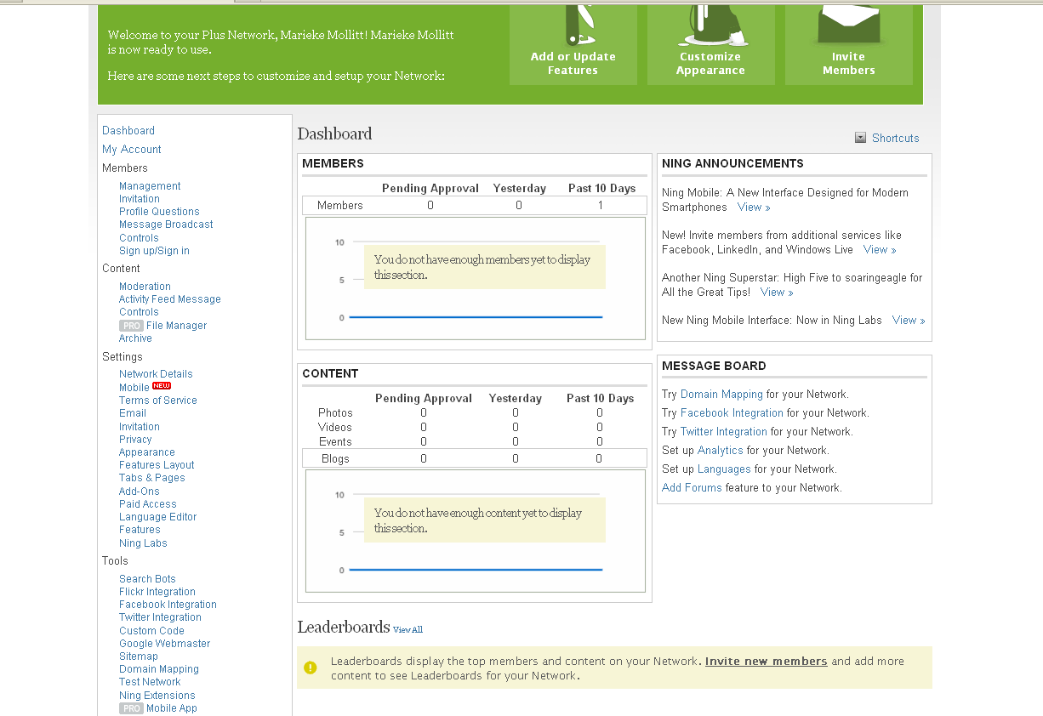

6. Promoting your social media

Once you have established your social media, it’s essential to make sure people know about them! Below are some different ways to do this:

-Include icons which link through to your pages within your email autosignature, including any admissions accounts you may have – for example they are included within all admissions@manchester.ac.uk emails.
-Include links within any marketing literature, whether printed or online.
-Always cross-market between websites/blogs/Facebook/Twitter – just because someone is following one of your sites, it doesn’t mean they are following them all, so it’s always useful to link to your various pages within each site
-Talk to administrators from other pages within the University and ask them to ‘like’ your page. This will enable them to share status updates from their page, greatly widening the amount of people that view your update and page generally. Similarly with Twitter, following and being followed by other relevant pages is very useful for retweeting and therefore reaching wider audiences.
-Advertising on Facebook can be relatively cheap – however, do consider why you are advertising. Often it is better to have fewer, but more engaged followers, than many who don’t get any use from, or will not interact with, your page.
7. Useful links
www.facebook.com/help

http://www.simplybusiness.co.uk/microsites/guide-to-social-media-success/

http://www.connectwisdom.com/webinars/

http://thesocialmediaguide.com/

