Welcome Week
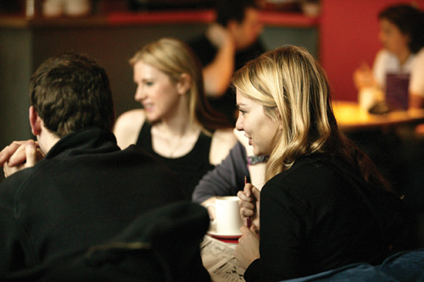

Details of events organised for you during
Welcome Week!

Welcome Week Fair
From Monday 17 September to Wednesday 19 September there will be a School of Arts, Languages & Cultures Welcome Week Fair in the North and South Foyers of the Samuel Alexander Building (see link to campus map below). There will be lots of information available about University services and facilities (eg. library, careers, sport) as well as more specific information relating to the School (eg. peer mentoring, societies). There will also be School Helpdesks so you can ask for help and advice.

RELIGIONS AND THEOLOGY - SCHEDULE FOR WELCOME WEEK SEPTEMBER 2012

Mon 17 Sept

11:00-12:00 WELCOME to Religions and Theology by Prof. David Law (Head of Subject) - Mansfield Cooper G.22 (campus map no. 65)

12:00-14:00 Scavenger Hunt with Peer Support. This will be a fun way to meet your fellow students and Peer Support group, and get to know the University Campus. Wear comfy shoes and bring an umbrella!

15:00-16:00 WELCOME to the School of Arts, Languages and Cultures by Professor Jeremy Gregory, Head of School. Includes an introduction to the careers service, speakers from the Students Union and e-Learning team – Stopford Lecture Theatre 1, Stopford Building

Tues 18 Sept

11:30-13:00 Discover the Religions and Theology Department: an introduction to R&T staff and the courses they offer – Samuel Alexander Building A113 (campus no. 67)

13:00-14:00 Lunch with Academic Advisors and Peer Support – Samuel Alexander Building (rooms to be confirmed at morning session)

15:00-16:00 Exploring your programme of study
Anthropology Forum (15:00-16:50) – Martin Harris Centre, John Casken Theatre (campus map no. 42)
Dr John Zavos (Study of Religions and Theology) - Samuel Alexander Building A113
Dr Michael Hoelzl (Theological Studies in Philosophy and Ethics) - Samuel Alexander Building A7

16:00-17:00 School of Arts, Languages and Cultures BBQ - Lime Café Quad (campus map no. 67)

Weds 19 Sept

10:00-11:00 EVENT FOR Comparative Religion and Social Anthropology Students
Joint Degrees Meeting with Social Anthropology – Humanities Bridgeford Street, Hanson Room (campus map no. 35): If you are a CRSA student, please attend this meeting to meet the key staff that oversee this joint degree, Drs. Atreyee Sen (R&T) and Ian Fairweather (Anthropology), and find out more about your degree.

Thurs 20 Sept

10:00-11:30 Designing your R&T Programme with Dr John Zavos and RELT Administrator – Samuel Alexander Lecture Theatre

11:30-12:00 Library Talk with Stephen Pearson, Faculty Team Librarian - Samuel Alexander Lecture Theatre

12:00-13:00 PASS (Peer Assisted Study Sessions) Sessions – Samuel Alexander Building (rooms to be confirmed at the morning session): an initial session with Level 2 & 3 students who will support you academically in your first year of study.

14:00-15:00 Seminar with Academic Advisors – Samuel Alexander Building (rooms to be confirmed at morning session): For this seminar, you need to have read the article by Hinnells that we mailed you about before you arrived at Manchester.

15:00-17:00 R&Tea Party for students (Levels 1 & PG) and staff – Contact Theatre

Friday 21 Sept

12:00-13:00 Designing your R&T Programme drop-in with John Zavos – Samuel Alexander WG4: you can drop in to see John if you need further help with your course choices or were unable to attend on Thursday morning.

19:00-late RAT Pack night out
R&T Night Out led by members of the R.AT. Pack (the R&T Society) – Meet at Owens Park Bar

