Welcome Week
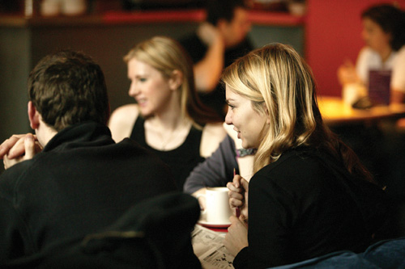

Details of events organised for you during
Welcome Week!

Welcome Week Fair
From Monday 17 September to Wednesday 19 September there will be a School of Arts, Languages & Cultures Welcome Week Fair in the North and South Foyers of the Samuel Alexander Building (see link to campus map below). There will be lots of information available about University services and facilities (eg. library, careers, sport) as well as more specific information relating to the School (eg. peer mentoring, societies). There will also be School Helpdesks so you can ask for help and advice.

MUSIC - SCHEDULE FOR WELCOME WEEK SEPTEMBER 2012

Monday 17 September
10.30-11.00 Tea and coffee in foyer of Martin Harris Centre with student mentors

11.00-12.00 Dr Herissone welcomes new students in the Cosmo Rodewald Concert Hall

12.00-12.30 Tour of Martin Harris Centre in your new tutor groups with your student mentors

12.30-13.00 Meeting with Academic Advisors

13.00 Lunch with Mentors, Room G16, Martin Harris Centre

15.00-16.00` Welcome to the School of Arts, Languages and Cultures by Professor Jeremy Gregory, Head of School, University Place Lecture Theatre 1.219

17.00-19.00 Auditions, Cosmo Rodewald Concert Hall

19.30-21.00 BBC Radio 3 Live in Concert: Sun Wook Kim plays Beethoven and Schubert piano sonatas; Cosmo Rodewald Concert Hall

Tuesday 18 September
09.30-13.30 Auditions, Cosmo Rodewald Concert Hall

14.00-15.00 School of Arts, Languages and Cultures BBQ – Lime Café (Lower Ground, Samuel Alexander Building)

Wednesday 19 September
09.30-13.30 Auditions, Cosmo Rodewald Concert Hall
13.30-17.00 Rehearsals for Introductory Concert, Cosmo Rodewald Concert Hall

Thursday 20 September
9.30–13.00 Rehearsals for Introductory Concert, Cosmo Rodewald Concert Hall

14.00–17.30 Auditions, Cosmo Rodewald Concert Hall

Friday 21 September
11.00–13.00 Timetable meeting in Cosmo Rodewald Concert Hall

13.30–17.00 Rehearsals for Introductory Concert, Cosmo Rodewald Concert Hall

