Welcome Week
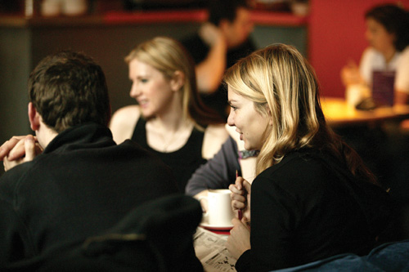

Details of events organised for you
during welcome week!

A series of events have been organised for you during Registration Week to introduce you to English Literature and American Studies and the School of Arts, Histories of Cultures in which we are based. You will be meeting both academic and support staff during the week and will be given an initial introduction to facilities such as the University Library. Some of the events are aimed to be fun and sociable and you will find invaluable information on offer!

English Literature – Welcome week schedule 2012

MONDAY 17 SEPTEMBER

14.00-15.00 SCHOOL WELCOME MEETING Theatre 1, Stopford Building

TUESDAY 18 SEPTEMBER

10.00-10.30 LIBRARY TALK A113, Samuel Alexander Building

WEDNESDAY 19 SEPTEMBER

16.00-17.00 WELCOME MEETING Samuel Alexander Theatre
17.00-18.00 WELCOME BBQ The Quad, Samuel Alexander Building

THURSDAY 20 SEPTEMBER

ACADEMIC ADVISOR MEETINGS – Please note that Groups 06 and 09 will meet at 14.00 pm; all other groups meet at 15.00 pm.

Group 01: Dr Iain Bailey 15.00 pm S1.2, Samuel Alexander Building
Group 02: Dr Roger Holdsworth 15.00 pm A213, Samuel Alexander Building
Group 03: Dr David Alderson 15.00 pm S2.8, Samuel Alexander Building
Group 04: Dr Malcolm Hicks 15.00 pm S2.2, Samuel Alexander Building
Group 06: Professor Gale Owen-Crocker 14.00 pm S1.11, Samuel Alexander Building
Group 08: Dr Iain Bailey 15.00 pm S1.2, Samuel Alexander Building
Group 09: Professor Jeremy Tambling 14.00 pm WLG8, Samuel Alexander Building
Group 10: Dr Alan Rawes 15.00 pm S1.10, Samuel Alexander Building
Group 11: Professor Patricia Duncker 15.00 pm A202, Samuel Alexander Building
Group 17: Professor Patricia Duncker 15.00 pm A202, Samuel Alexander Building

