
Research Equipment Administration Guidance
Introduction
This guidance note outlines the administrative processes to be followed as a result of the changes to RCUK rules on equipment purchase. This document should be read in conjunction with the Research Equipment FAQ document and RCUK Efficiency 2011-15: Ensuring Excellence with Impact guide.
Capturing Equipment information and Approval
All research applications including the purchase of individual items of equipment costing over £10k must now identify and include the following:
- A short description of the item and its main use, plus make and model if known.
- The proposed funding sources including the school’s proposed contribution
- Proposed location of the equipment (School, Building and Room number if known).
- The steps taken to confirm that the piece of equipment is not already available for use within the University, or at any other accessible location (for instance by making reference to any assets register/records consulted, staff consulted, other institutions contacted, other solutions considered)
- Confirmation of what will happen to existing equipment (where it is being replaced).

It is intended that faculty grant application approval documentation will be updated in the near future to incorporate these new requirements. In the meantime a proforma document (the Research Equipment Form) has been prepared which, whilst not mandatory, would assist staff to ensure that the new requirements have been met.
This information must be retained as part of the application records held within the School. The above information must be kept for all funding sources (not just RCUK).
The new RCUK rules mean that the School must make a contribution (usually around 50%) towards the cost of any equipment and Research Support colleagues must seek approval for this expenditure from the Head of School or their delegated authority before submitting RCUK applications.
It should be noted that where approval/authority for research applications is routinely delegated to Research Managers, unless that individual has authority to commit School funds to the purchase of the equipment, they should not be signing-off on applications with individual equipment items over £10k.
It is important to note that the threshold for minor equipment has risen from £3k to £10k and all items falling into this category should be included in the “Other Directly Incurred” costs section of the JeS form.
Recording Equipment Information
Greater asset utilisation will be a requirement going forward as research funding reduces and competition increases. Illustrated below are the requirements for recording equipment purchases under the new rules within pFACT, JeS and RMS
pFACT
The full cost of the equipment should continue to be costed and recorded in the pFACT Costing tool regardless of the % funding being applied for.
In order for pFACT to accommodate the change in the funding rules for equipment, changes need to be made to the default Income Recoverable template which feeds to the JeS Submission document. This is however a software issue that will be dealt with by the external Support Unit, now Unit4. Details of any changes will forwarded in due course.
In the meantime it will be necessary to amend the submission amount in JeS to reflect the amount being applied for.
In addition, as an interim measure all individual equipment items must be recoded separately in the RMS. An illustration of how to do this is provided below.
JeS Guidance
Purpose: this guide is to show JeS users how to enter equipment costs onto JeS post RCUK rule changes. It is not designed to be exhaustive and should be read in conjunction with relevant RCUK and internal finance documentation.
This guide assumes prior knowledge of JeS.
- Capital Equipment between £3k and £10k (inclusive of VAT)
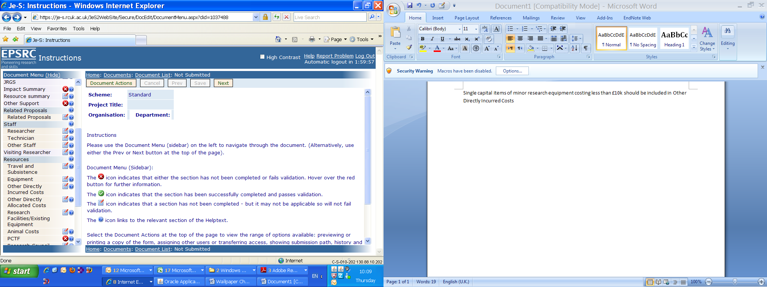
Single capital items of minor research equipment costing less than £10k should be included in Other Directly Incurred Costs.

- Capital Equipment between £10k and £134,011k (inclusive of VAT)
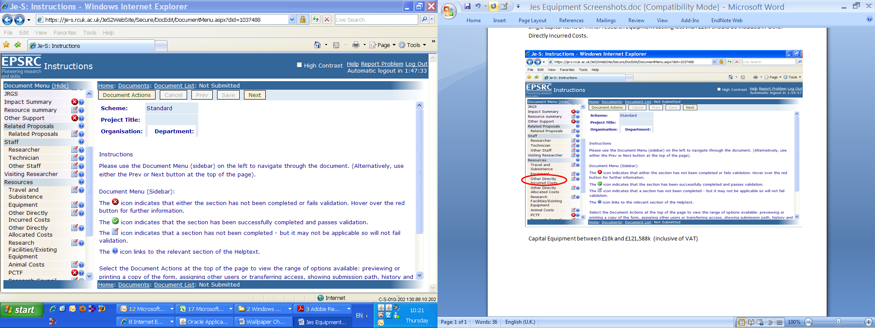
Each item of equipment in this category needs to be included under ‘Equipment’ and should reflect the full cost less any contribution ie, the actual level of funding sought such as £80k full cost of equipment item equals £40k input on to the JeS form. Research Councils will no longer contribute 80%, or more, of equipment costs. They may fund 50%.

N.B.
1. Each item, or groups of items, specified in ‘Equipment’ should contain a brief summary in the description field so that it can be easily cross referenced in the Justification of Resources/Case for Support. If the item is to be used for “instrument development” then this term should be included in brackets after the item description in the “description field” in JeS
Until JeS have updated their forms completely it may appear that the old rules apply where equipment values up to £50k were funded at 80% and over £50k were funded at 100%. If funded, adjustments will be made at time of offer.
2. The full cost should be included in the Justification of Resources or Case for Support (STFC) with an indication of UoM’s own contribution towards the cost. The expectation is that organisations will now contribute 50% of capital equipment costs.
3. Quotations for equipment costing more than £25k (including VAT) should be attached in the ‘Equipment’ section and not the attachments section.
- Capital Equipment over £134,011k (inclusive of VAT)
For capital equipment over £134,011k the individual items should be recorded in ‘Equipment’ (as per section 2).
However, in addition a business case should be provided and uploaded into JeS in the Equipment section of the form.
RMS Guidance
Purpose: to demonstrate how to add individual capital equipment items to the RMS. This document assumes prior knowledge of the RMS.
Overview: from the 1st May 2011 we are required by RCUK to comply with new rules regarding the purchase of capital research equipment. Any individual capital equipment items costing over £10k included on research grants or contracts must be recorded as a separate budget line on the Research Management System (RMS). This applies to any funder, not only Research Councils.
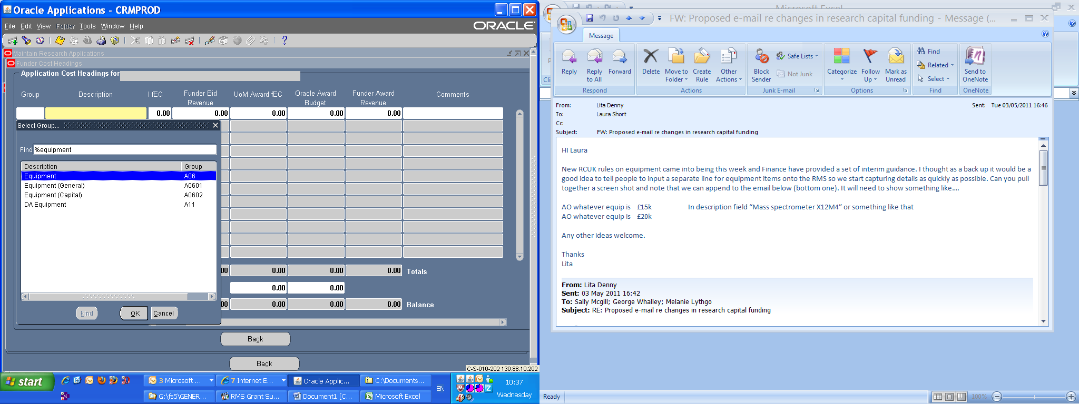
- Within funder ‘Cost Headings’ click on Group
- In the ‘Find’ box type %equipment%. This will limit the list to equipment items only.
- Select ‘Equipment (Capital)’ and ‘OK’
Follow this procedure for each item of capital equipment expenditure over £10,000

.
.

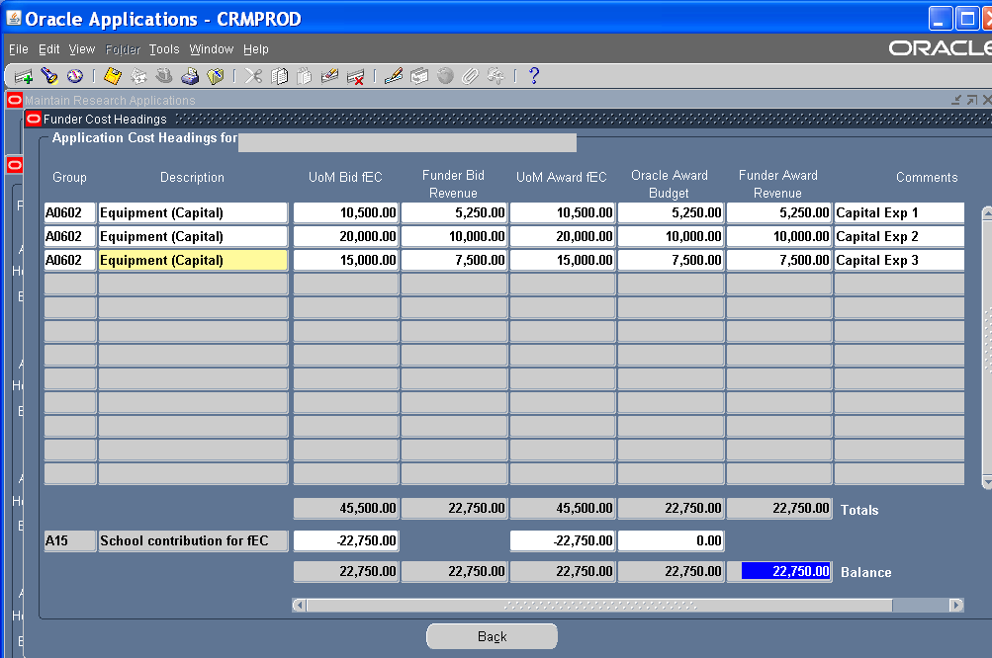
Working Example (assuming funder is a research council and we expect to receive 50% of cost):

