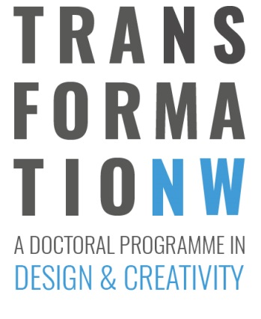
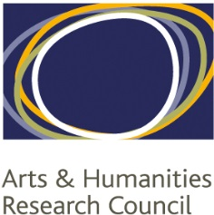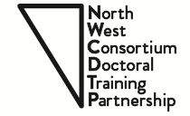

NWCDTP TRANSFORMATION NORTH WEST
STUDENTSHIP COMPETITION
Standard Application form for students applying for a PhD award under the Transformation North West Cohort

(September 2017 entry)

1. Studentship applied for (please tick):

+2 (PhD - current students)
+3 (PhD)

2. Please indicate a preference for the Institution you would like to register at:

Lancaster University University of Liverpool University of Manchester
Manchester Metropolitan University Keele University University of Salford
Royal Northern College of Music

3. Candidate’s details:

 | Name:
 | Address:
 | Town:
 | Postcode:
 | Country:
 | Telephone:
 | Email address:
 | Nationality/Resident Status: | UK National  UK Settled status  EU National not resident in the UK  EU National resident in the UK for the past three years  Other
4. Award details:

Award Type a. Full award b. Fees only

Mode of Attendance a. Full time b. Part time

5. PhD Themes and experience:

Please describe using up to 500 words, how your experience, skills and interests contribute to one of more of the themes in this programme set out in the additional information (see website).

6. Qualifications:

Year awarded | Qualification type | Qualification Subject | Awarding institution | Level | Class
Description:

7. Relevant Experience:

Please give details of any relevant previous experience and any relevant research training undertaken previously (using a maximum of 500 words):

8. References / Transcripts/ CV

Please attach two references, relevant transcripts and a CV (see guidelines for further details)

9. Interview Availability

Please indicate your availabilities for interview (please tick as appropriate):

Wednesday 26th July 2017 | Thursday 27th July 2017 | Friday 28th July 2017
09.00 – 13.00 | 09.00 – 13.00 | 09.00 – 13.00
13.00 – 17.00 | 13.00 – 17.00 | 13.00 – 17.00

If you are not available for any of those dates/times please indicate your closest availability:

10. How did you hear about us?

Please let us know how you have heard about these studentships:

11. Acknowledgement

I confirm that the information I have provided in this form is complete and accurate to the best of my knowledge at this date. I fully understand that it is my responsibility to ensure that the relevant forms are submitted to the relevant office in due time and that any missing information may render my application incomplete and ineligible. I authorise the North West Consortium DTP to disclose to the AHRC any information that is relevant to my application.

Signature:

(Type Name if submitted electronically)

Date:

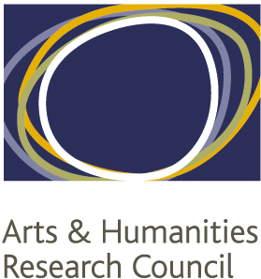

NORTH WEST CONSORTIUM
DOCTORAL TRAINING PARTNERSHIP
Equality and Diversity Monitoring

(September 2017 Entry)
The NWCDTP is requested by the AHRC to monitor the equality and diversity data from the students it is funding. This is mainly to assist the AHRC is delivering statistics on their funding allocation.

The information you provide us with is covered by the Data Protection Act. This means that we have a legal duty to ensure that the information is maintained on a confidential basis. Please be ensured that the data is anonymous and that this section will be kept separate from your application(s).

Gender
Male Female Prefer not to say
Is your gender identity the same as the gender you were assigned at birth?
Yes No Prefer not to say

Ethnic Origin
White |  | British
 |  | Irish
 |  | Other White European
 |  | Other White (please state)* |  | *
Mixed |  | White and Black Caribbean
 |  | White and Black African
 |  | White and Asian
 |  | Other mixed (please state)* |  | *
Asian or Asian British |  | Indian
 |  | Pakistani
 |  | Bangladeshi
 |  | Other Asian (please state)* |  | *
Black or Black British |  | Caribbean
 |  | African
 |  | British
 |  | Other black (please state)* |  | *
Chinese or other |  | Chinese
 |  | Other ethnic group (please state)* |  | *
 |  | Unknown
 |  | Prefer not to say
Religion/Belief
Buddhist |  |  | Muslim
Christian |  |  | Sikh
Hindu |  |  | Jain
Jewish |  |  | Zoroastrian
Other |  |  | No Religion
Prefer not to say

Sexual Orientation
Bisexual |  | Gay man
Heterosexual/Straight |  | Gay Woman/Lesbian
Prefer not to say |  | Other

Age
18 - 24 |  | 45 - 54
25 - 34 |  | 55 - 64
35 - 44 |  | 65 +

Disability
The Disability Discrimination Act defines a disabled person as someone with a physical or mental impairment which has a substantial and long term adverse effect on his or her ability to carry out normal day to day activities. (e.g. Has lasted or is expected to last over 12 months)
Do you consider yourself to be disabled according to this definition?
Yes No
If you answered yes, how would you define this impairment?

Acknowledgment
I confirm that the information provided above is accurate and I agree to the NWCDTP recording and using personal data contained in this form for the purpose of monitoring the Diversity & Equality, and for statistical purposes.

Date and Signature:

