BCOVS 2019 KEYNOTE LECTURERS

What happens to the brain when visual function is compromised by eye disease?

Antony Morland

Eye disease is becoming an increasing burden on society as the population gets older. Rightly, there is a focus on treating and curing diseases of the eye, but the impact of eye disease on the brain also needs to be considered.

In this presentation I will discuss the work we have undertaken on individuals with low vision that is either inherited or acquired later in life. I will show that individuals born with no cone-mediated vision, who as a result have a small central scotoma, can exhibit a remapping the visual cortex.

This plasticity may help individuals maximise the allocation of cortical resources to the vision that is spared. In contrast, scotomas that occur later in life because of macular degeneration do not appear to result in a remapping of visual cortex. There appears, therefore, to be a limit to brain plasticity later in life.

I will also present work on individuals with congenital misrouting of the optic nerve at the optic chiasm, as a result of albinism for example. The visual cortex in these individuals shows a remarkable preservation of the canonical cortical mapping of thalamic inputs. This again shows a limit to large scale remapping, but opens up the idea that there must be extensive plasticity at a synaptic level to allow useful vision to be preserved across the visual field.

Finally, I will show that not only does eye disease have effects on how visual information is functionally mapped in the brain, it also has an impact on cortical anatomy. The changes that occur are most frequently atrophic and this brings into focus the idea that the cortex may be vulnerable to long term deprivation that could potentially affect the way in which vision is ultimately restored through treatments.

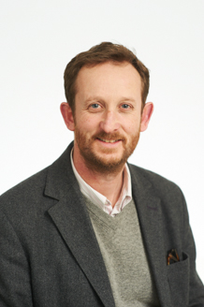

Tony graduated from Imperial College London in Physics and stayed in the Physics Department to study for a doctorate on colour vision.

In 1997 he gained a Wellcome Trust Research Career Development Fellowship that allowed him to pursue neuroimaging research of the visual system under the supervision of Professor Brian Wandell at Stanford University.

Following six years on the Psychology faculty at Royal Holloway University of London, he came to the University of York in 2006. His research interests are in imaging the visual areas of the human brain to reach a greater understanding of fundamental visual mechanisms in health and disease.

His work has been funded by the Wellcome Trust, Medical Research Council, the BBSRC, Fight for Sight and the European Commission. He is currently the director of the York Neuroimaging Centre and is the lead for Neuroscience in the York Biomedical Research Institute.

