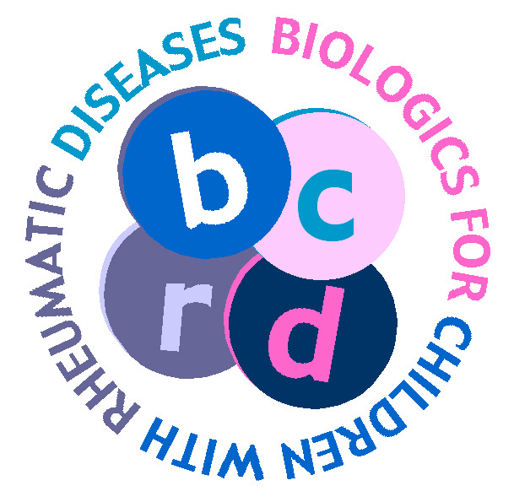

Biologics for Children with Rheumatic Diseases study (BCRD); IRAS ID 24269
Transparency Information Sheet

The University of Manchester is the sponsor for this study based in the United Kingdom. We will be using information from you and your medical records in order to undertake this study and will act as the data controller for this study. This means that we are responsible for looking after your information and using it properly. The University of Manchester will keep identifiable information about you for 10 years after the study has finished.
Your rights to access, change or move your information are limited, as we need to manage your information in specific ways in order for the research to be reliable and accurate. If you withdraw from the study, we will keep the information about you that we have already obtained. To safeguard your rights, we will use the minimum personally-identifiable information possible.
You can find out more about how we use your information at the following link: http://man.ac.uk/dD0af7

[NHS site] will collect information from you and your medical records for this research study in accordance with our instructions.
[NHS site] will use your name, gender, NHS number, hospital number, date of birth and contact details to contact you about the research study, and make sure that relevant information about the study is recorded for your care, and to oversee the quality of the study. Individuals from The University of Manchester and regulatory organisations may look at your medical and research records to check the accuracy of the research study. [NHS site] will pass these details to The University of Manchester along with the information collected from you and your medical records. The only people in The University of Manchester who will have access to information that identifies you will be people who need to contact you regarding your participation in the study, or audit the data collection process. The people who analyse the information will not be able to identify you and will not be able to find out your name, NHS number, or contact details.
[NHS site] will keep identifiable information about you from this study for five years after the study has finished.

The University of Manchester will collect information about you for this research study from your medical records. This information will include your name, NHS number, hospital number, gender, date of birth, contact details and health information, which is regarded as a special category of information. We will use this information to facilitate the collection of data from your clinical team and for linkage with other national health databases.

When you agree to take part in a research study, the information about your health and care may be provided to researchers running other research studies in this organisation and in other organisations. These organisations may be universities, NHS organisations or companies involved in health and care research in this country or abroad. Your information will only be used by organisations and researchers to conduct research in accordance with the UK Policy Framework for Health and Social Care Research.
https://www.hra.nhs.uk/planning-and-improving-research/policies-standards-legislation/uk-policy-framework-health-social-care-research/
This information will not identify you and will not be combined with other information in a way that could identify you. The information will only be used for the purpose of health and care research, and cannot be used to contact you or to affect your care. It will not be used to make decisions about future services available to you, such as insurance.

