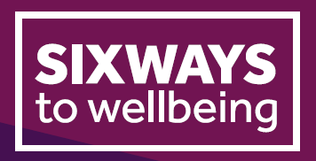

Wellbeing Action Plan

You can use this document to reflect on your own wellbeing at work, or to facilitate a discussion with your manager.

What helps you to say mentally healthy at work?

What can your manager do to proactively support you to stay mentally healthy at work?

Are there any situations at work that can trigger poor mental health for you?

How might experiencing poor mental health impact on your work

Are there any early warning signs that we might notice when you are starting to experience poor mental health?

What support can be put in place to minimise triggers or help you to manage the impact?

What steps can you take if you start to experience poor mental health at work, and what would you like your manager to do if they notice anything?

