Member Position – Greater Manchester Learning
The Members of The Greater Manchester Learning Trust (lead school Parrs Wood High School, Didsbury) are seeking to appoint a Member to its governance structure due to the departure of the current postholder.
Outlined below is some information regarding the role and how Members fit in the Trusts governance structure.

Trusts Governance Structures
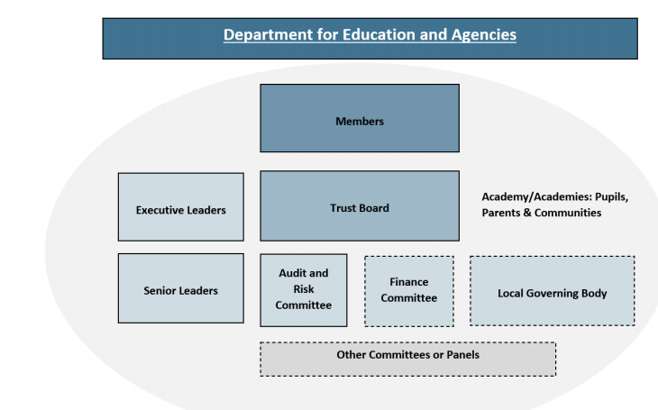

GMLT Governance Structure

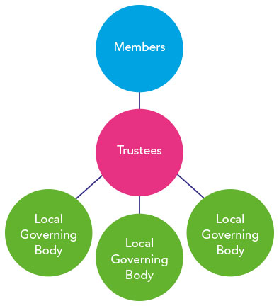

Role
Members play a limited but crucial role in safeguarding academy trust governance. While they must ensure they do not stray into undertaking the Academy Trustees' role, they should assure themselves that the governance of the trust is effective, that Academy Trustees are acting in accordance with the trust’s charitable object(s) and that they, the Members, use their powers to step in if governance is failing. Academy trusts are founded by Members, who may then appoint additional Members to join them. The first Members are the signatories to the memorandum of association which is drawn up when the academy trust is first established. These first Members agree the academy trust’s first articles of association, which include the academy trust’s charitable purpose.

Members should not be involved in the day-to-day business of the academy trust and must ensure they do not assume the powers of the Academy Trustees. However, they do have an important role in an academy trust, based on a number of key powers set out in the department’s model articles of association and in company law.

Members have a general duty to exercise their powers to further the academy trust’s charitable object, which in the majority of trusts is ‘to advance for the public benefit education in the United Kingdom.

It is essential that Members are aware of the powers available to them and know when and how to use those powers effectively. Members should make sure they are familiar with their own articles of association and funding agreement.

The powers of Members
Members help to ensure that Academy Trustees are exercising effective governance by utilising a range of powers including:
- Appointing and removing Academy Trustees: Members can appoint Academy Trustees and remove any or all serving Academy Trustees.
- Appointing and removing Members: There must always be a minimum of three Members. Members can appoint new Members or remove existing Members
- Directing Academy Trustees: Members can, by special resolution, direct Academy Trustees to take a specific action where Academy Trustees are unable, or unwilling to act in the best interests of the academy trust. Members should consider using this power if they believe the trust board is failing to carry out its core functions, or is acting unlawfully. Other examples of when members might consider issuing a direction to Academy Trustees include where they believe an external review of governance should be carried out and the Academy Trustees have not done so, where the board has failed to act on child safeguarding, and where the academy trust is in breach of its funding agreement.
- Amending the academy trust’s Articles of Association: Members can amend the articles of association (including the objects clause), subject to any restrictions in the articles, the funding agreement or charity and company law. Members can also change the name of the academy trust and wind it up. Academy trusts must gain permission from the Charity Commission for changes to some clauses; these are known as regulated amendments. These clauses relate to the academy trust’s charitable object, benefits, and arrangements on dissolution or winding up of the academy trust.
- Appointing and removing Auditors: Members appoint the academy trust’s auditors and will receive and review (but do not have to sign off) the academy trust’s annual audited accounts (subject to the Companies Act).

Time Commitment
In respect of the time commitment for the role this is approximately 2-4 days in respect of meetings and preparation time. The expected attendance is two members meetings per year (90-120 minutes per meeting). If you are interested in this opportunity please contact Louise Staunton, Trust Director of Finance for further details Tel:0161 446 8640, Email: l.staunton@parrswood.manchester.sch.uk

