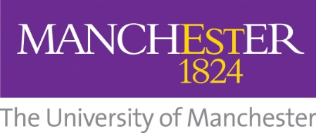
Institutional Review Agenda

Meeting with appropriate staff to discuss:

• Background to the partnership
• Rationale for the partnership and institutional context
• Management structures and financial management
• Liaison between Manchester and the Partner Organisations

Meeting with students on the programme

Meeting with appropriate staff to discuss

• Student information, admissions and institutional support.
• Quality management of the programme.
• Staff resources and staff development (where appropriate)
• Social facilities for students, staff accommodation and facilities where appropriate).

Panel to consider commendations and recommendations.

January 2021

