The National Confidential Inquiry into Suicide and Safety in Mental Health
Safer services:
A toolkit for specialist mental health services and primary care

Safer services:
A toolkit for specialist mental health services and primary care

Contents

Introduction 2

Safer care in mental health services 3
Safer wards 3
Early follow-up on discharge 6
No out-of-area admissions 8
24-hour crisis teams 9
Family involvement 11
Guidance on depression 13
Personalised risk management 14
Outreach teams 16
Low staff turnover 18
Reducing alcohol and drug misuse 19
Managing self-harm 21

Safer care in the Emergency Department 21
Safer prescribing 23

Safer care in primary care 23
Monitoring for depression 25
Additional measures for men 27

Introduction

About this toolkit  - The National Confidential Inquiry into Suicide and Safety in Mental Health (NCISH) has collected in-depth information on all suicides in the UK since 1996, with the overall aim of improving safety for all mental health patients.  - We provide crucial evidence to support service and training improvements, and ultimately, to contribute to a reduction in patient suicide rates and an overall decrease in the national suicide rate.  - Based on our evidence from studies of mental health services, primary care and accident and emergency departments we have developed a list of 10 key elements for safer care for patients. These recommendations have been shown to reduce suicide rates.  - This toolkit presents the 10 key elements as quality and safety statements about clinical and organisational aspects of care, based on more than 20 years of research into patient safety. It also includes statements about aspects of care in the Emergency Department and in primary care.  - This resource has been developed by the National Confidential Inquiry into Suicide and Safety in Mental Health (NCISH). | Important note  This toolkit is intended to be used as a basis for self-assessment by mental health care providers and responses should ideally be based on recent local audit data or equivalent evidence. We recommend each element is reviewed annually.  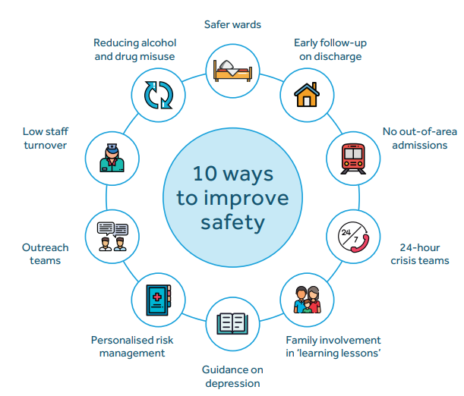  We value your opinion on our research and welcome your feedback on this toolkit, please email: ncish@manchester.ac.uk.

Safer wards | Safer care in mental health services
Safer wards  Services should review in-patient safety, and remove ligature points from wards. There should be measures in place to prevent patients from leaving the ward without staff agreement; this might be through better monitoring of ward entry and exit points, and by improving the in-patient experience through recreation, privacy and comfort. Observations policies should recognise that observation is a skilled intervention to be carried out by experienced staff and should recognise that suicide risk is increased within the first week of admission. | Our evidence  Following NCISH recommendations, suicide using non-collapsible ligature points became an NHS ’never event’ (a serious incident that is preventable) in 2009. This means that health services are required to monitor their incidence, and are provided with advice to reduce the risk.  Since then suicide by mental health in-patients has fallen by 46%, although the number of in-patient suicides in 2017-2019 have not fallen; there were 67 suicides by in-patients in the UK (excluding Northern Ireland) in 2019. Between 2009 and 2019, over a third of in-patient suicides took place on the ward. Many of these deaths were by hanging/strangulation from low-lying ligature points. Half of in-patients who died by suicide were on agreed leave. In our study of clinicians’ views of good quality practice in mental healthcare, clinicians emphasised practices that improved safety in a ward environment such as observations conducted by trained staff.
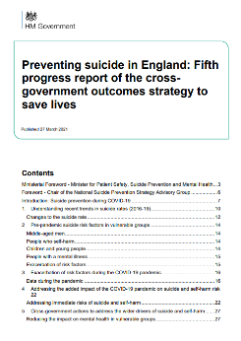
Guidance
This recommendation was originally cited in the Department of Health report An Organisation with a Memory in 2000.
More recently it is included in:
- HM Government’s Fifth progress report of the suicide prevention strategy for England
- The Welsh Government’s suicide and self-harm prevention strategy Talk To Me 2
Safer wards | Safer care in mental health services
Safer wards can be achieved by:

Removal of ligature points

 |  | Response |  | Date next review due | Comments
 |  | Yes | No
Acute in-patient wards (including PICU, forensic units), have been (re)designed to remove the following:
- Non-collapsible curtain rails
- Low-lying ligature points
There has been a comprehensive review of in-patient safety.

Skilled in-patient observation

 |  | Response |  | Date next review due | Comments
 |  | Yes | No
Observation policies recognise that observation is a skilled intervention to be carried out by experienced staff of appropriate seniority.
Observation policies recognise the increased risk of suicide within the first week of admission.
Safer wards | Safer care in mental health services
Safer wards can be achieved by:
Reducing leave from ward without agreement

 |  | Response |  | Date next review due | Comments
 |  | Yes | No
Technology is in place to improve monitoring of ward entry and exit points (including CCTV, swipe card access).
Staffing and observation protocols include information on the monitoring of in-patient ward access and exit points.
There is a standard response/protocol in place for patients who leave the ward without staff agreement.
There is acknowledgement in relevant policies that the in-patient experience (e.g. support and recreation, privacy and comfort) can be linked to the risk of leaving the ward without staff agreement.

Early follow-up on discharge | Safer care in mental health services
Early follow-up on discharge  Patients discharged from psychiatric in-patient care should be followed-up by the service within 72 hours of discharge. A comprehensive care plan should be in place at the time of discharge and during pre-discharge leave. | Our evidence  In the UK, there were 2,496 suicides within three months of discharge from in-patient care between 2009 and 2019. 14% of these post-discharge suicides occurred within the first week of leaving hospital, with the highest number occurring on day 3 after leaving hospital (day 1 = day of discharge, 21%).
Guidance
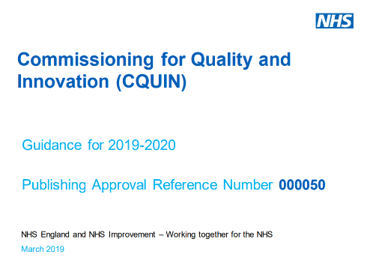
We have recommended all patients are followed up within 72 hours of discharge from in-patient care. The NICE guidance of following up all discharged patients within 7 days was formally reviewed as part of the NHS Commissioning for Quality and Innovation (CQUIN) 2019/20 scheme. Based on our findings, the time frame has since been reduced to 72 hours. NHS England and NHS Improvement have included 72 hour follow-up in the NHS Standard Contract 2022/23.
The 72-hour follow up standard is also cited in HM Government’s Fifth progress report of the suicide prevention strategy for England.
National clinical guidelines have been developed with reference to our findings on suicide following discharge from in-patient care. See the NICE guidance on transition between in-patient mental health settings and community or care settings.
In 2021/2022 NHS England will continue the 2020/2021 winter funding programme to improve the care of post-discharge patients in England.

Early follow-up on discharge | Safer care in mental health services
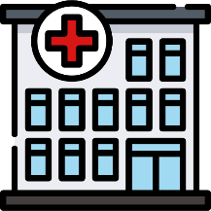
Care planning and early follow-up on discharge from hospital to community

 |  | Response |  | Date next review due | Comments
 |  | Yes | No
The discharge policy specifies follow-up of patients discharged from psychiatric in-patient care occurs within 72 hours of discharge in all cases.
There is a care plan in place for patients discharged from acute care.
There is a care plan in place for patients on pre-discharge leave.

No out-of-area admissions | Safer care in mental health services
No out-of-area admissions  Very ill patients should be accommodated in a local in-patient unit. Being admitted locally means that patients stay close to home and the support of their friends and family, and are less likely to feel isolated or to experience delayed recovery. Local admission should also result in simpler discharge care planning. | Our evidence  In the UK, 225 patients (9% of post-discharge deaths) died after being discharged from a non-local in-patient unit. In 2019 there were 13 suicides after discharge from a non-local unit. There has been a downward trend in the number of suicides by patients recently discharged from hospital in the UK. There were an estimated 180 post-discharge deaths in 2019, down from a peak of 299 in 2011.
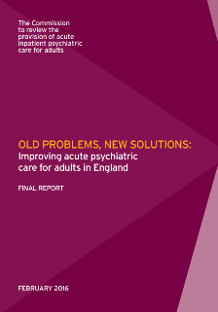
Guidance
Both the King’s Fund Under Pressure report and the Independent Commission on Acute Adult Psychiatric Care referenced this recommendation in 2015, calling for an end to acute admissions out of area.
National clinical guidelines have been developed with reference to our findings on suicide following discharge from in-patient care. See the NICE guidance on transition between in-patient mental health settings and community or care settings.

No ‘out-of-area’ admissions for acutely ill patients

 | Response |  | Date next review due | Comments
 | Yes | No
There are no acute out-of-area admissions. Where patients are discharged from a non-local in-patient unit, there is a policy in place for close follow-up in the community.

24-hour crisis teams | Safer care in mental health services
24-hour crisis resolution/home treatment teams  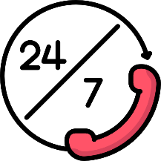  Community mental health services should include a 24-hour crisis resolution/home treatment team (CRHT) with sufficiently experienced staff and staffing levels. CRHTs provide intensive support in the community to patients who are experiencing crisis, as an alternative to in-patient care. CRHT teams should be monitored to ensure that they are being used safely. Contact time with CRHTs should reflect the specialist and intensive nature of that role. | Our evidence  The setting where suicide prevention can have the greatest impact is the crisis team; the main location where patients with acute illness are now seen. In England, there are on average 180 suicides per year by CRHT patients – over two times as many as under in-patient services. The introduction of a 24-hour CRHT appears to add to the safety of a service overall, with a reduction in suicide rates in implementing mental health services. In our study of the assessment of clinical risk in mental health services, both patients and carers emphasised the need for clarity about what to do and who to contact in a crisis.
Guidance
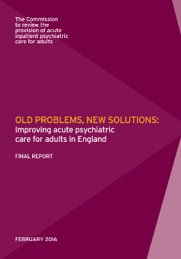
Both the King’s Fund Under Pressure report and the Independent Commission on Acute Adult Psychiatric Care referenced these recommendations in 2015, and emphasised the importance of CRHTs operating efficiently as intensive specialist community-based alternatives to in-patient care, and not simply as generic crisis teams.
This recommendation is included in HM Government’s Fourth progress report of the suicide prevention strategy for England. It is noted as an aim in the Fifth progress report of the suicide prevention strategy for England that by March 2021, all CRHT services will operate 24/7.

24-hour crisis teams | Safer care in mental health services
24-hour crisis resolution/home treatment teams

 |  | Response |  | Date next review due | Comments
 |  | Yes | No
Community mental health services include a 24-hour crisis resolution/home treatment team (CRHT) with satisfactory staffing levels.
The assessment for CRHT takes into account individual circumstances and clinical need, and recognises that CRHT may not be suitable for some patients; especially patients who are at high risk or who lack other social supports (e.g. live alone).

Family involvement | Safer care in mental health services
Family involvement in ‘learning lessons’  Working more closely with families could improve suicide prevention. Services should consult with families from first contact, throughout the care pathway and when preparing plans for hospital discharge and crisis plans.  Staff should also make it easier for families to pass on concerns about suicide risk, and be prepared to share their own concerns. This could help to ensure there is a better understanding of the patient’s history and what is important to them in terms of their recovery, and may support better compliance with treatment.  There should be a multi-disciplinary review following all suicide deaths, involving input from and sharing information with families. | Our evidence  Staff told us that greater involvement of the family by the service would have reduced suicide risk in 18% of patients.  One example of how clinicians think services can improve contact with families is by informing them when a patient does not attend an appointment. In only 27% of deaths by suicide the service contacted the family when the patient missed the final appointment before the suicide occurred. Policies for multidisciplinary review and information sharing with families were associated with a 24% fall in suicide rates in implementing NHS Trusts, indicating a learning or training effect.  Patients tell us they want their families to have as much involvement as possible in their assessment of clinical risk, including sharing crisis/safety plans with them. Clinicians tell us family involvement is vital to enhancing patient safety in mental health care settings.
Guidance
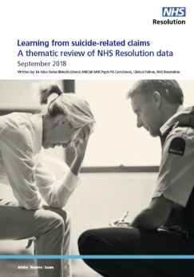
The Independent Commission on Acute Adult Psychiatric Care cite these recommendations, stating that families and carers are an under-used resource.
An in-depth thematic review of claims made after an individual has attempted to take their life by NHS Resolution recommends family members and carers are included in all serious incident investigations following a suicide death.

The NICE Quality Statement on suicide prevention and the NICE guideline on self-harm state individuals presenting with suicidal thoughts or plans, or individuals who have self-harmed, should have the opportunity to discuss whether they would like their family, carers or friends to be involved in their care.

Family involvement | Safer care in mental health services
Working with families

 |  | Response |  | Date next review due | Comments
 |  | Yes | No
There is a specific policy on multi-disciplinary reviews following all suicide deaths, including involving and sharing information with families.
Protocols for risk management encourage involvement with families and carers as much as possible in the risk assessment process, if wanted by the patient.
Care plans, for all patients, are devised collaboratively with carers and family members for ongoing safety management, if wanted by the patient.

Guidance on depression | Safer care in mental health services
Guidance on depression  There should be a local NHS Trust/Health Board policy based on NICE (or equivalent) guidelines for depression and self-harm. | Our evidence  Across the UK, suicide by patients with affective disorders (depression or bipolar depression) rose in 2018-2019 after falling since 2012, with an average of 659 deaths per year between 2009 and 2019. Services that implemented NICE guidance for depression and self-harm guidelines had significant reductions in suicide rates of 26% and 23% respectively.
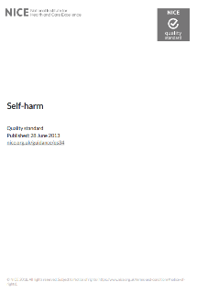
Guidance
See the NICE Quality Standard for the Management of Self-Harm and the NICE guideline on self-harm: assessment, management and preventing recurrence.
See the NICE guidelines on the identification and management of depression in children and young people and the NICE guidelines on depression in adults: treatment and management.

Implementing NICE guidance on depression and self-harm

 | Response |  | Date next review due | Comments
 | Yes | No
There are local Trust/Health Board policies based on NICE (or equivalent) guidelines for depression and self-harm.

Personalised risk management | Safer care in mental health services
Personalised risk management  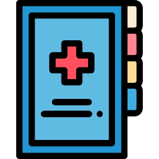  All patients’ management plans should be based on the assessment of individual risk and not on the completion of a checklist. Patients should have the opportunity to discuss with their mental health team the signs that they will need additional support, such as specific stresses in their life (e.g. economic adversity, experience or threat of domestic violence), anniversaries and dates that are important to them and online experience. Families and carers should have as much involvement as possible in the assessment process, including the opportunity to express their views on potential risk. Consulting with the patient’s GP may also be helpful.  Risk assessment is one part of a whole system approach that should aim to strengthen the standards of care for everyone, ensuring that supervision, delegation and referral pathways are all managed safely. | Our evidence  Most risk assessment tools seek to predict future suicidal behaviour. Clinicians tell us that tools, if they are used, should be simple, accessible, and considered part of a wider assessment process. Treatment decisions should not be determined by a score. Risk tools and scales have a positive predictive value of less than 5%, meaning they are wrong 95% of the time, and miss suicide deaths in the large ‘low risk’ group. In a sample of patient suicides, the quality of assessment of risks and management was considered by clinicians to be unsatisfactory in 36%.  In our study of suicide risk assessment in UK mental health services, we found risk is often individual, suggesting the management of risk should be should be personal and individualised.
Guidance
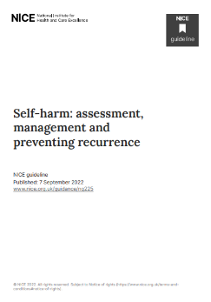
NICE guidelines on the assessment, management and preventing recurrence of self-harm state that risk assessment tools and scales should not be used to predict future suicide or repetition of self-harm, or to determine who should or should not be offered treatment or who should be discharged. The guidelines suggest risk assessment should focus on the person’s needs and how to support their immediate and long-term psychological and physical safety.
The use of risk assessment tools in mental health services has been debated in Parliament.

Personalised risk management | Safer care in mental health services
Personalised risk management, without routine checklists

 |  | Response |  | Date next review due | Comments
 |  | Yes | No
There is a comprehensive management plan based on an assessment of (changing) personal and individualised risks, and not on the completion of a checklist.
Protocols for conducting risk assessment should emphasise building relationships and gathering good quality information on:
- The current situation
- Past history
- Social and economic factors
- Significant dates and anniversaries
- Online experience
There is specific staff training in place in how to assess, formulate, and manage risk, including training staff in being comfortable asking about suicidal thoughts.
There is a guide in place on the effective communication of personalised risk management between different agencies, services and professions involved with the patient, including their family and carers and with primary care.

Outreach teams | Safer care in mental health services
Outreach teams  Community mental health teams should include an outreach service that provides intensive support to patients who are difficult to engage or who may lose contact with traditional services. This might be patients who don’t regularly take their prescribed medication or who are missing their appointments. | Our evidence  Implementation of an assertive outreach policy was associated with lower suicide rates among patients who were non-adherent with medication or who had missed their last appointment with services, and with lower suicide rates overall in implementing Trusts. In our study of clinicians’ views of good quality practice in mental healthcare, clinicians emphasised dedicated outreach services that provide intensive support to enhance patient engagement.
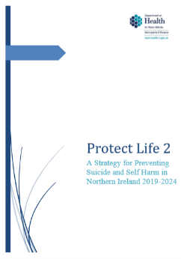
Guidance
The Independent Commission on Acute Adult Psychiatric Care includes recommendations for comprehensive and effective community mental health, including outreach teams.
The Northern Ireland strategy for preventing suicide and self-harm cites this recommendation.

Outreach teams | Safer care in mental health services
Community outreach teams to support patients who may lose contact with conventional services

 |  | Response |  | Date of next review | Comments
 |  | Yes | No
Community mental health services include an outreach service that provides intensive support to patients who are difficult to engage with conventional services (e.g. community patients who are not regularly taking their prescribed medication or who are missing their appointments).

Low staff turnover | Safer care in mental health services
Low staff turnover  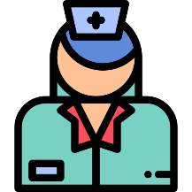  There should be a system in place to monitor and respond to non-medical staff turnover rates. Non-medical staff are all other health staff except doctors. | Our evidence  Organisations with low turnover of non-medical staff had lower suicide rates than organisations where staff changed frequently. In addition, those services with low staff turnover saw a greater reduction in their suicide rates when they implemented NCISH recommendations that services with high staff turnover.
Guidance
The King’s Fund cited this recommendation in their Under Pressure report in 2015.

Low turnover of non-medical staff

 | Response |  | Date next review due | Comments
 | Yes | No
There is a system in place to monitor and respond to non-medical staff turnover rates (i.e. nurses, qualified allied health professionals and other qualified scientific, therapeutic and technical staff).

Reducing alcohol and drug misuse | Safer care in mental health services
Reducing alcohol and drug misuse  We recommend there are local drug and alcohol services available that work jointly with mental health services for patients with mental illness and alcohol and drug misuse.  Other clinical measures that could reduce suicide risk in this group are alcohol and drug misuse assessment skills in frontline staff and specialist alcohol and drug misuse clinicians within mental health services. | Our evidence  Across all UK countries, alcohol and drug misuse is common among patients who die by suicide (47% and 37% of all patient suicides UK-wide, respectively, higher in Scotland and Northern Ireland). However, only a minority of patients who died by suicide between 2008 and 2018 were in contact with specialist alcohol and drug misuse services.  In England, there was a 25% fall in rates of suicide by patients in those NHS Trusts which had put in place a policy on the management of patients with co-morbid alcohol and drug misuse.
Guidance
See the NICE guidelines on coexisting severe mental illness and substance misuse.
Embedding suicide prevention in drug and alcohol policy and services is an action in the strategy for preventing suicide and self-harm in Northern Ireland.

Reducing alcohol and drug misuse | Safer care in mental health services
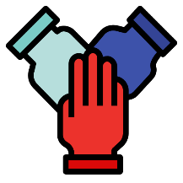
Specialised services for patients with mental illness and coexisting alcohol and drug misuse

 |  | Response |  | Date next review due | Comments
 |  | Yes | No
Specialist alcohol and drug services are available, with a protocol for the joint working with mental health services (including shared care pathways, referral and staff training).
There is a specific management protocol or written policy on the agreed management of patients with coexisting alcohol and drug misuse.
Protocols for managing self-harm patients who are under mental health care should highlight the short term risk of suicide, especially where there is coexisting alcohol and drug misuse.
There is specific training in place for staff on alcohol and drug misuse assessment.
There are specialist alcohol and drug misuse clinicians within mental health services.

Managing self-harm | Safer care in the Emergency Department
Managing self-harm  There is evidence that recent self-harm is increasingly common prior to suicide in mental health patients and in people not in contact with mental health services. Self-harm should be recognised as a suicide warning - presenting an indication of risk and a chance to intervene. We recommend protocols for managing self-harm patients who are under mental health care highlight the short-term risk of future suicidal behaviour. | Our evidence  Recent self-harm (in the previous 3 months) has risen as an antecedent of suicide in mental health patients. In the UK, over a quarter (29%) of patients who died by suicide between 2006 and 2016 had recently self-harmed – an average of 434 deaths per year. Self-harm is particularly evident in younger age-groups. Our findings show an episode of self-harm is common as a recent experience in mental health patients who die by suicide but risk can be under-estimated at assessment – most (76%) patients who had recently self-harmed were thought to be at low risk of immediate suicide at their final service contact.
Guidance
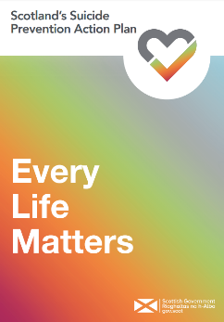
NICE guidelines on the management, assessment and preventing recurrence of self-harm describe the importance of a psychosocial assessment to identify the person’s strengths, vulnerabilities, and needs, including historic, changeable and current, future, and protective or mitigating factors. New NICE guidelines on the assessment, management and preventing recurrence of self-harm include information for people working in education and criminal justice settings.
Reducing rates of self-harm as a key indicator of suicide risk is cited in the HM Government’s Fifth Progress Report of the Suicide Prevention Strategy in England, the Welsh Government’s suicide and self-harm prevention strategy Talk To Me 2, Northern Ireland’s strategy for preventing suicide and self-harm, and in Scotland’s Suicide Prevention Action Plan.
A national programme of transformation funded by NHS England and NHS Improvement is establishing new and integrated models of primary and community mental health care across England. These models will provide improved care for adults and older adults who self-harm in the community, as laid out in the NHS Long Term Plan.

Managing self-harm | Safer care in the Emergency Department
Psychosocial assessment after self-harm

 |  | Response |  | Date next review due | Comments
 |  | Yes | No
There is a fully integrated liaison psychiatry service in place offering 24-hour specialist assessment and follow-up for all self-harm patients.
There is a policy in place for all patients who self-harm to have a skilled psychosocial assessment of risk of future self-harm and suicidal behaviour.
Protocols for managing self-harm patients who are under mental health care highlight the short term risk of suicidal behaviour.
Services that respond to self-harm meet NICE quality standards for self-harm care.

Safer prescribing | Safer care in primary care
Safer prescribing  Our evidence indicates a key measure to reduce suicide risk includes safer prescribing in primary and secondary care, particularly opiates/opioids prescribed to people with long-term physical illness (especially older patients) and benzodiazepines prescribed to people with anxiety disorders. These are medications that may have been prescribed for long-term pain, for someone else in the patient’s household or bought over the counter in a pharmacy or shop. | Our evidence  The main substances taken in fatal overdose are opiates and the main source (where known) is by prescription. In the UK, opiates (including opioid compounds) account for 36% of patient suicide deaths by fatal overdose, the most common being heroin/morphine (38%), codeine (18%), tramadol (17%) and methadone (13%). In Scotland fatal overdose by opiates is more common (49%). 38% of patients with a physical health problem die by self-poisoning, significantly more than patients without a physical co-morbidity (20%). The most common substances taken in this group are opiates/opioids, mostly prescribed. Management of chronic primary pain in people aged 16 years and over should not include certain medications, such as opioids.
Guidance
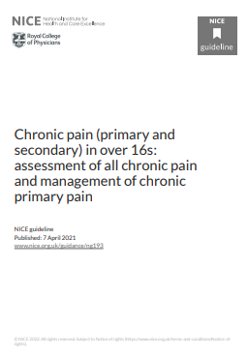
NICE guidelines on borderline personality disorder recommend short-term use of drug treatment may be helpful during a crisis, but that polypharmacy should be avoided. NICE guidelines on depression in adults with a chronic physical health problem advise certain medications (i.e. opioids) should not be prescribed to manage chronic pain in people aged 16 and over.
General Medical Council guidance and NICE guidelines on anxiety disorder highlight that doctors should check whether the treatment provided for a patient is compatible with other treatments they are receiving, including any self-prescribed over-the-counter medicines. Patients should also be encouraged to be open about their use of other medicines during assessment.
Reducing suicide through safer prescribing is cited in Northern Ireland’s suicide prevention strategy Protect Life 2, and the Welsh Government’s suicide and self-harm prevention strategy Talk To Me 2.

Safer prescribing | Safer care in primary care
Safer prescribing

 |  | Response |  | Date next review due | Comments
 |  | Yes | No
There is a standard procedure in place for safer prescribing of opiate analgesics and tricyclic antidepressants in primary care and accident and emergency departments, which takes into account the toxicity of these drugs in overdose by:
- Considering reduced, short-term supplies;
- Asking about supplies of over-the-counter opiate-containing medications kept at home or prescribed to someone else in the household;
- Ensuring patients newly prescribed antidepressants are aware of the time taken to work.
Protocols for managing patients with anxiety disorders highlight reduced prescribing of benzodiazepines.

Monitoring for depression | Safer care in primary care
Monitoring for depression  Good physical healthcare may help reduce suicide risk. Health care professionals working across all medical specialties should be vigilant for signs of mental ill health, especially when treating major physical illnesses including cancer, coronary heart disease, stroke or chronic obstructive pulmonary disease (COPD).  Clinical services should also be aware of the increased risk of fatal overdose, particularly by opiates/opioids in older patients with long-term physical illness. | Our evidence  Physical illness can increase the risk of suicide among mental health patients. In the UK in 2009-2019, a quarter of patients who died by suicide also had a co-morbid physical health problem and the figure rises to 47% in patients aged 65 and over. Depression is linked to increased suicide risk among physically ill people, particularly in certain diagnoses such as coronary heart disease, stroke, chronic obstructive pulmonary disease (COPD) and cancer. Often affective disorders have been present for more than 5 years in patients with a comorbid physical illness who died by suicide. 71% of people who died by suicide and had presented to their GP had a diagnosis of depression.
Guidance
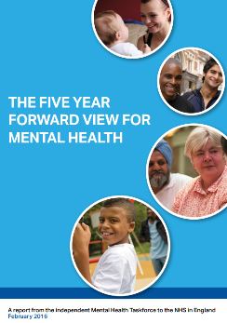
See the NICE guidelines on the identification and management of depression in children and young people and the NICE guidelines on depression in adults: treatment and management. NICE guidelines on the management, assessment and preventing recurrence of self-harm also highlight the importance of assessing for the presence of physical ill-health in older people who have self-harmed.
An integrated mental and physical health approach is a priority action for the NHS cited in The Five Year Forward View for Mental Health.

Monitoring for depression | Safer care in primary care
Diagnosis and treatment of mental health problems especially depression in primary care

 |  | Response |  | Date next review due | Comments
 |  | Yes | No
There is a mechanism in place to ensure that patients who present with major physical health issues are assessed and monitored for depression and risk of suicide.
There is a mechanism in place to ensure that patients with certain markers of risk (i.e. frequent consultations, multiple psychotropic drugs and specific drug combinations) are further assessed and considered for referral to specialist mental health services.
There is a standard procedure in place for mental health staff to regularly review care with GPs or specialist clinics.

Additional measures for men | Safer care in primary care
Additional measures for men  Since 2013, men aged 40-54 have had the highest suicide rate in the UK. The suicide rate in middle-aged men in the UK is 3 times higher than women of the same age and 1.5 times greater than men in other age groups. Suicide risk factors among middle-aged men include a reluctance to seek help, higher rates of substance misuse and isolation, a lack of social supports, and economic pressures such as unemployment. | Our evidence  Middle-aged men have the highest suicide rate in the UK but are often not in contact with services. Between 2009-2019, in all countries (except Northern Ireland), the highest suicide rates were in men in the middle-aged groups. Self-harm in middle-aged men has also increased, particularly after 2008. In our study of suicide by middle-aged men we found high rates of key risk factors in men in mid-life compared to their incidence in the general population, including unemployment, divorce, deprivation, substance misuse and physical and mental ill-health.
Guidance
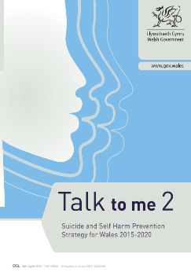
The marked rise in suicide in middle-aged men is cited in The Five Year Forward View for Mental Health.
Better targeting of suicide prevention in high risk groups such as middle-aged men is included in:
- HM Government’s Fifth Progress Report of the Suicide Prevention Strategy in England
- The Welsh Government’s suicide and self-harm prevention strategy Talk To Me 2
- Scotland’s Suicide Prevention Action Plan
Reducing the risk of suicide in middle-aged men is an ambition supported by a NHS commitment to provide every area in England with funding for suicide prevention and bereavement services, as laid out in the NHS Long Term Plan.

Additional measures for men | Safer care in primary care
Additional measures for men with mental ill-health

 |  | Response |  | Date next review due | Comments
 |  | Yes | No
There are psychological therapies suited to the needs of men in mid-life which can be offered.
There are measures in place to ensure services are responding to men’s needs in a way that helps and engages them. This includes protocols for joint working with primary care, A&E, and the justice system.
There is a standard procedure in place for men who may be uncomfortable seeking help (i.e. are disengaging) that signposts them to local informal sources of help.

