Beauty, Bioethics and the Body

An artsmethods@manchester supported workshop held on the 30th of October at the University of Manchester. Organised by Ajmal Mubarik.

The Beauty, Bioethics, and the Body workshop exploring the ethical issues and challenges of cosmetic enhancement took place on the 30th October at the University of Manchester thanks to the wonderful support of artsmethods@manchester.
I was delighted with the fantastic support of artsmethods whilst organising this workshop. From the very first moment they provided me with detailed help, advice and support on planning and running the event, providing fantastic catering, promotional material and on all of the necessary components of a successful workshop.
One of my aims when planning and designing the workshop was to unite researchers from an unprecedented variety of diverse research backgrounds to debate and challenge existing perspectives and practice, and to create a novel blueprint for future policy and research. This workshop was an interdisciplinary success as the support of artsmethods allowed participants from social anthropology, bioethics, law, philosophy, psychology, contemporary art, cultural studies, medicine, dentistry and literature to attend. They were led by a panel of leading academics in body image, cosmetic surgery, and enhancement.
An exciting and thought provoking day was packed with lively debate and fascinating presentations. These explored the influences upon body image, their impacts and the after effects of cosmetic enhancement. Presentations included a study of body-transformation fantasies and self-improvement in culture and literature; the cultural negotiations and legal response to non-mainstream body alterations; the impact of social and technological development on the provision of cosmetic body modification; the misuse of biomedical tools for self-improvement; the moral status of different eating disorder diagnostic labels; the influence of dominant cultural norms in the provision of cosmetic treatment; identity and global beauty standards; and artificial intelligence and communication post cosmetic enhancement.
Artsmethods was vital to the success of this workshop and both this and the positive, enthusiastic response of all of the participants has enabled me to form a new and growing network of researchers. I hope to plan further events with the outstanding support of the artsmethods@manchester team.

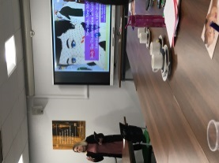
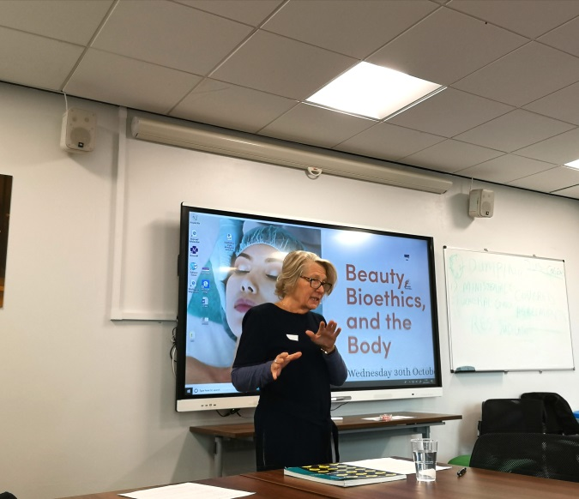

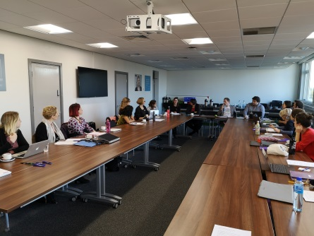
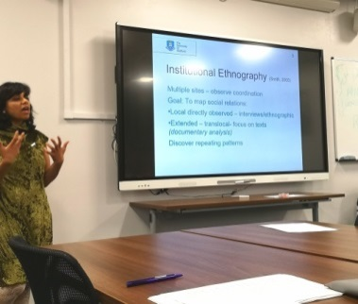

Beauty, Bioethics and the Body Organised by Ajmal Mubarik.

8.50 to 9.20: Registration and refreshments. 9.20 Welcome

9.25 Arianne Shahvisi. Consenting to FGC: should reinfibulation be permitted?
10.25 Marsha Wichers. Project Face Design. Facial Enhancement and the Human Condition
11.15 Jeanette Edwards. The tensions between bioethical, anthropological and feminist approaches to cosmetic procedures.
12.05 Carole Myers. Rhinoplasty in Brazil: the hidden powers of exclusion.
12. 25 Lunch
1 pm David Lawrence. Amplio ergo sum.
2pm Amy Slater. The role of social media in defining beauty norms. Ethical and social responsibility of game and app developers.
2.45 Rose Mortimer. Pride before a fall: The ethical significance of shame, pride and identity in eating disorder diagnoses.

3.10 Break. Tea, coffee

3.15 Rizwana Lala. The influence of dominant cultural discourses on the provision of cosmetic dentistry.
3.55 Michelle Greene. Fictional representations of self-improvement in novels, myths of transformational change, and social and medical stigma.

4.15 Richard Gibson. A Leg to Stand on? Theories of Health, Normality, & Body Integrity Identity Disorder
4.40 Mireia Garces-De-Marcilla-Muste. Elective amputations: a challenge to (ableist) normality.

5. 05 Closing comments.

'This work was supported by artsmethods@manchester

https://www.postgradbioethics.com/beauty-bioethics-and-the-body
Ajmal Mubarik: ajmal.mubarik@postgrad.manchester.ac.uk @medicine_law

