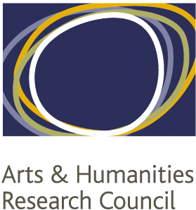

OVERSEAS INSTITUTIONAL VISIT GUIDANCE NOTES

Eligibility
- All AHRC students funded through the NWCDTP must apply for, and complete the Overseas Institutional Visit (OIV) within the three year funded period of their doctoral degree.
- Students can only apply for OIVs that relate to their PhD.
- Only one OIV application can be made during period of the studentship. Applications can be for up to three separate visits to the same host university or esteemed research institution during the course of the studentship as long as the total period of the visits does not exceed three months.
- Applications would usually involve visits to a University but in exceptional circumstances applications for visits to other high-ranking research organisations will be considered.
- OIV’s can be distinguished from fieldwork, applications for which are managed through a separate process.

How to apply
- Applicants should complete the attached OIV application form.
- The completed form should be sent to the: NWCDTP@manchester.ac.uk.
- This application form will then be assessed by the NWDTP Director. Applicants may be asked for further information where this is needed.
- Applicants should allow sufficient time to apply for a visa (where this is needed) and remember to keep within the permitted terms of that visa whilst they are abroad.

Health & Safety and Insurance
- Applicants should consult the Foreign and Commonwealth Office guidance relating to their intended destination. Visits must not be undertaken if the Foreign and Commonwealth Office advises against visiting the country concerned.
- Applicants should ensure that they carry out a risk assessment with their Supervisor prior to departure and this should be approved by the relevant Health & Safety Officer. Any other safety checks required by the applicant’s home institution should also be followed.
- Applicants should check with their relevant Insurance Office to see whether they are covered by their University insurance. If not, applicants must ensure that they take out all insurance that is required for the duration of the OIV.

Expenses
- Successful applicants in receipt of a full studentship award may be eligible for a paid extension to their stipend equal to the period of time spent overseas, this will be reviewed on a case-by-case basis. Fees only students will receive their expenses only.

Making the most of your OIV
- Think how you can get the most from your visit:
- Are there any conferences or seminars that you could attend while you’re there?
- Check whether your International Office has links with the area you are visiting?
- Does the British Council have a presence in the country or region that you are hoping to visit? Are there any events that you could attend or is there someone you could contact to help plan relevant activities?

