MRC Skills Development Fellowship
Stage 1 Application Form
[Please append a copy of your Academic Curriculum Vitae to this application form]

1. APPLICANT DETAILS
Surname |  |  |  | Forename/s
Email Address
(a)

(b) Title of Current Post

Date of appointment

Expected date of termination (if applicable)

(c) Current Salary Details
Salary Grade:
Basic Salary
Date of last increment

Source(s) of current salary support (please include all sources if your current salary is funded from more than one source)
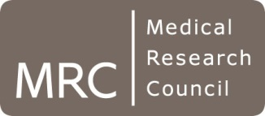

(d) Research Experience (please give brief details of your research experience and training; please describe the subject of any previous external fellowships here if relevant; 300 words max)

(e) Career breaks
Have you had any career breaks or periods of part time work, for example parental or long term sick-leave?

If yes, please provide details:

(f) Proposed duration of fellowship (36 months at 1FTE - please state if part time)

(g) Proposed start date

2. Project Details

- Project Title (up to 150 characters)

Project Proposal Outline
Please provide a supporting statement, including:
- A brief summary of the area you wish to work in and what your research project might address (including key objectives).
- Why your work and experience is of relevance to an MRC Skills Development Fellowship in one or more of the MRC Priority skills areas.
- Details of any potential sponsors at UoM that you may have already identified and why working with them would optimise your research and training opportunities.
- Brief plans for interdisciplinary training
- Potential research placement (3-6 months)
(Max 2 sides of A4, Arial point 11)

