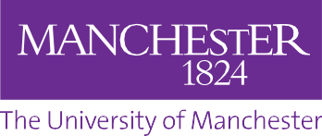
IMAGE RELEASE FORM

The University of Manchester often uses photographs or video film for publicity purposes. These images may appear in our printed publications, on our website, or both. We may also send them to the news media. We require your permission to do this.
Please read the information below, circle yes or no, then sign and date the form where shown.
I agree to the use of my image(s), in printed publicity or promotional literature produced by The University of Manchester, including leaflets, posters, newsletters and other display material; on The University of Manchester’s website and other social media sites, including Facebook, Twitter and YouTube; and in any publicity material about our services sent to the news media.
I understand that websites and other online media can be seen throughout the world, and not just in the United Kingdom, where UK law applies.
By signing this form, I confirm that I have gained consent from any persons featured in this image for the image to be used for the purposes mentioned above.

Year of study
Surname
Forename
Subject or course
I have read and understood the above. Yes / No (circle)

All photographs and video material is copyright to The University of Manchester
Our reference
Date
Signature
Email address
Please return this original form to: egc@manchester.ac.uk

