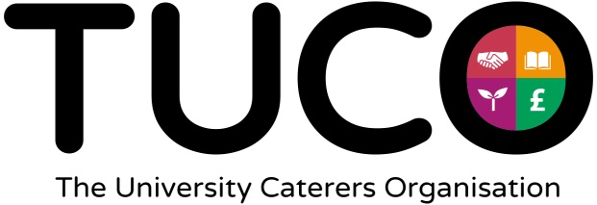

Joint Modern Slavery Awareness Event
The University, in conjunction with colleagues from The University Caterers Organisation (TUCO) hosted a successful event on 13th June to raise awareness of Modern Slavery in supply chains.
Modern Slavery is an international crime affecting millions of people regardless of age, gender or ethnicity in developed, and developing, countries. Within this country victims include people trafficked from overseas, or vulnerable people from the UK, who are forced to work illegally or against their will. The aim of the event was to raise awareness of the issue and share experiences with the TUCO catering suppliers and their supply chains.
The session was hosted by Sheri-leigh Miles from NETPositive Futures, and focussed on raising awareness of modern slavery in supply chains, and the challenges faced by suppliers when trying to tackle the issue of how to respond to the challenges of ethical trade. University colleagues were joined by representatives from all sectors of the catering industry who heard speakers from the University, TUCO, NETPositive Futures, Greater Manchester Programme Challenger, legal experts and one of our major suppliers. This was followed by an opportunity to share experiences and network with other attendees.
Feedback was overwhelmingly positive:
‘I found it very informative and certainly raised my awareness of the issues and challenges in this important and emotive subject.’ (Mark Lawton, Harlech Food)
‘An eye-opening and informative event today thanks to @TUCOltd and @UOMProcurement. We all need to work to ensure ethical practices at every stage of the supply chain.’ (HG Stephensons via Twitter)
‘I’ll certainly pass this on to customers and suppliers when speaking to them, hopefully using word of mouth we’ll help spread the awareness across the UK and in turn reduce modern slavery.’(Joshua Graves, Matthew Algie)
TUCO is committed to ethical procurement and raising awareness on relevant issues helps our members and suppliers to become more aware of the risks, modern slavery is a real danger and this event highlighted ways in which we can address the problem. (Mike Haslin, CEO, TUCO)
I thought the Modern Slavery event organised by the University and TUCO was very interesting and enlightening. Never have I seen such engagement amongst suppliers and buyers during the roundtable discussions, it just showed how keen people are to address the issues. It does however highlight how much more we need to be doing both as an institution and as consumers. (Sandra Milne, Solicitor, University of Manchester)
I found the experience of hearing from other TUCO suppliers and experts extremely useful together with the information of alliances with experts which gives me ideas on how to improve what we currently do in this important are. (Stuart Linsey, HG Stephensons).
You can watch a video and listen to some of the event speakers here: https://www.youtube.com/watch?v=M36nolfYDFY&t=1s
This is one of a number of actions to support the University’s zero tolerance approach to modern slavery and human trafficking.
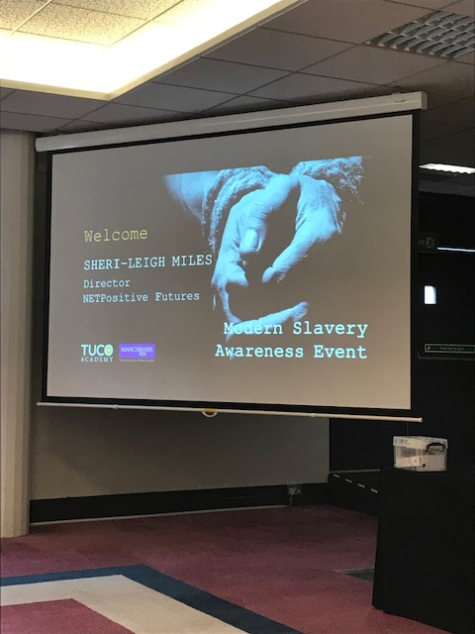

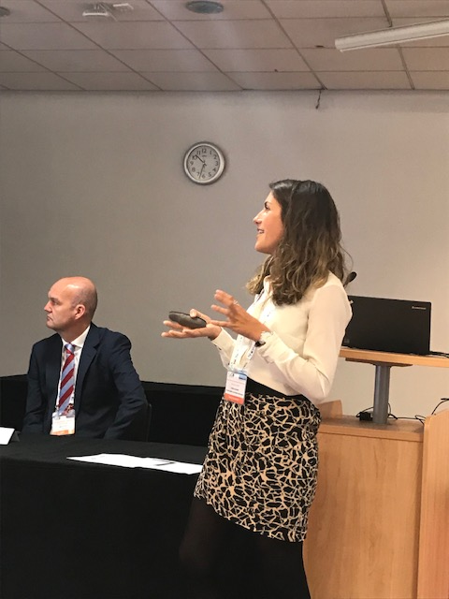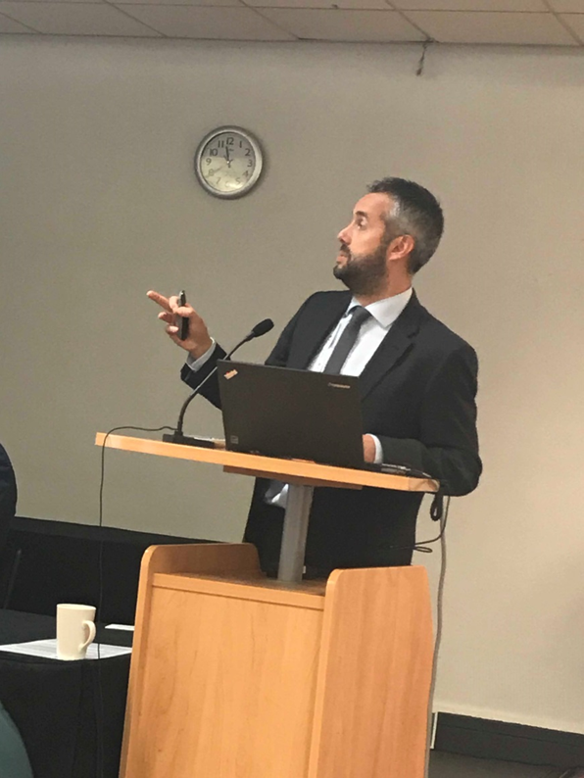
Caitlin Schindler, Sustainability & Ethics Manager, Bidfresh
& Damian Dallimore, Partnership Lead, Programme Challenger

