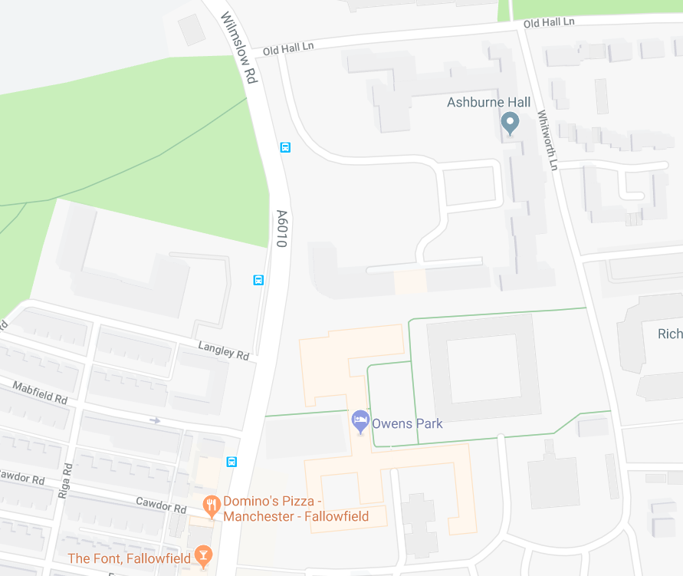

Owens Park is labelled

UMAC – Fallowfield
Room ASF1
Little Court
Owens Park,
Wilmslow Road,
Fallowfield
M14 6HD

Frequent Bus services run from Manchester to Owens Park along Wilmslow Road.

If you are a Blue Badge Holder and require parking please notify us prior to you Assessment and this will be arranged. Disabled Parking is available directly outside of Reception at UMAC– Fallowfield.

