How to Check Results online with a Candidate Number
Results will be available 13 days after the test at the British Council. You can check your result online from 10:00am on the 13th day after your test. To do this, you need the candidate number which you will be given on the test day.

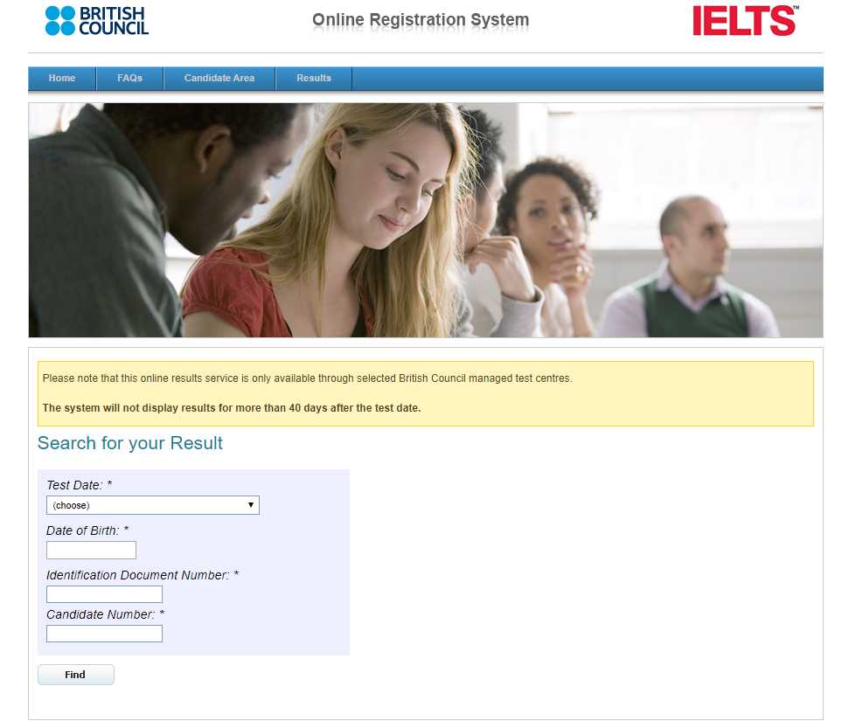
6 digit candidate number (usually starts with 00) – this was given to you on the test day.
Letters need to be in uppercase and make sure to include all special characters if your ID has any

How to Check Results via the Candidate Area (if you cannot remember your candidate number)
Log into your candidate area here: https://ielts.britishcouncil.org/CandidateLogin.aspx

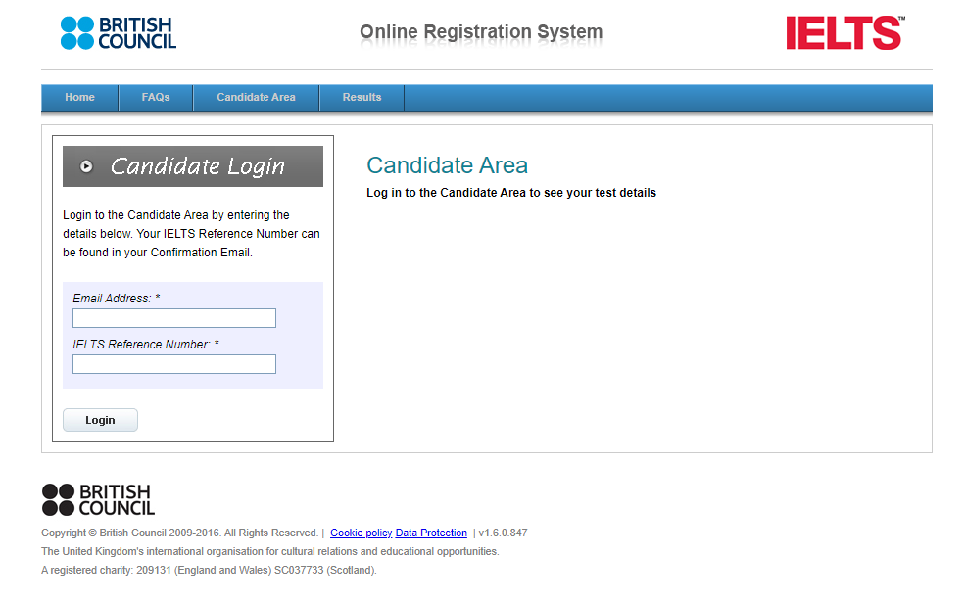
The same email address that you used during your IELTS application
You will find this reference number in the first email that you received when you registered for the IELTS exam titled IELTS APPLICATION SUMMARY. Please refer to that email for more information.

When you log into your candidate area, you should see a page like the
one below.

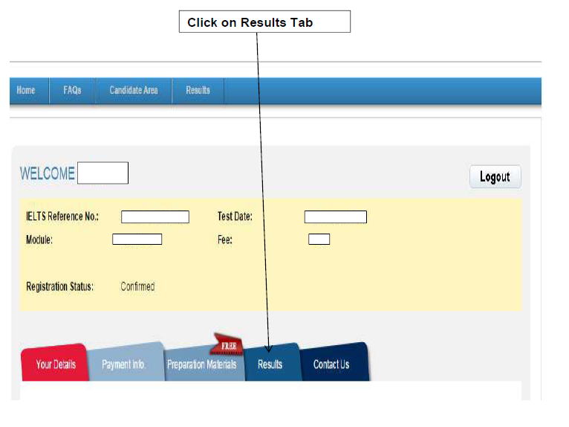

You should then be able to view your results. See example below

