Zochonis Special Enterprise Fund – South Africa Trip
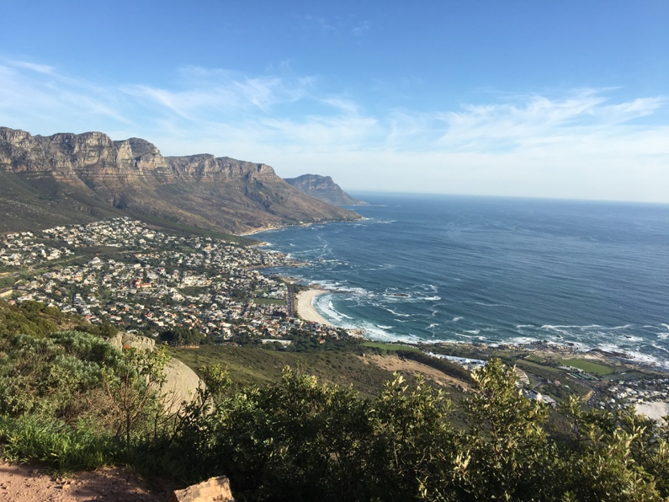
Thanks to the Zochonis Special Enterprise Fund, I was able to undertake a 3-week-long trip to Cape Town, South Africa to volunteer with a local organisation, SAVE foundation. SAVE is a non-profit organisation which aims to “enrich, educate and empower” the township and settlement communities. I chose to take part in the Educare Assistance project run by SAVE and I was placed in a pre-primary school in the township of Dunoon.
In this report, I will outline my experience of volunteering in Dunoon, the most rewarding and challenging aspects of the trip and the personal, professional and educational impact that the trip has had.

The Educare Assistance project aims to provide volunteers to disadvantaged communities in Cape Town who assist with the teaching and caring of pre-school children. In the townships, like Dunoon, many pre-primary schools struggle to provide effective early years education due to lack of funding, resources and skilled teachers and teaching assistants.
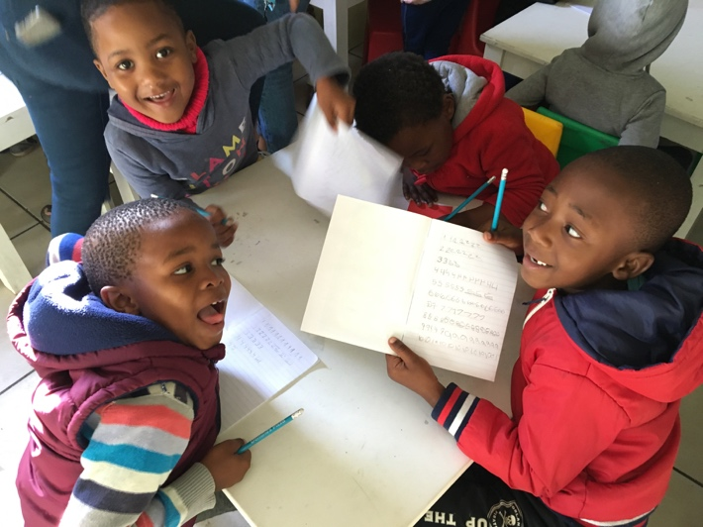
In South Africa, children do not receive compulsory education until the age of 7 and to attend these formal schools, children must be at a certain academic level, pre-school education is important. Without sufficient pre-school education, the children will either be very educationally behind their peers or not be able to progress to primary school at all.
Therefore, providing volunteers to the project, increases the availability of assistance to the schools without incurring the project provider any cost. This enables the children to receive constant foundation education which is fundamental to their cognitive and personal development. This gives the children a better start to their educational life, making them better prepared for primary school which subsequently increases their potential for further education and employment.

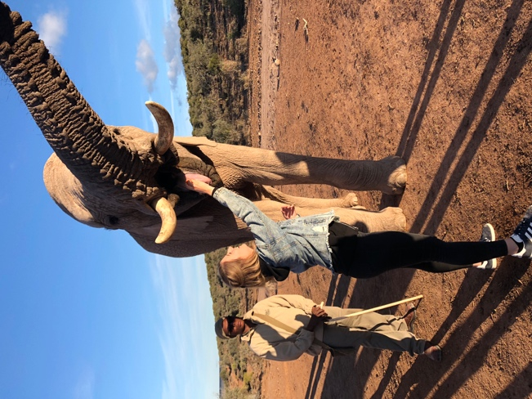
I attended the school from Tuesday to Friday each week, leaving the volunteer house at 8am and returning at 3pm. On Mondays, my fellow volunteers and I, planned the lessons and activities for each day of the week and prepared the materials needed (e.g. worksheets, equipment for crafts). Each week there was a different number of volunteers ranging from 3-6. The day usually started with “circle time” where we would say “good morning” to each of the children and volunteers. We would then lead an activity on the topic of the week, for example, the seasons. This would usually be followed by a short lesson on either simple numeracy or literacy, after which, the children would go outside for snack time. In the late morning there would either be a craft activity around the topic, for example paper plate flowers, or we would play nursery rhymes or songs to which the children would sing and dance. Following this would be lunchtime and then in the afternoon, the younger children had time for a nap and we would read the older children books, play with Lego or do colouring.

The weekends were free, for all volunteers, to go on trips or explore the local area. Some of the trips that I took part in included, climbing Lion’s Head mountain, visiting Cape Point and Cape of Good Hope and a trip along the Garden Route which involved caving in the Cango Caves, an elephant walk and a safari on the final day.

For me, the most challenging aspect of the trip was having to essentially become a teacher for the 3 weeks I was at the school. Before partaking in the project, I presumed our role, as volunteers, would be more of an assistance role to the full-time teachers and teaching assistants. However, for the duration of the project, the volunteers were planning all of the lessons for the week and running both the majority of the lessons and the other classroom activities (e.g. crafts). This was challenging as I have no teaching experience and therefore, I was apprehensive about running lessons and activities by myself.
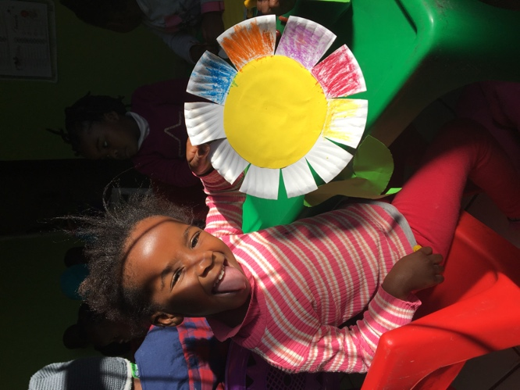
Despite this, as most of the teachers are not trained, having the volunteers who, despite not being trained teachers, are able to deliver lessons in English, allows the teachers to learn techniques, skills and activities and continue to use these when the volunteers leave.
In addition, it also benefits the volunteers, as through working with people from a different culture to their own, the project aims to improve cultural awareness and build global citizenship and thus encourages volunteers to be more active citizens in their own community.

The most rewarding aspect of the trip was undoubtedly getting to know the children and seeing them take part in our activities. After putting all our effort into planning and organising the activities and preparing the materials, to see the children engaging and enjoying taking part made me feel that my work was valuable. In the UK, pre-school crafts and activities are fundamental however, the children in the townships do not expect such activities in pre-school and so enjoy it a more as it is a special event.
Another rewarding aspect was witnessing the children improve their English. Through being an English-speaking programme, all volunteers, even if English is not their first language, would speak English to the children. I think that this exposure to English, in the taught lessons and in conversation with the children, will make the children familiar with English, which will put them ahead when they start English lessons at primary school. This, in turn, helps the children as being proficient in English increases their chances of employment later in life.

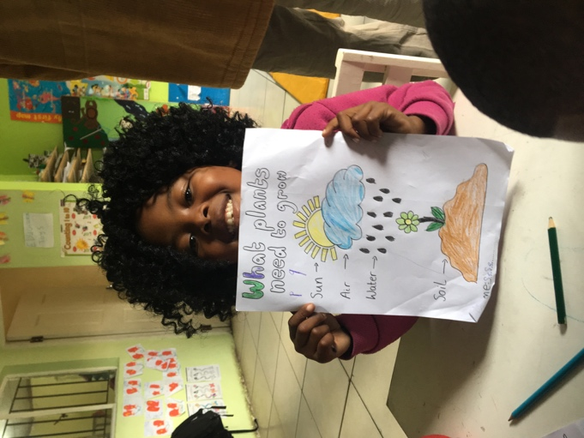
The trip had an overwhelming impact on me, educationally, professionally and personally. As I am a Speech and Language Therapy student, I was interested in the variation in child development in a different culture. Through this trip I have widened my knowledge of typical child development through applying my awareness of typical development in the UK to a different culture. I have also been able to experience the effect of living in a disadvantaged community, such as the townships, on the children and their language development. Research suggests that in the UK, being from a low socio-economic status is a risk factor for language disorder. However, the poverty in the townships is much more pronounced than any disadvantaged community in the UK and so investigating the impact of living in a township on language development could be an interesting research topic. I have also acquired some simple words and phrases in Xhosa for use in the classroom, this has enhanced my linguistic skills.
Professionally, as we were required to carry out most of the teaching activities, I have developed basic teaching skills which will be useful if I volunteer again in the future. I also improved my team-work and communication skills, as I worked alongside volunteers from different countries, as well as the South African teachers, to plan and carry out the lessons.
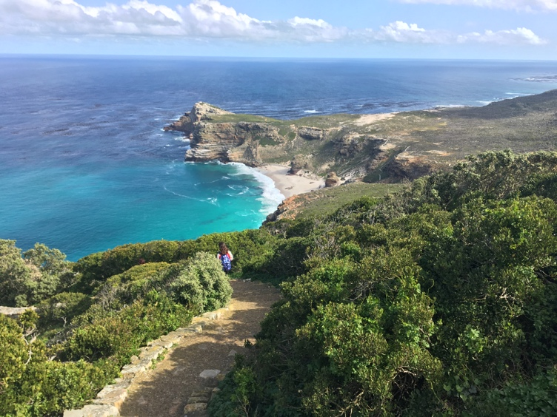
Personally, the most interesting part of the trip, but also the most shocking, was witnessing the contrast between the ‘rich’ and the ‘poor’ in South Africa and learning that for such a naturally beautiful country it has a lot of issues. I had never before been faced with populations in such poverty alongside such westernised middle-class populations within the same city. Learning that this gap is continually widening has made me more aware of the ongoing politics within the country and interested in whether there will ever be a movement towards equality.

Overall, I believe that this trip has definitely increased my global understanding and cultural awareness, as I was immersed in a culture entirely different to my own. I am now more aware of the issues regarding education, employment, health and crime in South Africa and believe this knowledge will benefit me as I can compare the difficulties in other countries, including the UK, to those in South Africa.

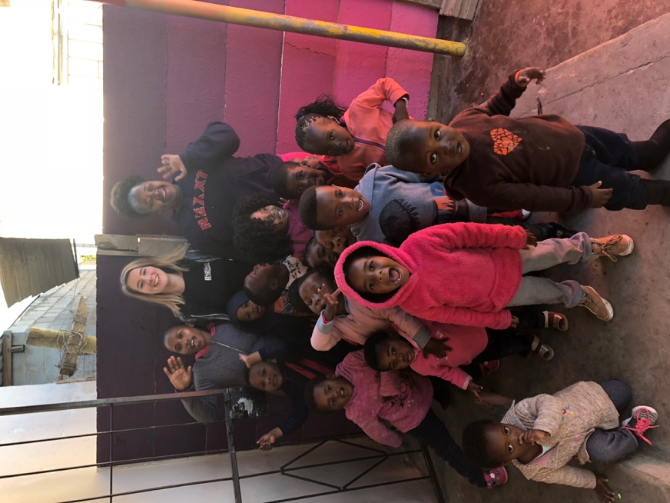
Deciding to volunteer in South Africa was the best decision I have ever made. It has made me a more well-rounded person personally, educationally and professionally. It has also enhanced my global understanding and made me aware of issues that I would not have had knowledge of otherwise. I would like to say a massive thank you to the Zochonis Special Enterprise Fund for allowing me this opportunity of a lifetime. I very much hope the award continues to be funded to allow other students to experience the world in the same way.

Expenditure | Flights | £1117.28
 | Registration fee | £229.21
 | Programme fee | £536.61
 | Spending money | £600
 | Travel insurance | £81.07
 | Vaccinations | £60
 | Total | £2624.17
Funding | Zochonis Special Enterprise Fund | £450
 | Global Impact Award | £250
 | Total | £700

1409 words

