Zoom how to guide
This guide details some useful tips on how to use Zoom for the Patient and Public Involvement and Engagement 2020 Celebration event. If you have any queries either before or during the event please contact Anna at anna.kell@manchester.ac.uk.
Joining the event
- To join the event, click on the following registration link, this will automatically open an internet tab for the meeting.
- Or type in the meeting ID: onto the following website: https://zoom.us/join
Please note: if you are typing the numbers by hand, make sure they are correct to ensure you enter the right meeting.

Zoom meeting passwords
- Some meetings will request that you enter a password. This is to protect the meeting from uninvited guests joining - making the meeting safer and more secure.
- If a password is needed for your Zoom meeting, you will be sent this in advance with the link to join the meeting.

Waiting for a host to start the meeting
- We recommend that you sign on 5 minutes before the event. If you sign on early, you will see a message that says “Waiting for the host to start the meeting”. Do not exit – this is a security message and you will need to wait for the host to admit you.

Joining a meeting without video
- As you are about to enter a Zoom meeting, there is a small tick box that says to switch your camera off when joining the meeting.
- This means that when you have entered the meeting, your camera will automatically be off and the other meeting attendees will not be able to see you.
Muting your microphone
- Once you are in a Zoom meeting, in the bottom left hand corner of your screen is a small icon that looks like a microphone.
- If you click this microphone button, you can mute yourself. Click this button again and your microphone will come back on. In some meetings, the host of the meeting may mute everyone in a meeting automatically.
- It is good practice to have your microphone switched on mute when other people are talking in a meeting to reduce the background noise and distractions for the speakers.

Switching off your video
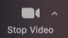
- Once you are in a Zoom meeting, in the bottom left hand corner of your screen is a small icon that looks like a camera.
- If you click this camera button, you can switch your video off. Click this button again and your video camera will come back on.
- When in a meeting with your video on, it is good practice to have a plain background behind you in good lighting so that other people in the meeting can easily see you.

Gallery View or Speaker View
- To change who your main screen will focus on during the meeting, you can change your ‘view’. The automatic setting is ‘Speaker View’ which allows you to view a large image of the speaker with smaller images of the other participants at the side.
- In the top right hand corner of your screen, you will see an icon that looks like a cluster of squares. If you click this, you can make your screen go to ‘Gallery View’ where you will be able to view all participants of the meeting on one screen.
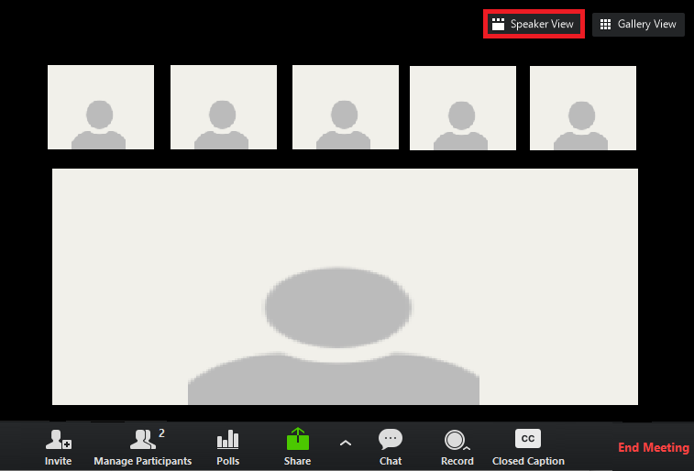
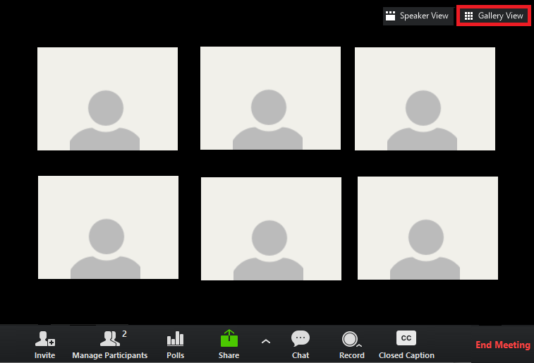
Gallery view Speaker view
We recommend you using ‘Speaker View’ for the celebration event

Changing your name
- Before you enter the meeting, you can type your name in the second box of the ‘Join Meeting’ pop-up. Please note: You will need the name you registered with on Eventbrite to join the celebration event
- Once in the meeting, you can change your name by hovering your computer mouse over your name and click ‘Rename’ when it appears.
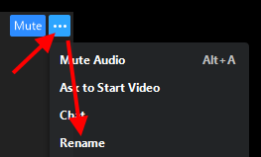

Chat function
- Once you are in a Zoom meeting, in the middle of your screen at the bottom is a small icon that looks like a cartoon speech bubble. This is your chat function.
- The chat function allows you to send messages to people publically or individually who are in the meeting with you. This can allow for conversations to happen whilst someone is speaking on the main screen.
- Please note: when using the chat function, please be polite and considerate. The use of offensive language could make the host remove you from the meeting.

Raising your hand
- Another way to ask a question during a meeting is to ‘raise your hand’.
- You can do this by clicking on ‘participants’ in your meeting bar, then clicking the blue icon of a hand.
- This allows the host of the meeting to see you would like to say something. Please wait until the host has invited you to speak before you do so.

Please note: During the PPIE Celebration event, the chat function and the raise hand function will be used to allow you to ask questions.

Polls
- Polls in a Zoom meeting are small pop-up quizzes where the host can ask the attendees some quick questions. They can be a good way to collect small amounts of data as well as act as an ice breaker in the meeting.
- These questions will appear on the screen and you can select your answer to the question. Only you will be able to see your answer as the results are anonymous for the host.
- The host may display the results of the poll with an overview of how many people selected which answer.

Break out rooms
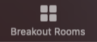
- Break-out rooms are mini meetings within the main Zoom meeting where a smaller number of attendees can gather in a separate virtual space away from the main group.
- Break-out rooms are a good way to have smaller discussions with other attendees and get to know people – just like a table discussion.
- You can be automatically assigned into a break-out room by the host or manually placed in one. You will usually be told how long you will be in the room for and when you can expect to return to the main meeting room. Only hosts can create break-out rooms.

Recording the meeting
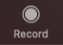
- Some meetings might be recorded as a video file to be watched at a later date by people who could not attend the meeting.
- The hosts will tell you in advance if the meeting is recorded and allow you to turn your video off should you wish. Breakout rooms are not recorded.

Leaving the meeting
- When you are ready to leave a meeting, click the red button in the bottom right corner of your screen and select ‘Leave Meeting’.
- This will remove you from the meeting, even if the meeting is still continuing.
- Please make sure you want to leave the meeting before clicking this button. If you accidentally leave, you can re-join the meeting with the original meeting link unless the meeting has been ‘locked’ by the host.
- The host will end the meeting for everyone once the event has finished.

Further information
- https://support.zoom.us/hc/en-us for general support resources
- https://support.zoom.us/hc/en-us/sections/201740096-Training for training videos
- https://support.zoom.us/hc/en-us/articles/360029527911 for live training sessions
- https://zoom.us/privacy for Zoom’s privacy information

General Data Protection Regulation (GDPR)
As this event will be hosted and recorded on Zoom your personal data will be processed by Zoom which may mean that your personal data is transferred to a country outside of the European Economic Area, some of which have not yet been determined by the European Commission to have an adequate level of data protection. Appropriate legal mechanisms to ensure these transfers are compliant with the UK General Data Protection Regulation are in place. The recordings will be removed from Zoom and stored on The University of Manchester’s managed file storage as soon as possible following the event. Your name will not be included in these recordings.
All personal data is held and processed by The University of Manchester strictly in accordance with the General Data Protection Regulation (GDPR) and the Data Protection Act 2018. You have the right to withdraw your consent up until the time of recording, by cancelling your registration to the live session.
For further information about Data Protection at the University visit: https://www.manchester.ac.uk/discover/privacy-information/data-protection.
To find out more about data protection please visit our PPIE Privacy Notice: http://documents.manchester.ac.uk/display.aspx?DocID=43063.

