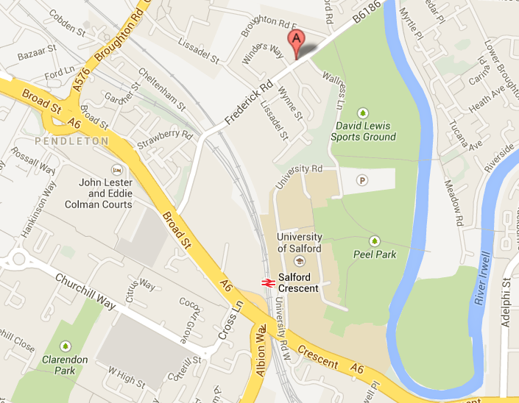

Salford Innovation Forum is marked as A

Rooms 110 and 111
51 Frederick Rd,
Salford, Greater
Manchester
M6 6FP.

Frequent Bus services run from Salford Crescent Station to Technology House/ Fredrick Road Bus Stop

Free Parking is available, please ring the buzzer at the entrance barrier and inform reception you have an appointment with UMAC - Salford.

There are plenty of disabled parking bays next to the reception entrance.

