BCOVS 2019 KEYNOTE LECTURERS

Melanopsin – why you should care
Robert Lucas

We have known for 20 years that retinal photoreception extends beyond rods and cones. Since then, a lot has been learnt about the melanopsin-expressing, intrinsically photosensitive retinal ganglion cells (ipRGCs) responsible for this photoreception and their contribution to our sensory capacity.

Despite being small in number (<1% of human ganglion cells) ipRGCs are extraordinarily influential. In addition to playing a critical role in synchronising biological clocks to the light:dark cycle, they drive light-dependent adjustments in behavioural and physiological state.

The discovery of ipRGCs can thus have implications for diagnosis and treatment of retinal dystrophy, and for the design of artificial light sources and visual displays. I will present an overview of the anatomy and physiology of this inner retinal photoreceptor system and of our own efforts to understand their numerous function(s) and apply these discoveries for practical benefit.

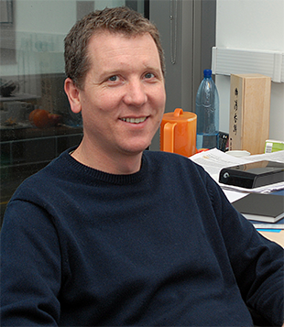

Having graduated with a BSc in Biological Sciences from the University of York, UK, Robert Lucas spent several years working in the pharmaceutical industry, supporting phase III and IV clinical trials. He then returned to academia to undertake a PhD in neuroendocrinology at the Institute of Zoology in London. During these post-graduate studies he developed an interest in circadian biology and pursued this as a post-doctoral researcher in the laboratory of Russell Foster in the Biology Department at Imperial College London.

In Russell’s laboratory he worked on the retinal mechanisms providing light information to the circadian clock, and continued that work as an independent researcher in the Medical School at Imperial College London. During this time he was able to contribute to the discovery of the melanopsin inner retinal photoreceptors that play such an important part in this process, and discovered that they are also the origin of the pupil light reflex.

Since moving to the University of Manchester in 2003, he has continued to study retinal control over circadian clocks and other aspects of physiology and behaviour. His interests have expanded to more conventional aspects of vision science as the various ways in which melanopsin photoreceptors support vision have been identified. Lessons from this inner retinal photoreceptor have been applied to develop new potential therapies for retinal degeneration.

Rob studies these processes primarily in laboratory rodents, but recently also in human subjects, taking a keen interest in the real world application of these discoveries: he has active collaborations with partners from lighting, visual display and biopharma industries.

