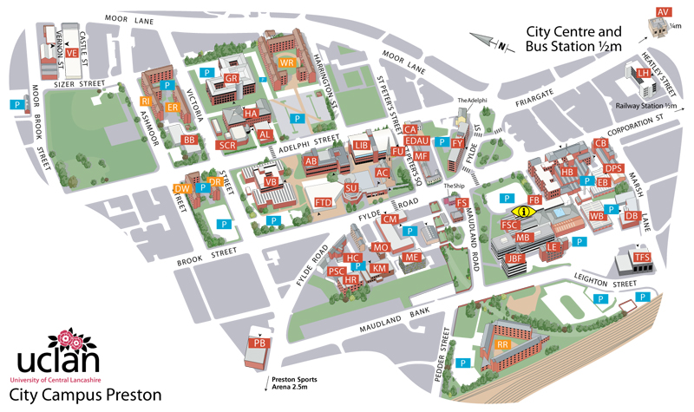
Access SUMMIT – Preston
Student and Academic Support Services (1st Floor)
Foster Building
University of Central Lancashire
PR1 2HE

