David Lewis and His Place in the History of Analytic Philosophy
conference
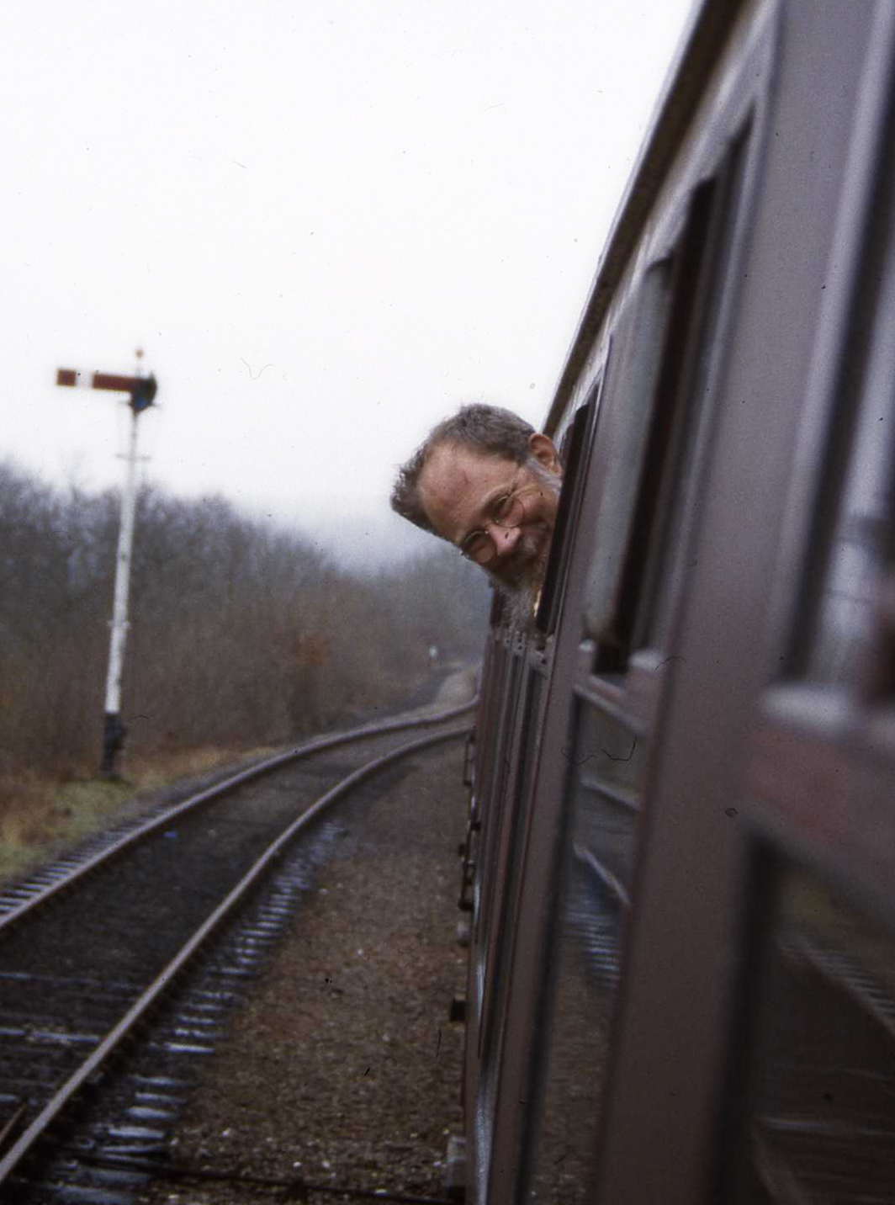

17-19 June 2019

Conference information

1. Location information (including accessibility)
2. Conference Quiet Room and other places to hang out
3. Other information: virtual conference, wifi
4. Chairing policy
5. Our events policy
6. Conference programme
7. Abstracts for parallel sessions
8. List of delegates & dinner attendance (please check!)

Contact information
Our two graduate helpers, Lydia and Jonas, will generally be around in the foyer of HBS during registration and the breaks and will help you if they can.
The conference email address, lewismanchester2019@gmail.com, will be regularly checked before and during the conference. In an emergency you can try calling or texting Helen’s mobile on 07885 448315, but please do not use this for any other purpose!
Campus security: call 0161 306 9966, or 69966 from an internal phone.
Electronic versions of any handouts and Powerpoint presentations (as and when we receive them), and this information booklet, are available at tinyurl.com/lewis-conf-info
You will also find the campus map there.

1. Location information
Please be aware of the dedicated cycle lanes on Oxford Road! These run behind the bus stops and it’s quite easy to crash into a bike if you don’t look out for them.
Humanities Bridgeford Street (HBS) (building 35 on the campus map) houses the registration desk, refreshment zone, the Cordingley Lecture Theatre (keynotes and parallel sessions), the Hanson Room (parallel sessions on Monday), and G.32 (parallel sessions on Tuesday). All are on the ground floor. The main entrance to HBS is on the north side.
- Registration desk and all refreshments: Outside Cordingley.
- Cordingley Lecture Theatre: Starting at the main entrance, go up the few steps/ramp, turn right just in between the lift and the stairs.
- Hanson Room: Left out of Cordingley, at the top of a few steps (or wheelchair lift).
- G.32: Right out of Cordingley, then right again and at the end of the corridor.
- Toilets are in the basement. (See below for disabled toilets.)
- There is a courtyard outside; straight ahead and then left when you enter the building.
- Accessibility: There is a wheelchair ramp and wheelchair entrance at the main entrance, and then another ramp to get you up 3-4 steps to get you to the main ground floor level of the main lifts (straight ahead to your right) and café. To access the Hanson Room there is a manually operated wheelchair lift. Disabled toilets are a bit of a trek; turn left inside the main entrance, go down the corridor and turn right near the end. The toilets are on your left part-way down that corridor. All corridor doors are either fully automatic or have a button to open them. For additional information, go to www.accessable.co.uk/venues/humanities-bridgeford-street
The Arthur Lewis Building (ALB) (building 36 on the conference map) houses the parallel sessions on Wednesday and the conference quiet room.
- Boardroom (2.016/7), parallel sessions: Second floor; turn left out of the lift and it’s straight ahead of you.
- G.020 (quiet room, see §2 below): Turn right inside the main entrance, go right down to the end of the corridor, and turn left. The room is the one with the glass wall and Venetian blinds immediately on your left.
- Toilets are in the same place on each floor: just before the lifts on your right (women) and left (men).
- There is a café on the ground floor of ALB; go straight when you enter the building.
- Accessibility: ALB is fully wheelchair-accessible; the main entrance has a wheelchair entrance on the right of the revolving doors. The lifts are straight ahead and on the right. All toilets are wheelchair-accessible. For more detailed information, go to www.accessable. co.uk/venues/arthur-lewis-building

Conference drink & dinner venues
Navarro Lounge and Mowgli are both on the ground floor of building 29, on University Green. Turn left out of HBS and they’re both just on the other side of the lawn, at the front of the building facing you. Both fully wheelchair-accessible.
Abode is at 107 Piccadilly – roughly halfway between Piccadilly Station and Piccadilly Gardens, on the far (station) side of the road. The brasserie is in the basement.
Abode accessibility: There are a couple of steps up to the hotel. Please press the disabled button outside the left-hand entrance; someone from reception will bring a ramp out for you. Once inside, there is a lift down to the brasserie. If you cannot walk to/from the dinner venue, we are happy to pick up the bill for a taxi. Please keep your receipt(s) and let Helen know so that she can send you an expenses form.
Getting to Abode: It’s about a 20-minute walk from ALB/University Place. If you don’t want to walk, take any bus from the ALB side of the road to Piccadilly Gardens (or if it’s the 147, Piccadilly Station); Abode will be a short walk from there. It will only be a little more expensive to share a taxi between several people, however (probably about £6).
The nearest chemist is Faith Pharmacy on Booth St. West. Turn left and left again out of the HBS main entrance and walk until you get to Higher Cambridge Street; turn right and Booth St. West is the first street you hit. The chemist is just on the left (about 300m away).

2. Conference Quiet Room and other places to hang out
The Quiet Room is G.020, ground floor, ALB (see §1 above). It will be available 11am-6pm Monday, 9am-6pm Tuesday, and 9am-1pm Wednesday. NB: ALB closes at 6pm.
You are welcome to use this room if you need a bit of peace and quiet. You can take refreshments in there (but please remove your rubbish afterwards; there are bins in the foyer) and you should be able to access wifi. If you take headphones you can even watch the talks from there!
Please note that this really is a quiet room and not a general conference hang-out room. Please do not chat in there! The person you’re talking to is probably in there because they didn’t want to talk to anyone. Please don’t listen to music either (unless you’re on your own).
Other places to hang around/get coffee: There is a café on the ground floor of ALB (the café in HBS will be closed (see §1)). There are several cafes on the ground floor of building 29 facing onto University Green, where you can get coffee, cake, breakfast, etc. Takk (Oxford Road end of University Green) does the best coffee (and, for vegans, oatmilk).
Pubs and bars: Navarro Lounge on University Green is the closest; there is also a bar at the Crowne Plaza (the big hotel on the left as you’re facing the cafes on University Green). Further afield, the Lass O’Gowrie on Charles Street – across Princess Street from the Ibis on the corner of Princess and Charles – is nice and normally quiet. Or there’s Sand Bar on Grosvenor St, just next to the Sugden Sports Centre (building 22), and – closer – Kro Bar south on Oxford Road, just past Dover Street.
If you’re not going to the conference dinners: Navarro Lounge and Kro Bar (both above) are fine. Sand Bar (above) does very good pizzas. Good for vegans is Habesha, an Ethiopian restaurant upstairs at 29-31 Sackville Street, just north of Canal Street. It’s cheap and nice (but unsuitable for wheelchair users because it’s up a spiral staircase). While you’re up that way, take a selfie sitting on the bench next to Alan Turing in Sackville Gardens! Of course there are loads of other places to eat too!

3. Other information: virtual conference, wifi
Virtual conference: We are live-streaming the sessions in Cordingley. You should therefore be aware that people other than those physically present will be listening to what you have to say. There will be a camera facing the audience, but only virtual speakers can see you (so that they know people are there and listening!).
Virtual participants will be able to ask questions on the online question board for the speakers/panellists during the Q&A sessions.
Audience members in these sessions are requested to wait for the roving mic and ask their questions clearly.
For the live stream and online question board, go to tinyurl.com/virtual-lewis
For our Lewis project Facebook group, go to tinyurl.com/lewis-conf-fb

Wifi: Eduroam is available across most of the campus. If you have a university IT account, your eduroam username is youruniversityusername@youruniversity.ac.uk (or whatever). So if your username is hsyiw23 and you are at the University of Manchester, your eduroam username is hsyiw23@manchester.ac.uk. NB: this may not be the same as your university email address (which in this case might be, say, helen.smith@manchester.ac.uk). Your password is the same as your university login password.
If you can’t access eduroam, ask at the conference registration desk for a guest account to get wifi access via UoM Guest.

4. Chairing policy
If you are chairing a session, thanks so much for agreeing to do it! Good chairing will be essential to its success. This means that there are quite a few important responsibilities for chairs, which we hope you won’t find too onerous. If you are an audience member, please read the ‘Managing questions’ part below.
Before your session starts
- Cordingley only: You and the speaker need to have been mic-ed up. Please make sure the tech support person has seen you and sorted this. For back-to-back sessions both speakers need to be mic-ed up at the start of the first session.
- Make sure your speakers are there and that they have any technology/supplies that they need. Either Helen or Anthony will be there in case there are any hitches. (If they’re virtual, you should be able to see them on the screen; a tech person will tell you if there is a problem!)
- Double check the name of the talk and how to pronounce the speaker’s name if necessary.
Introductions
- Introduce yourself, and your speaker. When introducing speakers, follow the same simple format for all: their name (no title), and the title of their talk – no preamble!
- If it’s a virtual speaker, please ask the audience to wave at them!
Break between talk and questions
- For the keynotes only, please have a 3-minute break before going to questions.
Managing questions
- Hands only, please: no hand-finger distinction!
- There is no obligation to take questions in the order in which people put up their hands. E.g. you might call on people who you haven’t heard from already at the conference, and/or look out especially for questions from the back.
- If in Cordingley, please keep an eye out for Jonas, who may feel the urge to read out a question from a virtual participant. Please do call on Jonas at least once during the question session so that the virtual participants know they aren’t being ignored. More than once is fine; the question will be coming from a different person!
- Please have a One-Question-Per-Question policy. Just cut someone off if they have already asked a question but are still speaking! (‘And my second question is …’.) You might let people get away with asking a short clarificatory question first. (‘Is this your view …? If so, my question is …’.)
- Questioners should generally resist the urge to ask a follow-up question, and should definitely not do so without asking the chair’s permission first. Grant permission sparingly, especially if there are a lot more people with questions.
Timekeeping
- Be very strict about ending on time. Strictness may result in momentary annoyance for some, but it is a cause for rejoicing in most, and even the annoyed quickly see that it is right.

5. Our events policy
We strive for a welcoming and friendly atmosphere at all our events and for all participants. We ask that participants in our events be kind to others, and we do not tolerate harassment of participants in any form.
Conventions for presentations, chairing, and questions
We aim for events and seminars to be venues in which ideas can be explored in a spirit of inclusion and tolerance. We'd like everyone to behave politely and respectfully towards speakers and other participants. When in doubt, please defer to whoever is chairing, or ask the chair or organisers.
- Our departmental events will, where possible, follow the BPA-SWIP guidance on inclusivity for women in philosophy and on accessibility for disabled participants. Accessibility information will be included in calls for papers for departmental events.
- For sessions of 45 minutes or more, chairs will institute a 3-5 minute break between presentations and questions, to allow participants to think through questions, talk them through with colleagues, or look something up.
- Chairs are free to take questions in whichever order they see fit. Since less confident people tend to sit at the back, chairs may choose to take questions from the back of the room first.
Preventing and addressing harassment
It is very important to us that no one is harassed at departmental events. If you are the victim of harassment or a witness to harassment (such as sexual harassment, unwanted physical contact, or offensive or unwelcome comments about race, ethnicity, gender and gender identity, class, sexual orientation or disability), we will listen to you and take you seriously. Please do not feel afraid to come forward and talk to us about what you have experienced and what you would like us to do to help.
- Departmental events will in general have a designated equality and diversity representative. Harassment and other matters of equality and diversity, such as accessibility issues, may always be reported to them, in addition to the organisers themselves. Organisers should introduce this person at the start of each event.
- When in doubt you may always report any harassment to the departmental equality and diversity officer, Dr Frederique Janssen-Lauret (frederique.janssen-lauret@manchester.ac.uk).
- We will support the victim and take action to address the harassment, usually by either asking the harasser to stop and making sure that they comply, by asking them to leave, or, in severe cases, by banning them from campus.
Explicit language and imagery
Some philosophy papers discuss potentially traumatic material such as sexual assault, violence, slurs and pejoratives, sexism, racism, other forms of structural inequality. We want to balance encouraging the academic freedom to research and discuss such topics, which is often necessary for progress, with the needs of victims of such violence and injustice in the audience. Explicit language and imagery are sometimes necessary to make a point, but please use them judiciously. Be aware that people in your audience may have been traumatised by racist, sexist, homophobic, transphobic, or sexual abuse or assault.
- When you discuss potentially traumatic topics, language, or imagery, please make this clear in the title of your paper, in your abstract, or at the start of your presentation. This allows audience members to make an informed choice about being involved, and to prepare themselves if they need to.
- If your paper is not primarily about potentially traumatic material, but some of your examples may be, where possible choose examples which are not likely to make people relive trauma. For example, consider whether it is necessary to use sexual assault as an example of a morally bad act, to use racial slurs as examples of pejorative language, or to quote graphic language. Where explicit or offensive examples are essential to your paper, by all means discuss them. But, as above, please make clear from the start that your paper contains such material.
- If you need examples of pejoratives, slurs or derogatory language, consider whether it makes sense to use examples which might be applied to you. This may help you gauge their potential force and effect on an audience.

6. Conference programme
All keynote talks are in the Cordingley Lecture Theatre, ground floor, Humanities Bridgeford Street.

Many of the presentations and handouts are available at tinyurl.com/lewis-talks

Day 1 – Monday, 17 June 2019

12.00pm | Coffee, tea & biscuits/registration (outside Cordingley)
1.00pm | Welcome (Helen Beebee and Anthony Fisher)
1.15pm | Keynote: Angelika Kratzer (UMass-Amherst): ‘David Lewis and how we think about natural language semantics today’  Chair: Helen Beebee (Manchester)
2.30pm | Coffee & cake
3.00pm | Cordingley Theatre (virtual): Fatema Amijee (Simon Fraser): ‘The rationalist foundations of Hume’s Dictum’ / Chair: Edward Elliott (Leeds)  Hanson Room: Michelle Liu (Oxford): Lewis on qualia and revelation’ / Chair: Joel Smith (Manchester)
3.30pm | Cordingley Theatre (virtual): Insa Lawler (Ruhr University Bochum), ‘David Lewis on non-declarative sentences: setting the record straight’ / Chair: Edward Elliott (Leeds)  Hanson Room: Seamus Bradley (Leeds), ‘Lewis, laws and similarity; an incongruence in Lewis’s Humean supervenience project’ / Chair: Joel Smith (Manchester)
4.00pm | Break
4.15pm | Keynote (virtual): Daniel Nolan (Notre Dame): ‘What would Lewis do?’  Chair: Anthony Fisher (Manchester)
5.30pm | Drinks at Navarro Lounge, University Green (own expense)
6.30pm | Dinner, Mowgli, University Green

Day 2 – Tuesday, 18 June 2019

9am | Coffee, tea & biscuits
9.30am | Keynote: John Bigelow (with Martin Leckey) (Monash): ‘New work for properties of properties’  Chair: John Heil (Washington University in St. Louis)
10.45am | Break
11.00am | Cordingley Theatre (virtual): Michaelis Michael (UNSW): ‘David Lewis and the nature of logical space’ / Chair: Seamus Bradley (Leeds)  G32: Abigail Thwaites (MIT): ‘Variable binding in quantified modal logic’ / Chair: Anthony Fisher (Manchester)
11.30am | Cordingley Theatre: Jade Fletcher (Edinburgh): ‘Piecing together Lewis’s philosophy of language’ / Chair: Seamus Bradley (Leeds)  G32: David Efird (York), ‘David Lewis and his place in the history of analytic theology / Chair: Anthony Fisher (Manchester)
12.00pm | Lunch
1.00pm | Cordingley Theatre (virtual): Aaron Segal (Hebrew University of Jerusalem): ‘David Lewis and the vindication of idealism’ / Chair: Helen Beebee (Manchester)  G32: Edward Elliott (Leeds): ‘What is Lewisian interpretivism?’ / Chair: Neil McDonnell (Glasgow)
1.30pm | Break
1.45pm | Keynote: Frederique Janssen-Lauret and Fraser MacBride (Manchester): ‘David Lewis and the Age of Metaphysical Revolution’  Chair: Thomas Uebel (Manchester)
3.00pm | Coffee & cake
3.15pm | Keynote (virtual): Jonathan Schaffer (Rutgers): ‘Lewis on what else there Is’  Chair: Alastair Wilson (Birmingham)
4.30pm | Break
4.45pm | Keynote (virtual): Sara Bernstein (Notre Dame): ‘Paradoxes of time travel to the future’  Chair: Fraser MacBride (Manchester)
6.00pm | End
7.00pm | Dinner at Abode Manchester (near Piccadilly Station)

Day 3 – Wednesday, 19 June 2019

9am | Coffee, tea & biscuits
9.30am | Keynote: Frank Jackson (ANU): ‘Lewis: metaphysics first’  Chair: Hugh Mellor (Cambridge)
10.45am | Coffee & cake
11.00am | Cordingley Theatre: Alastair Wilson (Birmingham): ‘Plenitude and recombination’ / Chair: Ann Whittle (Manchester)  Boardroom, 2nd floor, Arthur Lewis Building: David Balcarras (MIT): ‘Meaning by convention’ / Chair: David Efird (York)
11.30am | Cordingley Theatre: Lilith Newton (Edinburgh): ‘David Lewis and context-sensitivity in modal epistemology’ / Chair: Ann Whittle (Manchester)  Boardroom, 2nd floor, Arthur Lewis Building: William Kilborn & Bridger Landle (York): ‘Many, but one’ / Chair: David Efird (York)
12.00pm | Break
12.15pm | Keynote: Wolfgang Schwarz (Edinburgh), ‘Lewis’s empiricism’  Chair: Frederique Janssen-Lauret (Manchester)
1.30pm | End

7. Abstracts for parallel sessions
Monday, 3pm
Fatema Amijee (Simon Fraser): ‘The rationalist foundations of Hume’s Dictum’
Hume’s Dictum – the thesis that there are no necessary connections between distinct things – is a cornerstone of Lewis’s metaphysics. Yet, despite the central role of the thesis in Lewis’s system, Lewis does not seem to have an argument for it. Moreover, given his other commitments, Lewis cannot take facts about necessary connections between distinct things to be explanatorily basic. My paper shows that Lewis’s commitment to Hume’s Dictum can be justified, but only on rationalist grounds, and that this tacit commitment to rationalism renders Lewis’s neo-Humean metaphysics unstable.

Michelle Liu (Oxford): ‘Lewis on qualia and revelation’
In his 1995 paper ‘Should a Materialist Believe in Qualia?’, Lewis discusses the thesis of revelation (or what he calls ‘the identification thesis’), according to which the essence of a quale is revealed in an experience with that quale. Lewis thinks that revelation ‘seems obvious’ and is part of our ordinary conception of experience, but he rejects it because of its incompatibility with the version of physicalism he is committed to. In this paper, I take a closer look at Lewis’ remarks on revelation. Drawing also on his 1997 paper ‘Naming the Colours’, I clarify the incompatibility of revelation and common-sense functionalism. Finally, I relate Lewis’ ideas to recent discussions on the metaphysics of consciousness in which the thesis of revelation plays a crucial role.

Monday, 3.30pm
Insa Lawler (Ruhr University Bochum): ‘David Lewis on non-declarative sentences: setting the record straight’
Intuitively, the meaning of non-declarative sentences (e.g., “Is the cat on the mat?”) cannot be analyzed in terms of their truth conditions. Yet, David Lewis (1970) proposes that they have truth conditions in virtue of being syntactic variants of corresponding explicit performative sentences (e.g., “I (hereby) ask you whether the cat is on the mat.”). His proposal has been widely rejected. One main objection is that it violates our intuitions. I bracket it, passing verdict on the role of intuitions for semantic theories. I show that four other main objections can be rebutted, namely (i) that Lewis’ account implies absurd claims about non-declarative sentences, (ii) that Lewis is inconsistent in not treating declarative sentences as being equivalent in meaning to “I assert that X” sentences, (iii) that Lewis’ account cannot be applied to embedded wh-clauses, and (iv) that explicit performative sentences differ substantially from their corresponding non-declarative sentences.

Seamus Bradley (Leeds): ‘Lewis, laws and similarity; an incongruence in Lewis’s Humean supervenience project’
We argue that there is a problem with the conjunction of Lewis' account of counterfactual conditionals and his account of laws of nature. This is a pressing problem since both accounts are individually plausible, and popular. There is a well-known objection to Lewis' account of counterfactuals, the most famous instance of which is the so-called “nuclear button” example due to Fine. In response to this objection Lewis clarified his original account of counterfactuals. What we show is that Lewis' modified account is incongruent with his account of laws of nature. In short, Lewis needs to appeal to the notion of similarity in terms of the laws of the possible worlds in order to ground the correct truth conditions for counterfactual conditionals. Such a notion of similarity doesn't supervene on similarity at the level of the Humean mosaic and thus is unfriendly to Lewis' general project of a metaphysics based on Humean Supervenience. The notion of law-based-similarity is underspecified, but one thing that we do know about it is that it cannot supervene on mosaic-similarity on pain of getting the truth conditions wrong for counterfactuals. His two accounts – of counterfactuals and of laws of nature – are incongruent.

Tuesday, 11am
Michaelis Michael (UNSW): ‘David Lewis and the nature of logical space’
Lewis famously described the space of possible worlds as “a philosophers’ paradise”. Lewis seems to have approved of Pavel Tichy’s attack on Kripke’s rupture between necessity and a priority and also the attempts of two-dimensionalists to reduce the a priori to the necessity of the diagonal (in particular Humberstone and Davies, on the one hand, and Stalnaker, on the other). Lewis’s take is insightful and powerful. Despite that, I shall argue that Lewis’s own offering was paradise on the cheap. I want to consider the extensional reduction of modality and its interpretation. I shall address the issue of making sense of the a priori and Lewis’s commitment to a two-dimensional reduction of the a priori. I’ll give reasons to think that this reduction can’t work. And briefly explore where this leaves us given its important role in Lewis’s analytical functionalism.

Abigail Thwaites (MIT): ‘Variable binding in quantified modal logic’
Addressing a ‘purely formal difficulty’ for counterpart theory, David Lewis revealed an interesting feature of the counterpart semantics for modal operators. More specifically, Lewis made the surprising claim that modal operators in a counterpart semantics are variable-binding. This is puzzling. Modal operators, unlike the quantifiers of ordinary predicate logic, certainly do not wear their binding properties on their sleeve. The talk will look more closely at Lewis’s surprising claim. I will argue that drawing lessons from Quine and Carnap might help us better understand where Lewis was coming from.

Tuesday, 11.30am
David Efird (York): ‘David Lewis and his place in the history of analytic theology’
In this paper, I argue that Lewis’s methodology, as outlined in his introduction to the first volume of his Philosophical Papers, paves the way for analytic theology, which, I also argue, is a branch of philosophy, and not theology. On this methodology, philosophy is an exercise in a cost/benefit analysis, something that can be done regardless of one’s commitments. Given this methodology and this conception of analytic theology, I argue, atheists can make as much of a contribution to analytic theology as theists can, which I think Lewis does, in the following three papers: ‘Evil for Freedom’s Sake’, ‘Do We Believe in Penal Substitution?’, and ‘Divine Evil’. I conclude by examining the contribution Lewis makes to analytic theology in these papers in the context of his wider philosophy and the ways other philosophers influenced him in his letters.

Jade Fletcher (Edinburgh): ‘Piecing together Lewis’s philosophy of language’
David Lewis presents two distinct semantic projects. One of these projects is philosophical analysis, which is concerned with conceptually analysing concepts in terms of their functional role and specifying world invariant truth conditions for statements involving those concepts. Another project is that of radical interpretation, which proposes a method for assigning an interpretation to sentences of the object language without presupposing any semantic machinery. Those engaged with Lewis’s philosophy of language have tended to take one of these projects to be his primary semantic theory, and downplay the significance of the other. In this paper I argue for an interpretation of Lewis according to which they are both integral to understanding his philosophy of language, and in particular that the former project is dependent on the latter.

Tuesday, 1pm
Aaron Segal (Hebrew University of Jerusalem): ‘David Lewis and the Vindication of Idealism’
It was a commonplace among nineteenth century Idealists that philosophy is intrinsically systematic: that philosophical issues are so intricately interconnected that there’s no way to philosophize bit-by-manageable-bit. This commonplace was emphatically rejected by early analytic philosophers, and its denial was consistently maintained throughout the twentieth century by all the major figures in analytic philosophy. Until David Lewis. If Lewis is right in his claims and arguments, then the Idealists were right after all. Or so I shall argue. At the heart of contemporary analytic philosophy lies a vindication of its opposition’s central contention. I will catalog some senses of ‘systematicity’ in which Lewis’s analytic predecessors were also systematic, isolate the sense in which Lewis was groundbreakingly systematic, sketch what I take to be the most promising way to formulate precisely a minimal version of the Idealist claim, and argue that the minimal version best explains a pair of Lewis’s metaphilosophical claims.

Edward Elliott (Leeds): ‘What is Lewisian interpretivism?’
In ‘Radical Interpretation’, Lewis all-too-briefly discusses his method of interpretation, based on the principles of Rationalisation and Charity. In this paper, I focus on two exegetical questions. First: Q1. How were Rationalisation and Charity supposed to interact? In ‘Radical Interpretation’, Lewis gives us no guidance as to how exactly we’re supposed to apply his principles to arrive at an interpretation—he merely says that we ought to “fill in [the interpretation] by means of the Rationalisation principle and the Principle of Charity”. Unfortunately for us, this remark is consistent with a range of precisifications. And second: Q2. How exactly did Lewis take Rationalisation and Charity to work? Here, again, matters are less than perfectly clear. Indeed, in different papers Lewis gives apparently distinct and inconsistent glosses on what these principles say. I will argue for what I take to be the best interpretation of Lewis’ answers to these questions.

Wednesday, 11am
Alastair Wilson (Birmingham): ‘Plenitude and recombination’
In On the Plurality of Worlds, David Lewis imposes a condition on realist theories of modality which he calls ‘plenitude’. Lewis apparently assigns this condition considerable importance, and uses it to motivate his principle of recombination, but he never says exactly what plenitude amounts to. This paper attempts to make sense of this puzzling state of affairs. I first look at some obvious ways of reconstructing the plenitude criterion, and argue that they do not fit with the textual evidence. An argument due to John Divers and Joseph Melia is diagnosed as equivocating between an overly-demanding constraint and a more acceptable constraint which fails to establish the desired conclusion. I propose a deflationary interpretation of plenitude according to which it consists in nothing more than the application of standard theoretical virtues to a modal realist’s total theory.

David Balcarras (MIT): ‘Meaning by convention’
I argue that some of the standard objections to Lewis’s conventional metasemantics in terms of truthfulness and trust turn largely on issues that are orthogonal to the theory of meaning, and thus can be bracketed for the purposes of metasemantic inquiry. But the problem of subsentential meaning cannot be bracketed. Lewis’s metasemantics is sentence-first in orientation; word-meaning is supposed to be fixed posterior to sentence-meaning. I raise some problems with standard ways of implementing this aspect of Lewis’s view, and then propose a new, ‘disquotational’ theory on which word-meaning supervenes directly on sentence-meaning, or at least for languages like ours. Roughly, this view takes disquotational specifications of word-meaning, like ‘‘goat’ means goat’, as contingent a priori; so, if we give them a standard Lewis-style two-dimensional analysis, the truth of these metalinguistic sentences supervenes on that which fixes their meaning. Therefore, word-meaning supervenes on the conventional goings-on upon which sentence-meaning supervenes.

Wednesday, 11.30am
Lilith Newton (Edinburgh): ‘David Lewis and context-sensitivity in modal epistemology’
One of the objections most commonly levelled at Lewis’s contextualism says that his Rule of Attention (RA), according to which any not-P possibility that is attended to in a context must be eliminated in order for S to ‘know’ P in that context, makes it implausibly easy to induce sceptical contexts, in which most of our ordinary knowledge-attributions come out false. Epistemologists sympathetic to Lewis’s contextualism tend to respond by scrapping RA. I argue that move this is insufficient for overcoming the problem at hand. For another of Lewis’s rules, his Rule of Resemblance, makes it almost as easy to induce sceptical contexts as does RA, due to its invocation of the notion of ‘salient resemblance’. But I suggest that a similar problem arises for modal epistemologies more generally. Taking seriously Lewis’s comments on the ‘vagueness’ of counterfactuals suggests that such modal epistemologies as safety and sensitivity theories will likewise be vulnerable to context-shifts brought about by changes in which possible worlds are under consideration in a context, as the satisfaction of safety or sensitivity counterfactuals depends on which antecedent-worlds count as ‘closest’ to the actual world, and a possible world being conversationally salient may suffice for bringing it into the sphere of closest worlds in a context.

William Kilborn & Bridger Landle (York): ‘Many, but one’
David Lewis defended a solution to the famous problem of the many; that answer has two parts. Unfortunately, both parts face well-known difficulties. We argue that there is a better alternative available to Lewis: a counterpart-theoretic one. We begin by presenting and defending a new version of counterpart theory. We then show how it addresses the problem of the many. Our offered solution has significant advantages over Lewis’s preferred solution. Moreover, Lewis has pressing reasons to be friendly toward the counterpart-theoretic solution to the problem of the many. The view coheres well with some of his most prized intuitions and the rest of his broader metaphysical system. Finally, it allows Lewis to, in a more satisfying way, get closer to his original, stated aim of having a view that “concedes that the many are [Fs] but seeks to deny that the [Fs] are really many”.
8. List of delegates & dinner attendance
Please check that the information about whether or not you’re coming to dinner is accurate, and let Helen know a.s.a.p. if it isn’t.

Name | Dinner Monday | Dinner Tuesday
Abigail Thwaites
Alastair Wilson |  | X
Alberto Miguel Gómez
Alex Grzankowski |  | X
Angelika Kratzer | X (Crowne Plaza) | X
Ann Whittle
Anthony Fisher | X (Crowne Plaza) | X
Bridger Landle | X | X
Chloe Whiteley
Cynthia Macdonald
David Balcarras | X | X
David Efird | X | X
Edward Elliott | X
Frank Jackson | X | X
Frankie Golding
Fraser MacBride |  | X
Frederique Janssen-Lauret | X
Graham Macdonald
Helen Beebee | X | X
Henry Taylor |  | X
Hugh Mellor | X (Crowne Plaza) | X
Jade Fletcher | X | X
Jessica Isserow | X
Joel Smith
John Bigelow | X | X
John Heil | X (Crowne Plaza) | X
Jonas Raab | X | X
Lilith Newton |  | X
Lydia Farina | X
Mike Wilcox
Nathanael Boardman | X | X
Neil McDonnell |  | X
Olivia Coombes | X
Paul Dundon
Raamy Majeed | X | X
Renée Bleau
Robbie Williams
Samuel Boardman | X | X
Seamus Bradley | X
Theodore Paradise | X | X
Thomas Uebel
Will Gamester | X | X
William Kilborn | X | X
Wolfgang Schwarz | X | X
Zach Thornton | X | X

Notes

Notes

Notes

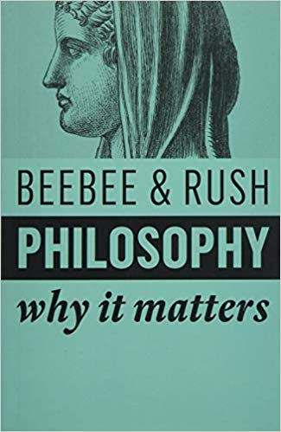  Helen Beebee & Michael Rush. 2019. Philosophy: Why It Matters. Polity Press. | Fraser MacBride. 2018. On the Genealogy of Universals: The Metaphysical Origins of Analytic Philosophy. Oxford University Press.
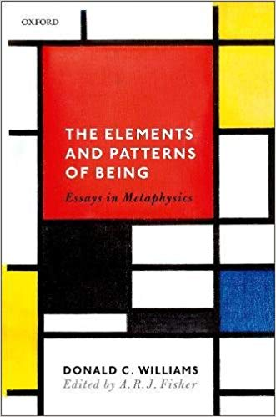  A.R.J. Fisher (ed.) The Elements and Patterns of Being: Essays in Metaphysics. Oxford University Press. | 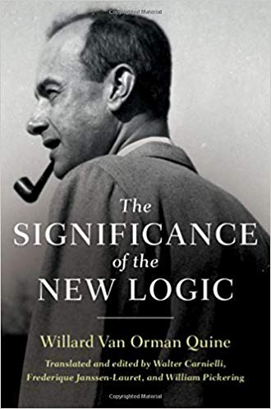  Walter Carnielli, Frederique Janssen-Lauret & William Pickering (eds.) The Significance of the New Logic. Cambridge University Press.

