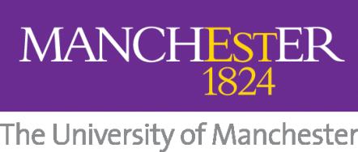
School of Arts, Languages and Cultures
PhD FUNDING COMPETITIONS 2017-18 APPLICATION FORM
The School is offering a range of funding opportunities for September 2017 entry.
Full details can be found here:
http://www.alc.manchester.ac.uk/fees/postgraduate-research-funding/
CLOSING DATE for all PGR competitions: 5pm, GMT, Friday 10 February 2017
Please enter the following details in BLOCK CAPITALS

Name:

Application ID Number:

Email:

Programme applied for:
I confirm that I wish to be considered for the following competitions
(please tick as appropriate):
School PhD Studentships

PGR Subject-Specific awards (please specify) *

HCRI Studentships
(PhD Humanitarianism and Conflict Response applicants only)

*Please note that some subject specific awards require additional information and have different deadlines. Please check the website for further clarification: http://www.alc.manchester.ac.uk/fees/subjectspecific/

Signature of Applicant:

Date:

