This easy access version of the University’s Research Privacy Notice has been developed by Mary Hargreaves, Project Support Officer in the Division of Cardiovascular Sciences, who has kindly given permission for us to share for best practice.

Lay Privacy Statement Key Facts
By law, data can be collected for a number of reasons. These reasons are known as the ‘legal basis’. Anyone wanting to collect data must have a legal basis to do so. The law allows us as researchers to collect your data under two legal bases:
- A task carried out in the public interest
- A process necessary for scientific research purposes
The University of Manchester is the data controller for this study. This means they are in charge of protecting your data and making sure it is only used for what we have told you it will be used for.
Your data will be kept securely and confidentially. Nobody outside of those listed on the information sheet will be able to identify you from your data, and your data will be anonymised (your name and personal details removed) as soon as possible.
Any data which has been anonymised and cannot be linked back to you will be kept for X years. This data may/will not be shared with other researchers (delete/amend where appropriate) investigating stroke, and ethical approval will be applied for in this case.
Further details can be found in The University privacy notice

Easy Access Privacy Statement Key Facts
The law says that we must have a legal basis to collect your data.

This means we need to have a particular reason for collecting your data. We can collect your data under two legal bases:
- A task carried out in the public interest
- A process necessary for scientific research purposes

The University of Manchester is the data controller for this research.
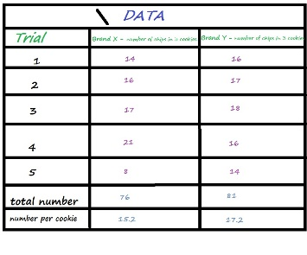

This means the University of Manchester is responsible for making sure your data is:
- Kept securely and confidentially
- Only used in the way the researchers tell you it will be used

Your data will be anonymised as soon as possible. This means any personal information which could identify you will be removed.
John Smith

The data remaining will be kept for X years.

Your anonymised data may/will not be shared with other researchers. (Delete where appropriate: ) These researchers will be investigating stroke.
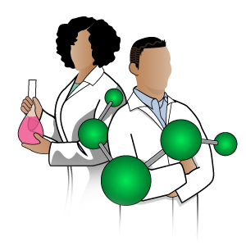

Anyone who wants to use your anonymised data to research stroke will need to get ethical approval.

You can learn more about your data privacy by reading The University privacy notice

