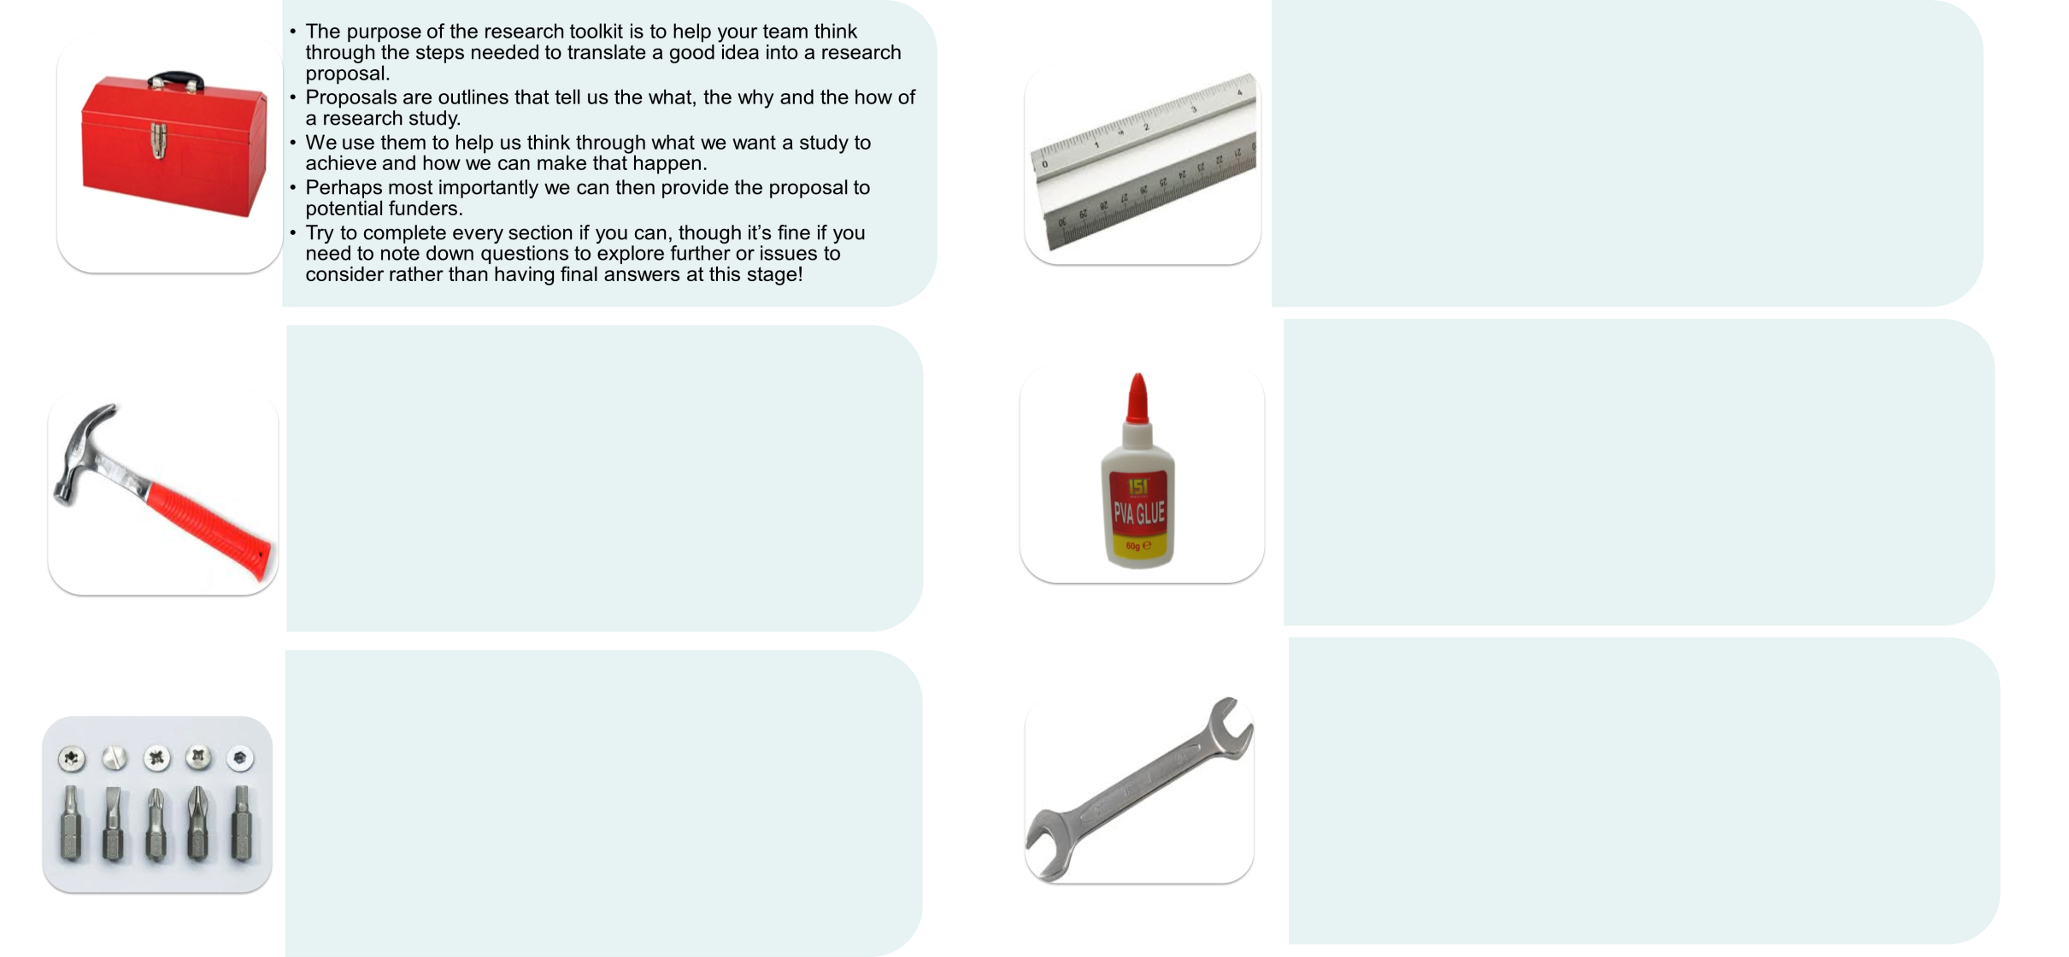

The purpose of the research toolkit is to help your team think through the steps needed to translate a good idea into a research proposal.   
Proposals are outlines that tell us the what, the why and the how of a research study. We use them to help us think through what we want to study to achieve and how we can make it happen. Perhaps most importantly we can then provide the proposal to potential funders.

**Additional Notes**

The right tool for the right job! What is your study design?

Draw the line! Who are your participants?

Stick together! Who will be on your team?

Spanner in the works! What might the challenges be?

Nail it down! What is your research question?