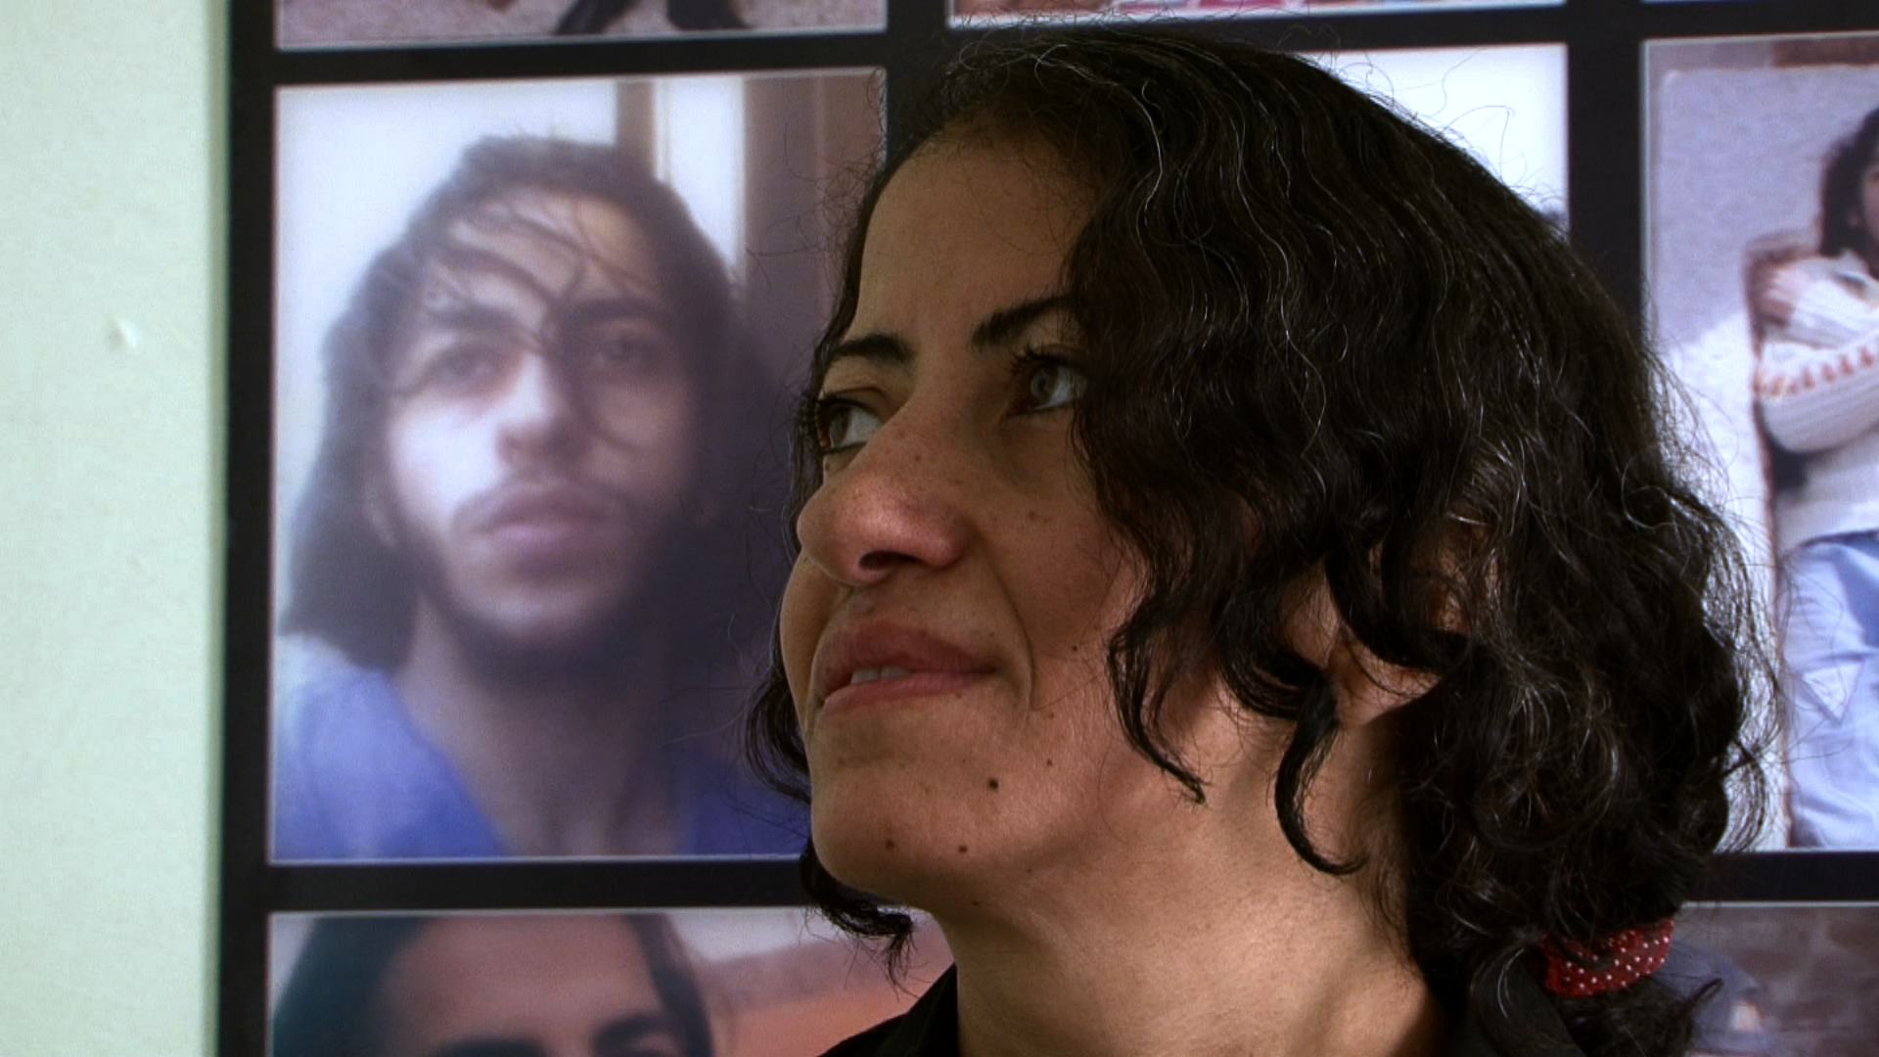

**Speakers and Titles:**

**- Keynote:** “The Prefigurative Politics of Volunteer Subtitling in the Egyptian Revolution” **(Professor Mona Baker - University of Manchester)**

- Screening the documentary film **“The Trace of the Butterfly”** – **Q&A with filmmaker Amal Ramsis**

- Presentation + Film “The Living Martyrs: Palestinian Prisoners in Israeli Jails” **(Professor Caroline Rooney – University of Kent)**

- “The Poetics of Hope and Frustration in the Works of Two Contemporary Egyptian Poets” **(Professor Faten Morsy – Ain Shams University)**

- “Shut ub your mouse, Obama! [Shut up your mouth, Obama!]: Media Discourse, Self- Representation, and Identity Construction in Post-2011 Egypt” (**Dr Walid El Hamamsy – Cairo University)**

- “‘*Entrapments* *in the Shadow of Da*‘*ish*:’ The Vilification of the Northeastern Lebanese Border in the Aftermath of the 2011 Syrian Protests”

**(Dr Michelle Obeid – University of Manchester)**

- Negotiating Narrative on Twitter: Collective Storytelling in the Context of the 2013 Military Intervention in Egypt”

**(Mr Neil Sadler - PhD candidate - University of Manchester)**

- “Para-translation as Activism: Iraqi Women Writers’ Fiction in English-Arabic Translation”

**(Mrs Ruth Abou Rached - PhD candidate - University of Manchester)**

***For queries, please contact Dr Dalia Mostafa (Middle Eastern Studies – dalia.s.mostafa@manchester.ac.uk)***

## **An Image from the ‘Trace of the Butterfly’**

## **by Amal Ramsis**

**Workshop 12 December 2015 (9.30am-5.30pm)**

**Venue: Room 5.206 University Place**

**The School of Arts, Languages and Cultures**

**The University of Manchester**

**The University of Manchester**

# Socio-Cultural Implications of Post-2011 Literature, Cinema,

# and Media in Egypt and the Arab World

**Free Event – supported** **by the SALC Research Networking Fund and**

**the Centre for Translation and Intercultural Studies**