Zochonis Special Enterprise Award Fund Report: Guerrilla Gardening in Nigeria

The idea for my project was birthed in one of the lecture rooms of Manchester University’s Samuel Alexander Building while I was listening to Pam Warhurst, a guest speaker for the Leadership in Action Module I took in my final year. She spoke about a group of people from Todmorden who started a movement based on food and community. It was simple; they grew food around their town for public consumption, supported local farmers and anyone who wanted to take part was welcomed.
The initiative resonated with me and I wanted to apply a similar concept in my home country of Nigeria. I thought deeply about what a scheme like this would mean for a country ridden with poverty, food insecurity, volatile national politics, conflict zones with many of its people suffering from malnutrition and social exclusion. It will be highly ambitious to get a society that has come to have an every-man-for-himself attitude on board. I also considered the fact that most of Nigerians especially the youth had turned their backs on agriculture due to Nigeria’s dependence on petroleum as its major export. Efforts since the late 1970s to revitalize agriculture in order to make Nigeria food self-sufficient again have produced only modest results.
I was mostly worried about introducing a concept heavily reliant on volunteers to a country with a lack of volunteering culture. 5 years ago, if you had told me I would propose planting fruits and vegetables as a way towards "community resilience" and not to make profit, I would have laughed at your face- Nigerians are hustlers. How do I even begin to recruit volunteers? I decided my aim for this project was to start a conversation even if it was with one person. Planting food did not mean I was eradicating hunger but it was my way of encouraging social change, having this mind-set made it easier for me to conquer my fears. I had three objectives to achieve on my trip to Nigeria. Firstly, to find out type of food that can be grown in Nigeria in accordance with the climate, topography and even the diet of Nigerians. Secondly, to gauge the kind of reception the project would receive by chatting to locals as well as people in authority about taking over unused or unattractive bits of public land to plant food to feed the community. Thirdly, to see the potential places that planting could be done and tools/materials needed to start.

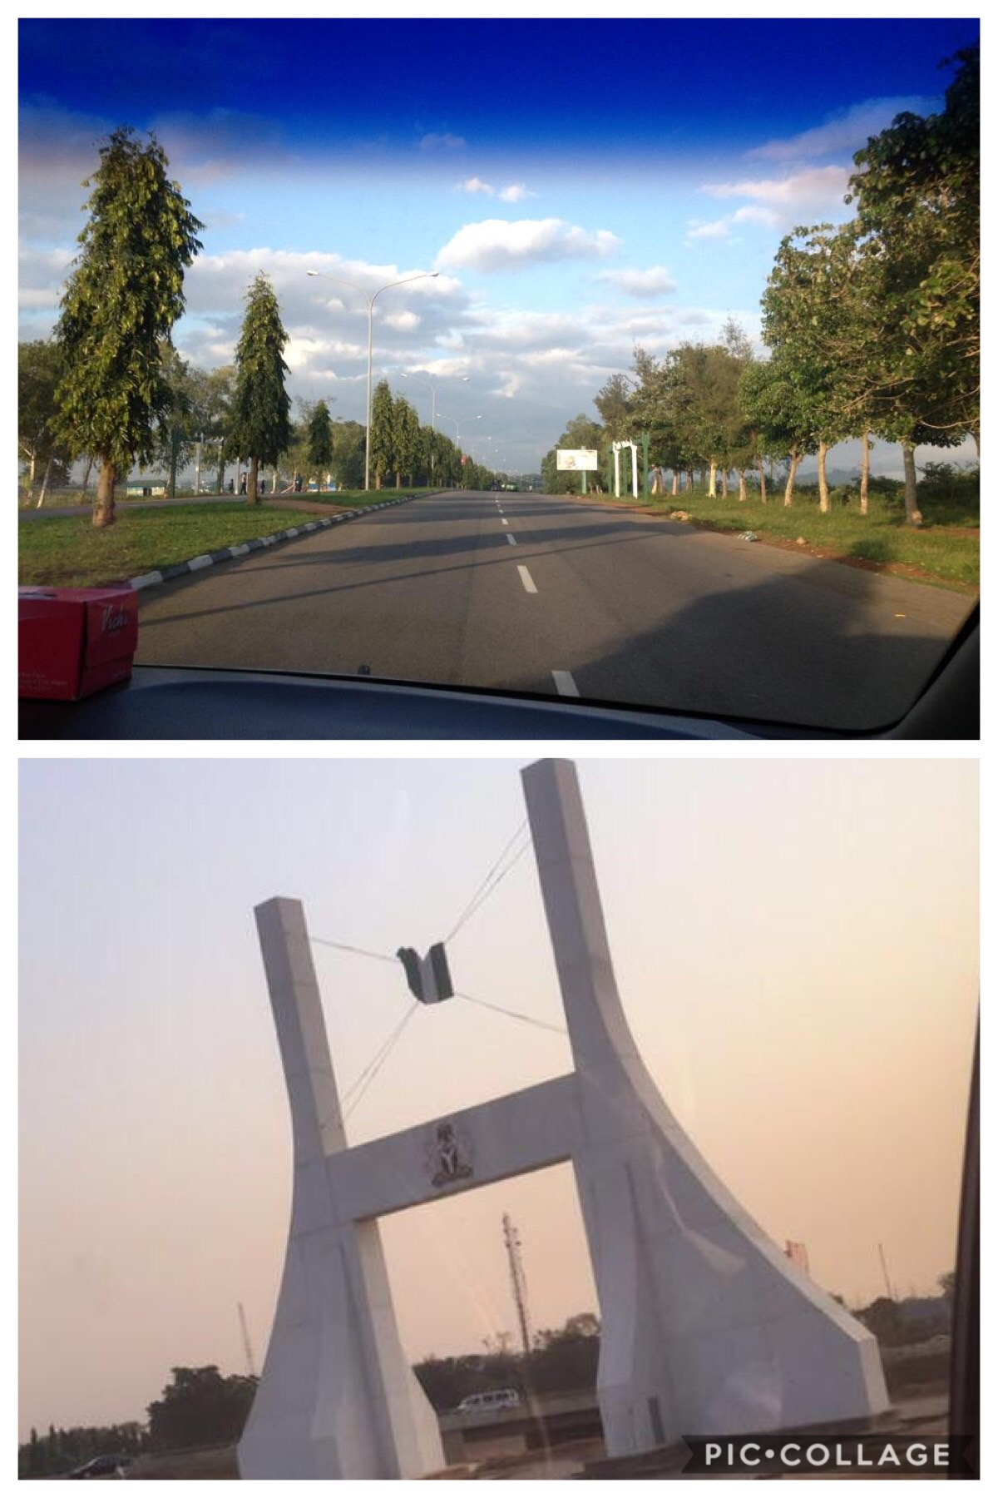
Top: Streets of Abuja
Bottom: City Gate, A monument decorated with the Nigerian Coat of Arms and the nation's flag imprinted on a map of Abuja. It is a ceremonial gate into the Federal Capital.

I arrived Abuja Nigeria by 5am on the 6th of August 2018, the first day of a 24-day trip. I lived here until I was 15 when I went off to boarding school in England so I immediately felt at home. My parent’s driver, Muhammad, who I had known most of my life, picked me up at the airport and drove me to the house I grew up in where I was greeted by my father and a few relatives. This trip gave me the opportunity to do a pilot study for my project but I was also able to do other memorable things. I accompanied my father on a work trip to Jos, which gave me the chance to explore the odds my project had in another state in Nigeria other than Abuja.
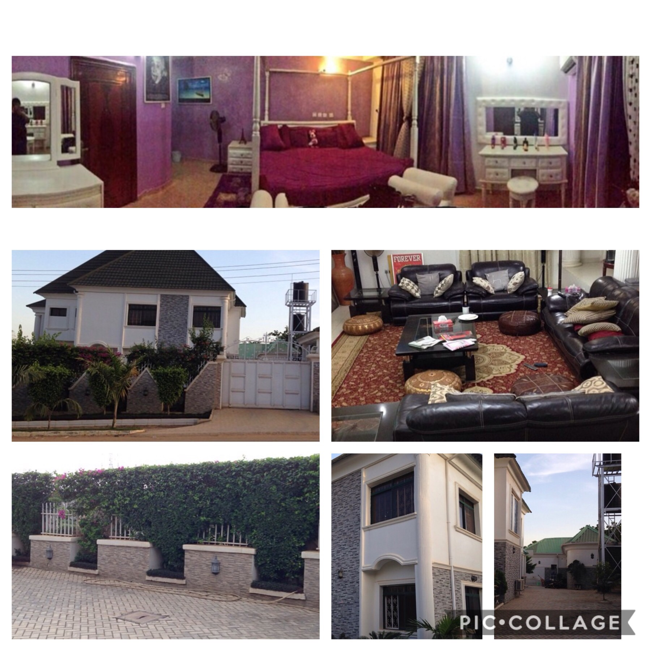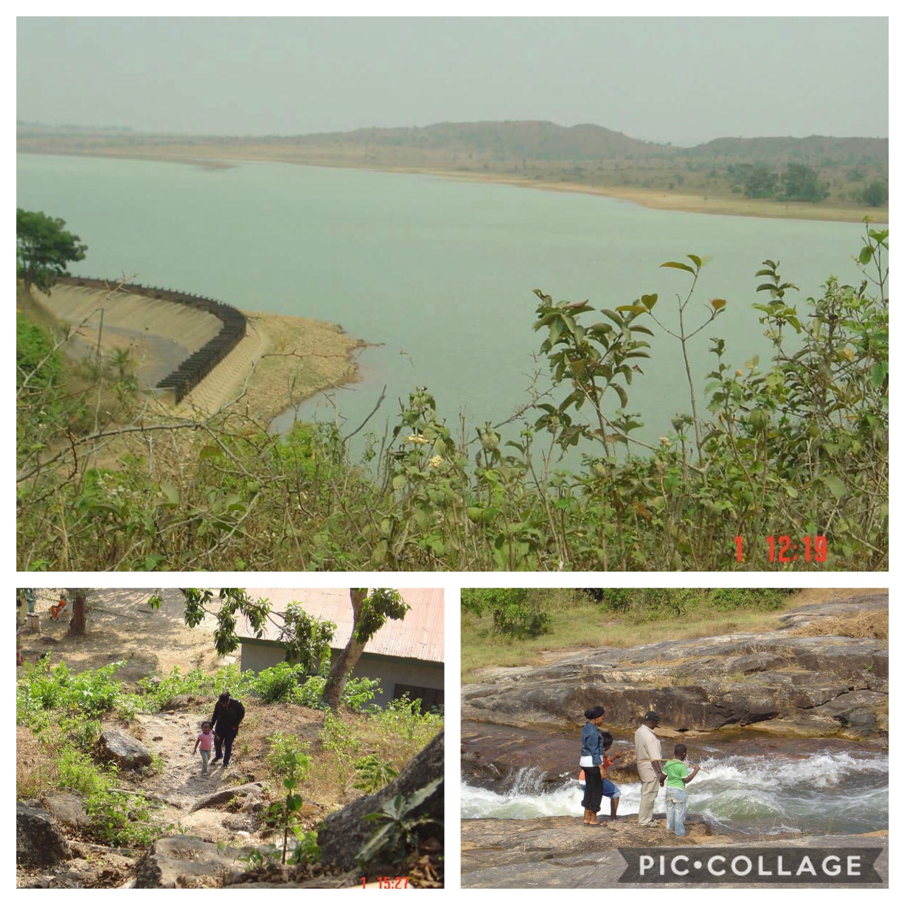
Jos, Nigeria
Top: My room Bottom: The House I grew up in

Since moving to England, I had not been back home for the Eid celebrations so I was ecstatic to take part in this year’s one. I even stepped up to do the Eid cooking for the household and visitors as my mother, who usually had the responsibility was back in England. It was lovely to catch up with old friends and even attend the wedding ceremony of a family friend. Indeed it was a memorable visit made possible by the Zochonis fund.

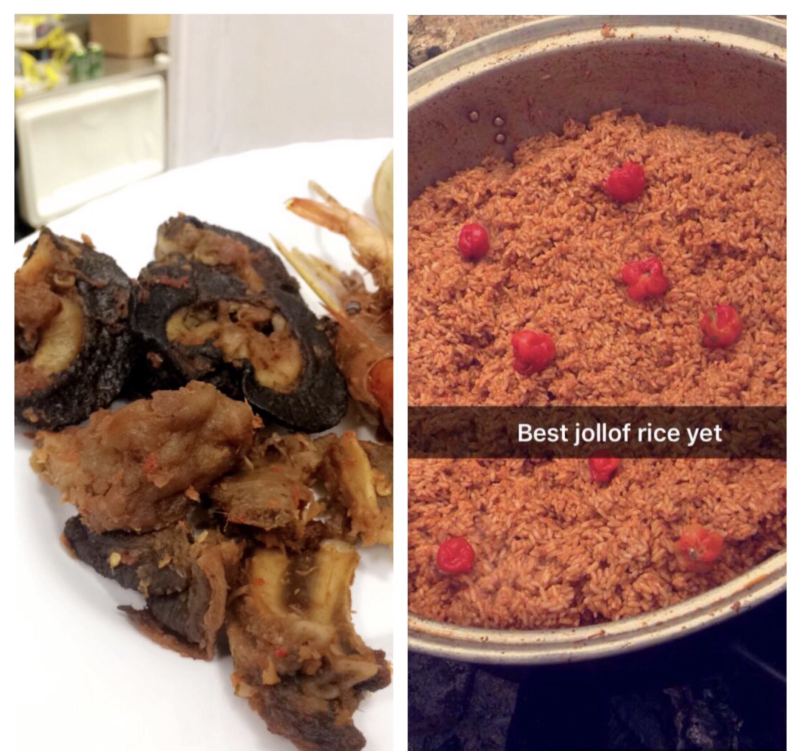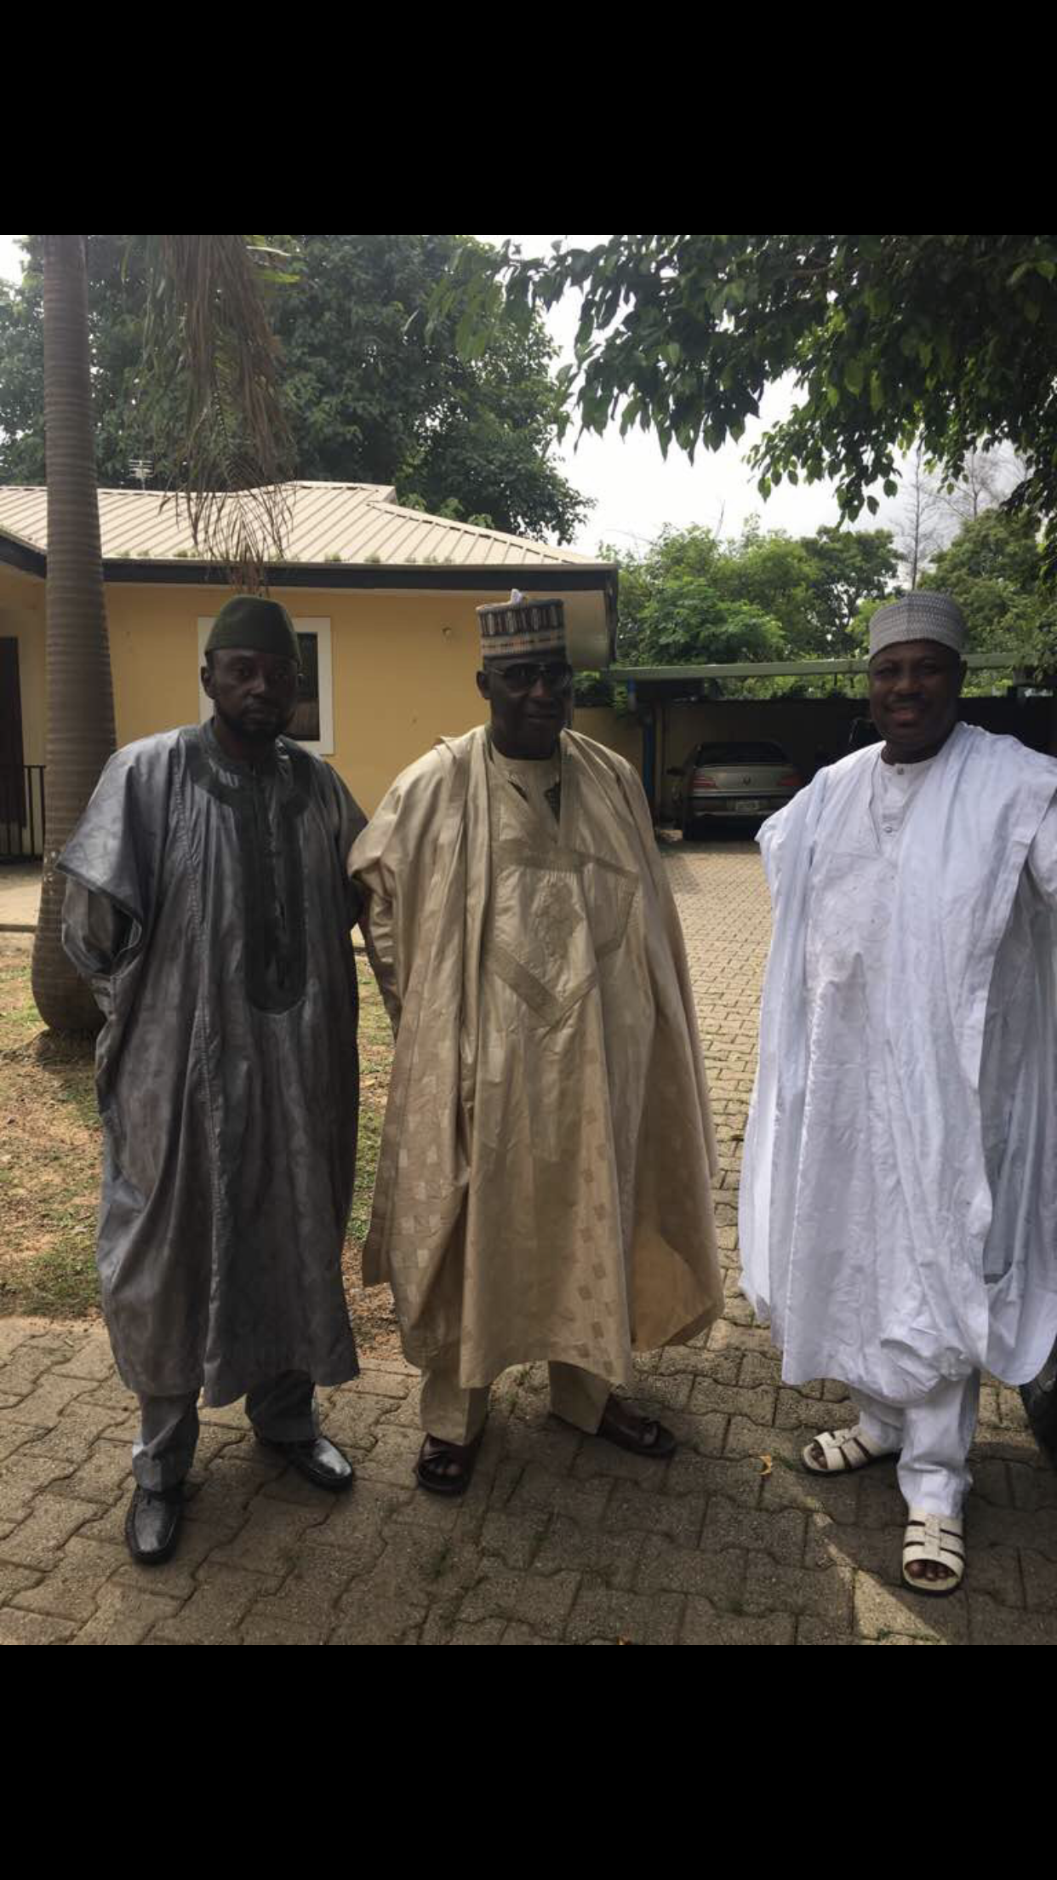
Top: Snails are a delicacy in Nigeria
Bottom: My pot of Jollof rice for Eid

My father and his cousins on Eid
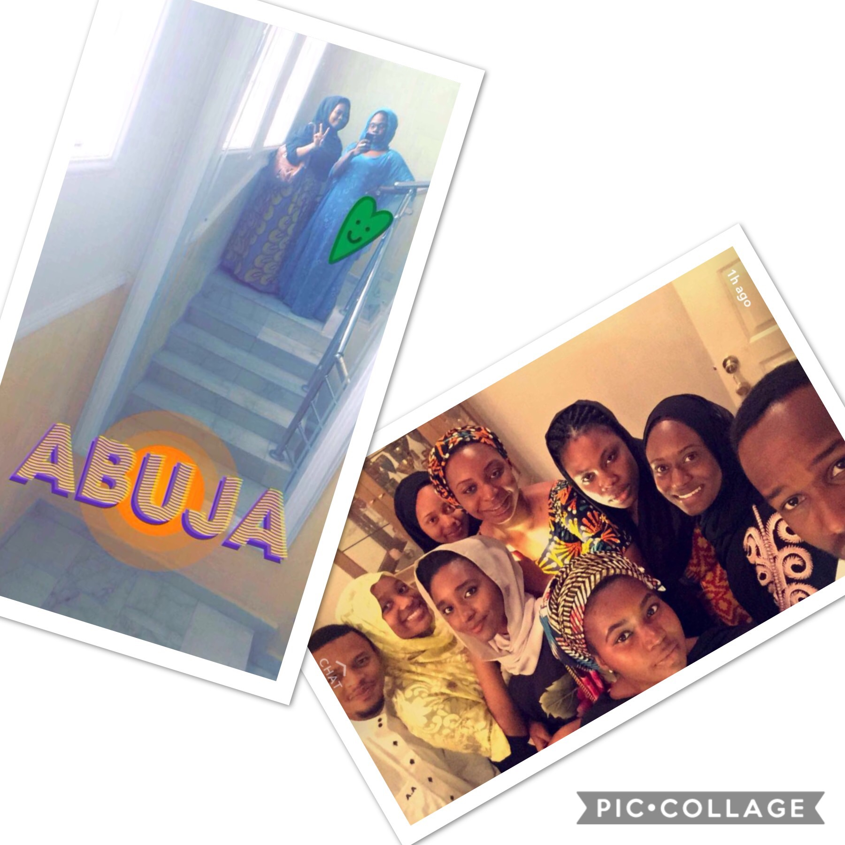
Caught up with some old friends

A picture of me in my modest dressing on a typical day and one of me and some friends at the wedding I attended
Each time I left the house I took every opportunity I got to speak to locals about the project to hear their views. My friends and family were very supportive but as expected, not everyone was receptive to what Muhammad called my ‘privileged girl solution’ to a national issue. A woman I spoke to at the market clearly said she did not have time to plant food for everyone else because she did not see how it would benefit her.
A vast number of people thought it would be a waste of my time, as they could not foresee longevity even if the project was an initial success. The road safety officer said “ People will just pick the food in surplus amounts to sell because we are always looking for ways to make money in this country”
Another person said, “ Even if I help you plant and enjoy it, I do not have the land to do my own growing. Madam I live in a two bedroom flat with my immediate family and eight of my cousins”. I jokingly replied, “Brother, the whole of Nigeria is your land”.
I highlighted to the road safety officer that we could begin by planting in places like hospitals, mosques and police stations where security guards were always present so there could be some sort of supervision in the way people helped themselves to the food before a planting culture was established. He agreed that it could work and even recommended that some of the planting could be done in internally displaced camps.

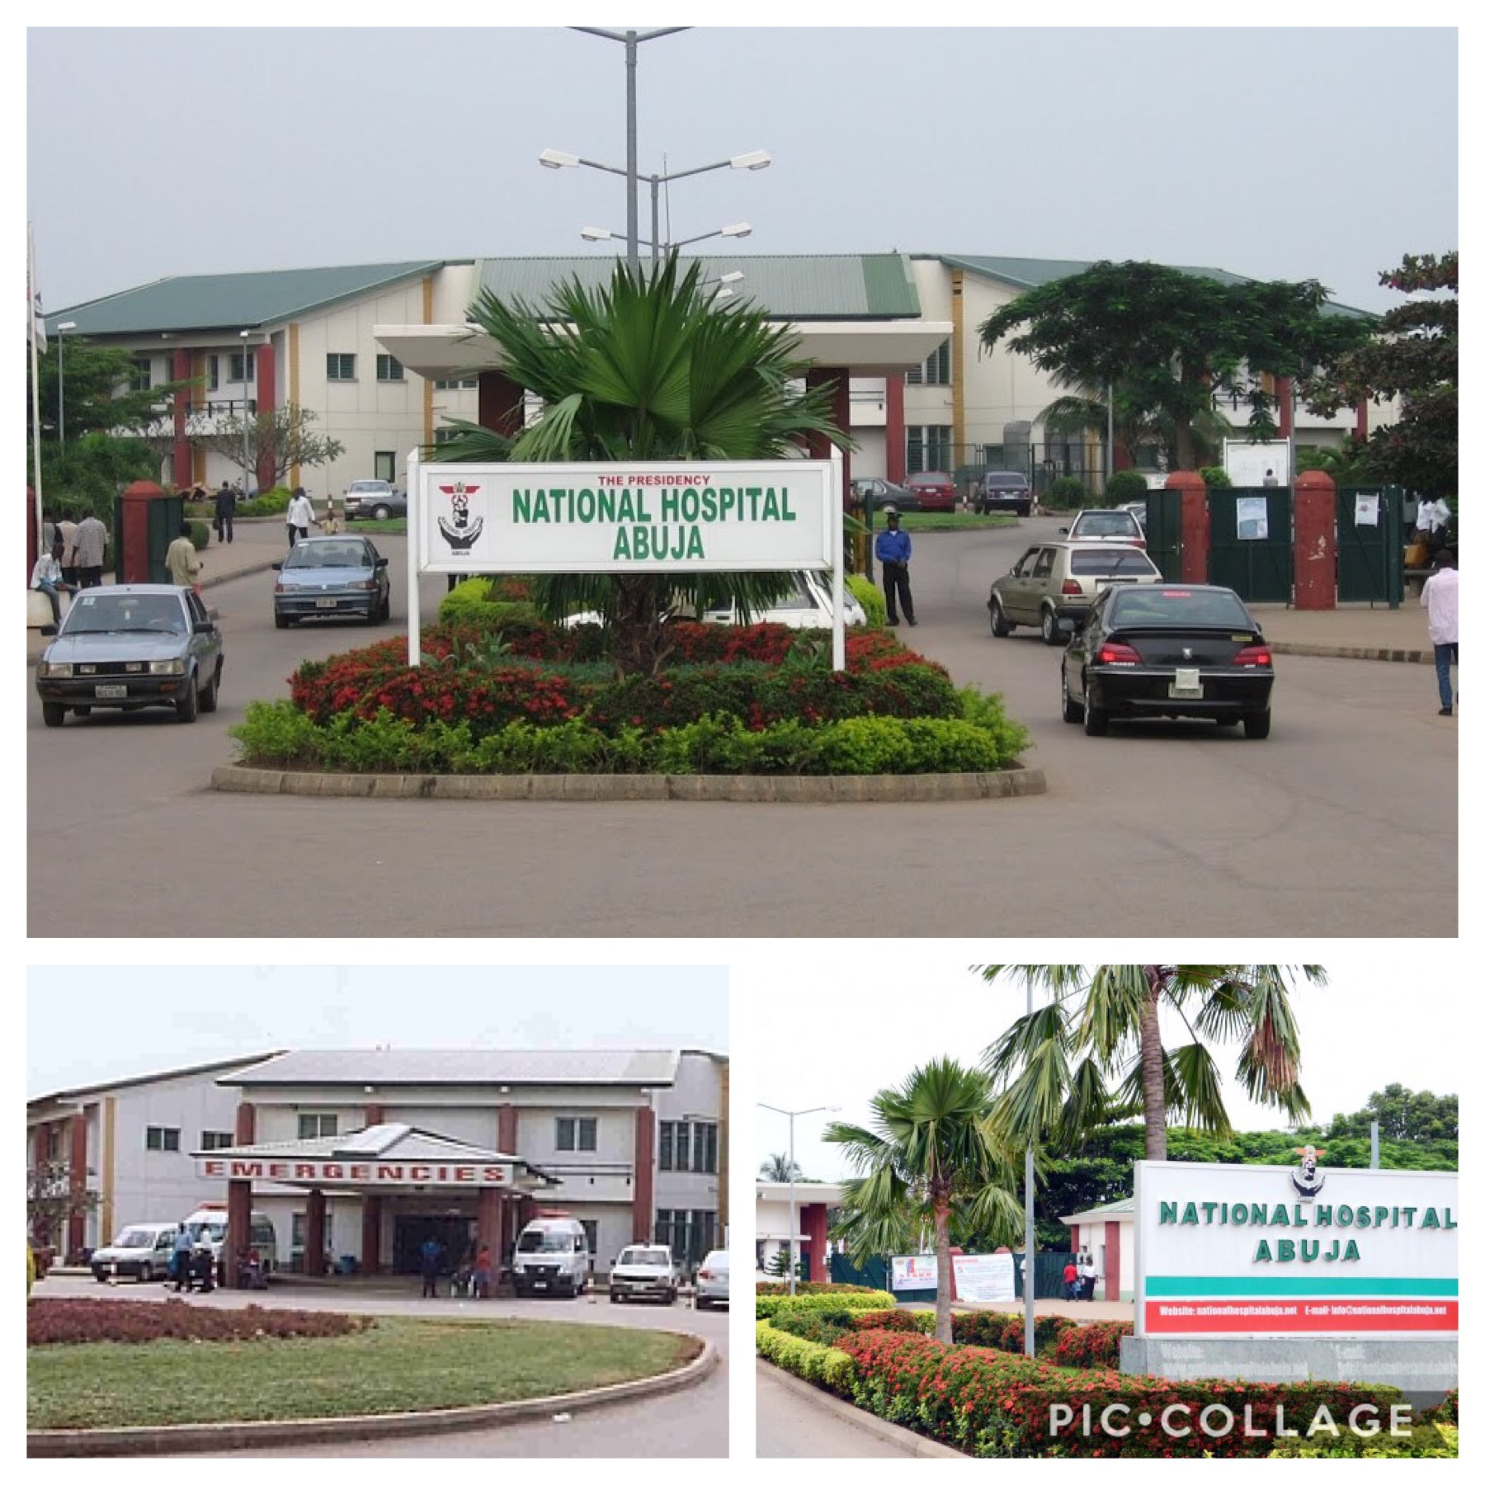
National Hospital, Abuja

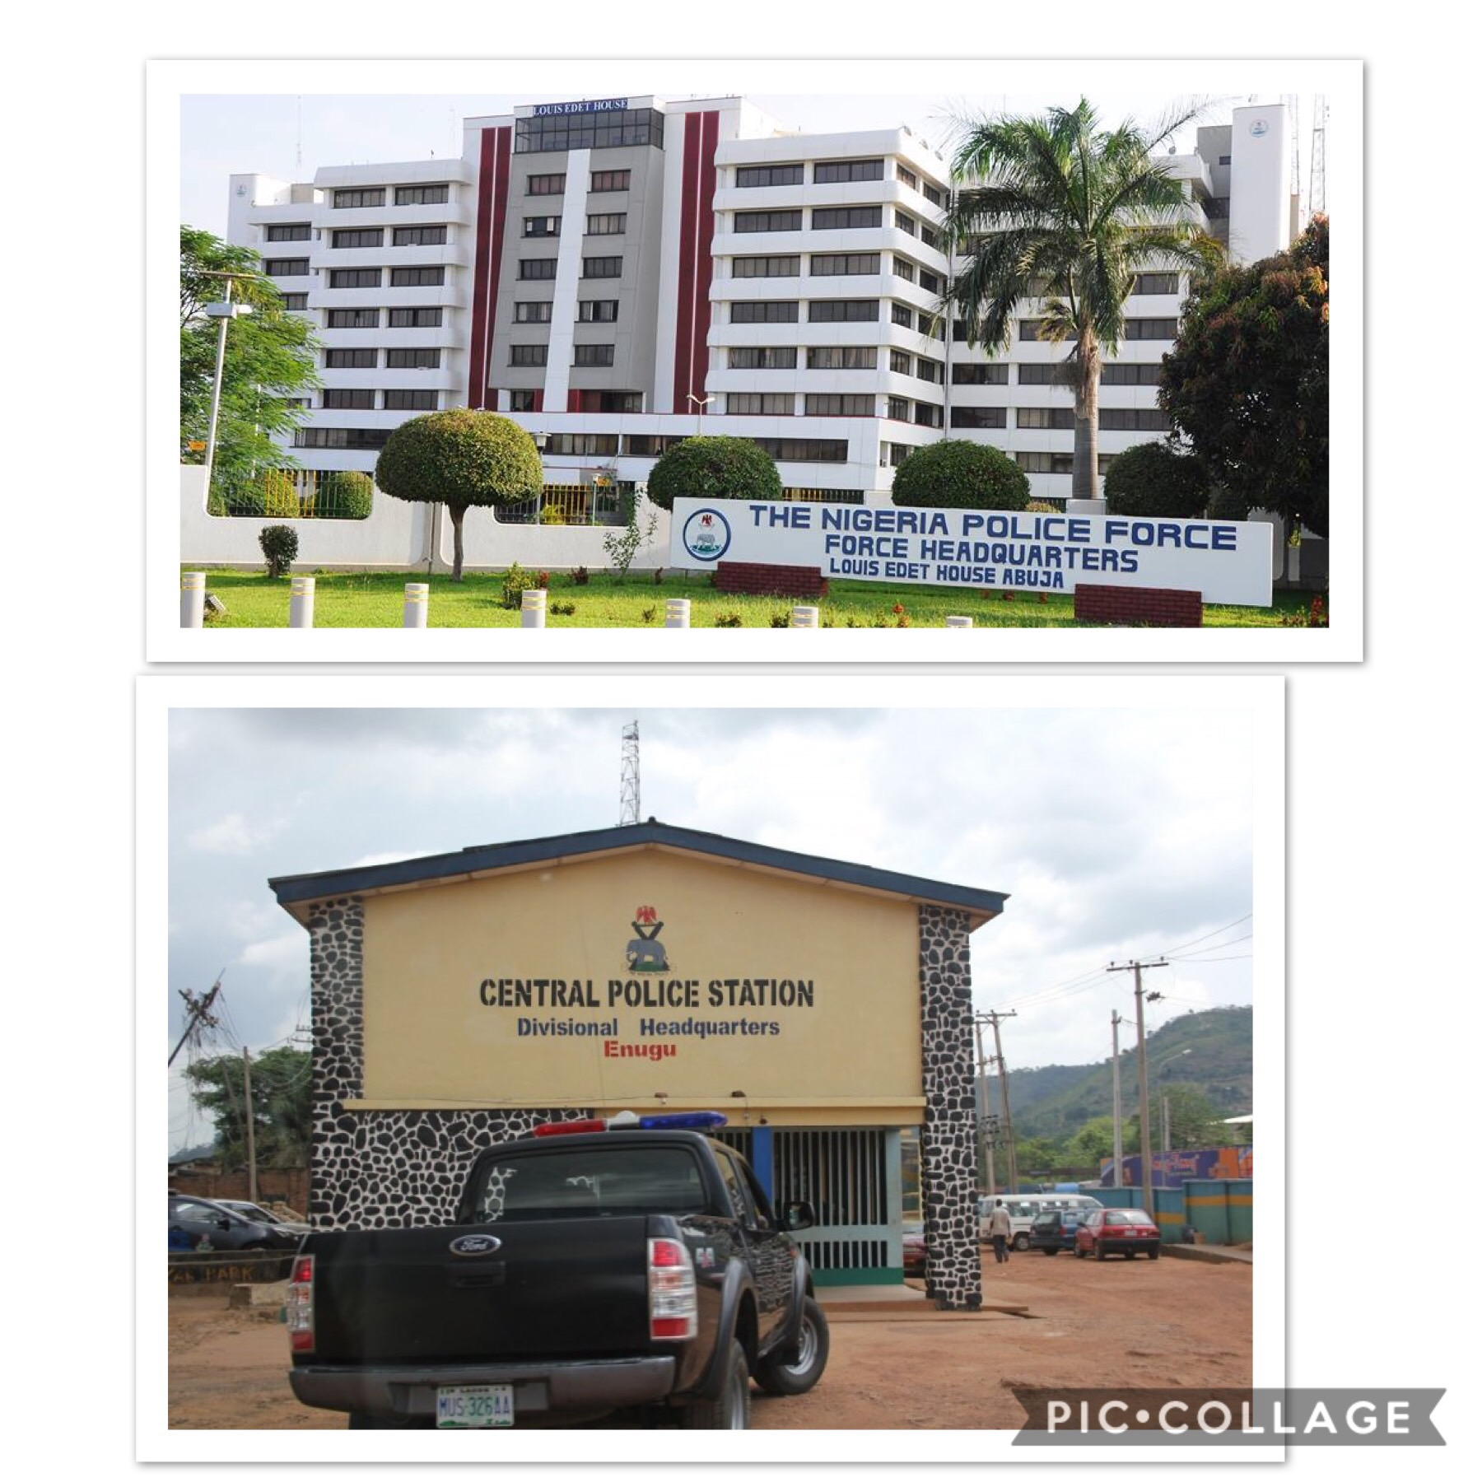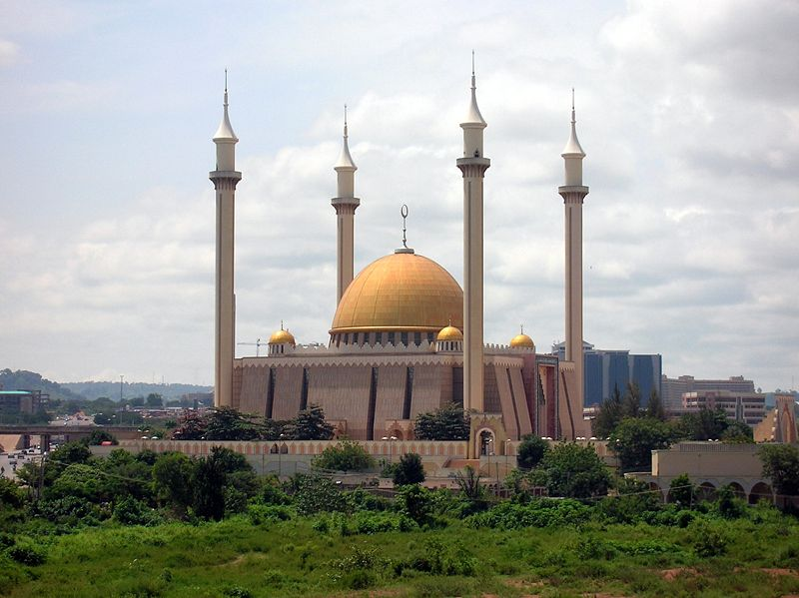
Central Mosque Abuja
Top: The Nigerian Police force headquarters
Bottom: A police station in Abuja

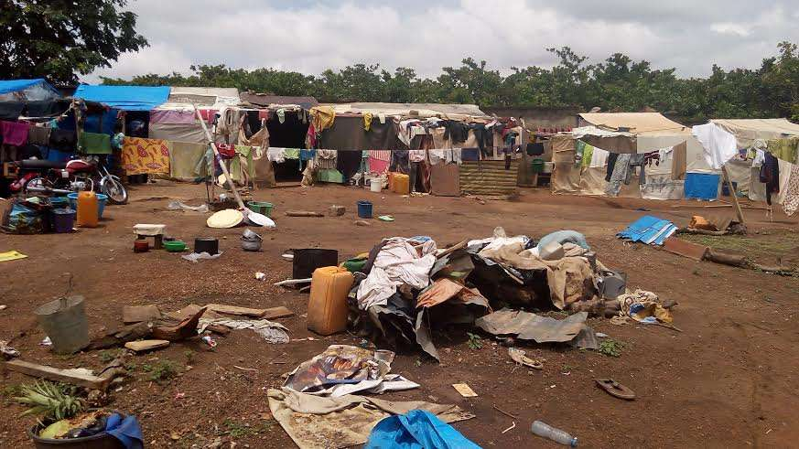
An Internally Displaced Camp in Abuja for those affected by the Boko Haram Insurgency.

When I visited the places I discussed with the road safety officer, I saw that they had discussed plots that could be turned into abundant sources of healthy food. This finding got me really excited and I could envision the project coming to life.
Subsequently, I found out the types of food that I could potentially grow as a result of conversations I had with local farmers and people that knew one ore two things about growing food. I narrowed the list down to food that would not be stressful to grow and those that could be consumed immediately after harvest. Nigeria has a tropical hot climate and has three seasons namely: dry, rainy and harmattan.
I have considered the following vegetables and fruits:
- Cucumbers are hearty plants and easy to grow. They need full sunlight and soil that is rich in organic matter.
- Tomatoes grow well in most soil types of Nigeria however the best type of the soil is loose loamy soil. They require a minimum of 8 hours of continuous sunlight each day, and 4 months of warm, dry weather.
- Carrots have been successfully cultivated in the Northern part of the country. They grow in sandy soil and can be harvested at any desired size.
- Avocados do best at moderately warm temperatures with moderate humidity
- Fluted Pumpkin commonly known, as Ugwu is one of the vegetables that can be cultivated in every part of Nigeria due to its tolerance of drought and poor soil conditions. It is widely consumed in almost every part of the country.
- Oranges, bananas, pineapples and papayas tend to be in favour of full sunlight exposure and a frost-free climate.
- Watermelons need the soil temperature to be at least 21°C to avoid poor germination.
.

There is a lot of potential for this project to go from one vegetable/fruit patch in front of a police station in Abuja to many food patches in all the 36 states in Nigeria. I hope the project encourages parents to involve their children so the younger generation can grow up with the habit of growing their food. I hope this project can promote food productions within the country and minimize food importation. If just one individual does not go hungry for a day because of a banana I planted or if someone is inspired to start planting, I have done my job.

I intend to return to Nigeria in the summer of 2019 with posters seeking volunteers, signs ready to place next to the plants showing what they are, their nutritional values, the dates they will be ready to eat and instructions for how to do some more planting and additional signs saying “help yourself to fruits and vegetables”.
This trip has allowed me build my contacts and given me an insight into what I will be dealing with. Meanwhile, I will continue to learn about soil science, urban gardening and work towards becoming self sufficient in producing the food I eat. As well as raise funds for the tools and materials needed

Sources of funding
Zochonis Special Enterprise Award Fund £450
Savings from my part time job £500
Total £950

Expenditure
Flight tickets £848.61
Petrol £60
Subsistence and expenses £250
Total £1158.61

