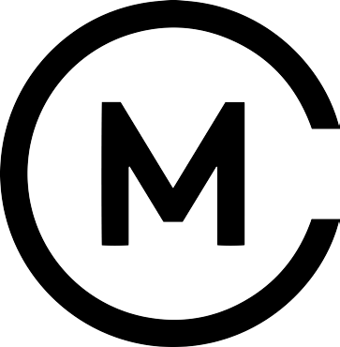

Soft drinks

Fentimans  
*Botanically brewed dandelion and burdock, ginger beer, Seville orange* £2.05

Lovely ‘100% Hand pressed juices from England’s orchards & hedgerows:

*Apple, rhubarb & ginger, sparkling elderflower, sparkling lemonade* £2.05

Classic Coca Cola / Diet Coca Cola £2.05

Freshly squeezed orange juice £2.50

Cheshire spring water: still / sparkling £1.50

Pips organic hand-pressed fruit juice   
*Child Friendly* £1.50

Ale, beer and cider

The Whitworth Pale Ale   
*Citrus and floral, brewed in Manchester!*  £4.00

Brooklyn Lager   
*Dry hopped aroma, smooth caramel malt* £4.00

Red Bank Cider  
*Medium sweet, crafted from English apples* £4.50

Red Bank Seasonal Fruit Cider  
*Wild blueberry* £4.50

Aspall Suffolk Cider  
*Dry and fruity, established 1728* £4.00