

This example of an easy access participant information sheet has been developed by Mary Hargreaves, Project Support Officer in the Division of Cardiovascular Sciences, who has kindly given permission for us to share for best practice.

Mary has also developed an easy access version of the research privacy notice, a copy of which can be found on our website.

The NIHR provide [information on enabling people with aphasia to participate in research](https://www.nihr.ac.uk/nihr-in-your-area/stroke/aphasia.htm) which you may also find helpful.

Division X

Institute of X, University of Manchester, CSB, Address

1. **Study title: X**

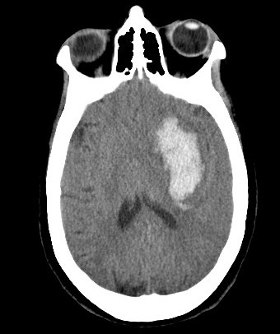

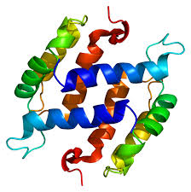



1. **The invitation.** You are invited to take part in a **research study**

Before you decide, it is **important** for you to **understand** why the research is being done and **what it will involve**.

Please take the time to read the following information.

**Ask** if anything is **not clear** or if you would like **more information. **

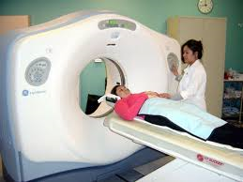

**and** an extra brain scan

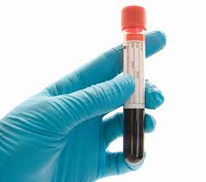

To have a **blood test**

C:\Program Files (x86)\Microsoft Office\MEDIA\CAGCAT10\j0293236.wmf

**++**

C:\Users\mdmossh3\AppData\Local\Microsoft\Windows\Temporary Internet Files\Content.IE5\Z33CB208\MC900434403[1].wmf



1. What is the **purpose of the study?**

We want to take a **blood test** taken soon after intracerebral haemorrhage (stroke)

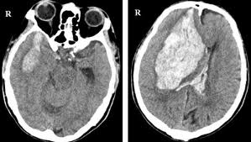





so we can check for a **link** between the **proteins** in the blood and risk of further bleeding (**haematoma expansion**).

If we can **identify** patients at risk **earlier**, it can be **treated** sooner,

C:\Users\mdmossh3\AppData\Local\Microsoft\Windows\Temporary Internet Files\Content.IE5\3TMVT4UM\MC900023538[1].wmf

C:\Users\mdmossh3\AppData\Local\Microsoft\Windows\Temporary Internet Files\Content.IE5\Z33CB208\MC900290954[1].wmf

C:\Users\mdmossh3\AppData\Local\Microsoft\Windows\Temporary Internet Files\Content.IE5\P5Q76OES\MC900423171[1].wmf



**+**

**+**

leading to **improved** **recovery** from stroke and shorter hospital stay.

1. **Why have I been chosen?**

You have had a **stroke** caused by **a bleed** on your brain

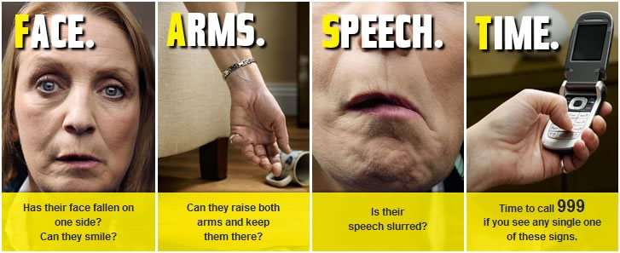

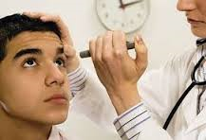

You will be closely monitored over the next few hours for signs of deterioration

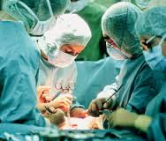

So doctors can treat you quickly

1. **Do I have to take part?**

**No.** It is **up to you** to decide whether or not to take part.



The **standard of care** you receive will not be affected in any way













The result of the brain scan will be available to the doctors looking after you. If you feel uncomfortable at any time, the research will stop.



You will also undergo an extra **brain scan** at **12-36 h** after your stroke to look for changes in the amount of **blood in your brain**.

**&**

We would like to take an **extra blood test.** This will have been **taken already** when you were first admitted. **We will not use this without your consent to participate in the study**



A research nurse will also record **information** about your **health**, including **medication** you currently take and **details of your stroke**





1. **What will be involved if I agree to take part?**

**Soon after your admission to hospital**

C:\Users\mdmossh3\AppData\Local\Microsoft\Windows\Temporary Internet Files\Content.IE5\Z33CB208\MC900280990[1].wmf

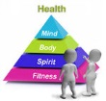



C:\Program Files (x86)\Microsoft Office\MEDIA\CAGCAT10\j0293236.wmf



The research nurse will call you in 3 months to see **how you are**.

She will record how well you have recovered since you were discharged from hospital

C:\Users\mdmossh3\AppData\Local\Microsoft\Windows\Temporary Internet Files\Content.IE5\LJJ0T0KN\MC900440655[1].wmf







**This will end your study participation**

7. What are the benefits of taking part?



Taking part in the study will **not** **benefit you** but you will help **increase** our **understanding** of haematoma expansion







**8. What are the risks of taking part?**

The **risks** of participation include:

-**exposure to radiation** during the extra brain scan and

-**discomfort** from the extra blood test.

You may pause or stop the assessments at any time.

You are free to withdraw from the study at any time.



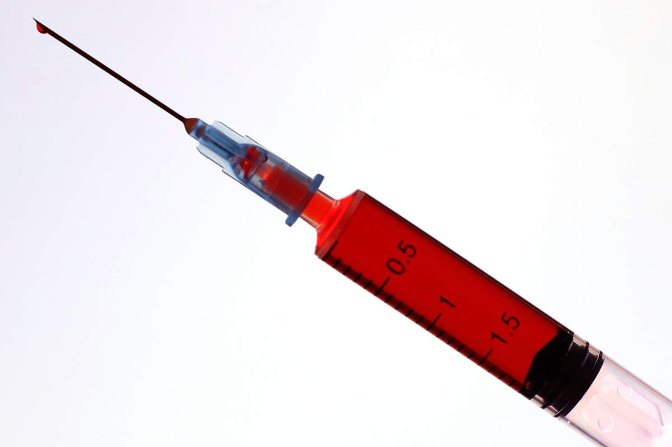



C:\Users\mdmossh3\AppData\Local\Microsoft\Windows\Temporary Internet Files\Content.IE5\Z33CB208\MC900295721[1].wmf

C:\Users\mdmossh3\AppData\Local\Microsoft\Windows\Temporary Internet Files\Content.IE5\Z33CB208\MC900048519[1].wmf

**11. Who is organising and funding the research?**

This study is **organised** by the X Division at the **University of Manchester**

The study is **funded** by **X**

This study has been **approved** by an **NHS Research Ethics Committee**

If you withdraw, we will use the information already collected in the final analysis.

If you do not want us to use your information or retain your samples, please tell us and theywill be confidentially destroyed.



You are **free to withdraw** from the **study** at **any time**

**10. What will happen if I do not want to carry on with the study?**

**9. Will my taking part in the study be kept confidential?**

Your name will not be shown You will be identified by a number

Only **authorised** people will be **allowed** to see your information.

John Smith





and **securely stored** at X

All your **personal information** (name, address and telephone number) will be kept confidential

**C131**

**12. What will happen to the results of the research study?**

We will **publish** the **study results** in an academic journal.

The results may be **presented** at **conferences**.

The results will be part of an **educational project** for Dr X, Profession Here. You will **not be identified** in any publication.

**13. What if I need more information or there is a problem?**

If you need further **information**

or have any concerns about the study please contact the research team on:

**XXXX XXX XXX**

**If you decide you would like to take part, please read and sign the consent form.**

**You will be given a copy of this information and signed consent form to keep.**

**Please take time to decide whether you want to take part.**

**Thank you for reading about this study.**

C:\Users\mdmossh3\AppData\Local\Microsoft\Windows\Temporary Internet Files\Content.IE5\LJJ0T0KN\MC900423171[1].wmf

C:\Users\mdmossh3\AppData\Local\Microsoft\Windows\Temporary Internet Files\Content.IE5\3TMVT4UM\MC910217191[1].wmf

C:\Users\mdmossh3\AppData\Local\Microsoft\Windows\Temporary Internet Files\Content.IE5\Z33CB208\MC900056528[1].wmf

C:\Program Files (x86)\Microsoft Office\MEDIA\CAGCAT10\j0293236.wmf

**Please now turn the page to read information about your privacy.**











The law says that we must have a **legal basis** to collect your data.

This means we need to have a particular **reason** for collecting your data. We can collect your data under two legal bases:

1) A task carried out in the public interest

2) A process necessary for scientific research purposes

The University of Manchester is the **data controller** for this research.

This means the University of Manchester is **responsible** for making sure your data is:

1) Kept securely and confidentially

2) Only used in the way the researchers tell you it will be used

Your data will be **anonymised** as soon as possible. This means any personal information which could identify you will be **removed**.

The data remaining will be kept for X years.

Your anonymised data may/will not be shared with other researchers. (Delete where appropriate: ) These researchers will be investigating stroke.

Anyone who wants to use your anonymised data to research stroke will need to get ethical approval.

You can learn more about your data privacy by reading [The University privacy notice](http://documents.manchester.ac.uk/display.aspx?DocID=37095)