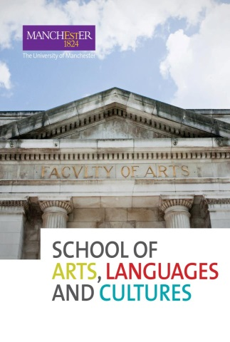



|  |
| --- |
| **The Undergraduate Scholars Research Programme**  Further information  **Introducing Undergraduate Scholars**  The School of Arts, Language and Cultures’ Undergraduate Scholars Programme (henceforth UG Scholars) is an extra-curricular, non-credit bearing programme of research for intellectually adventurous undergraduate students.  UG Scholars is unlike any course you will have experienced in your undergraduate degree. It comprises a largely self-directed programme of group based interdisciplinary research which aims to encourage students to learn through research. It is extra-curricular so you will need to fit it in around your existing studies, and it is not credit bearing. However, instead of credit, what you will get from this course, apart from enhanced independent research skills, is an experience of interdisciplinary research, experience in presenting that research, and a series of other key skills in research design, group work, digital literacy and more. Ultimately, the more you put in, the more you will get out! Upon successful completion of the course, it will also be recorded formally on your Higher Education Academic Record so it will appear on your final degree transcript.  **The specifics**  The UG Scholars programme will take place in Semester 2 and is open to students of all levels. Students should read the abstracts for the 7 interdisciplinary research projects that are available and apply for one of these on the application form provided.  As a UG Scholars student you will receive training in general and project specific research skills. An academic will lead your interdisciplinary research project, and the research will be undertaken in groups comprised of undergraduates from different years and degree programmes. Mixed level group work, interdisciplinarity, and an opportunity for you to develop your research questions, methods and mode of presentation, within the remit of an overarching research theme or project devised by staff, are distinctive characteristics of the UG Scholars programme, and ensure that it differs significantly from other independent research work you will do in the course of your degree.  The programme will involve 15 contact hours (all online), including consultations with staff, training in research skills, the final presentation of research findings and a showcase celebration of all projects. You will be encouraged to write a short project design for your research, supporting you to develop key research specific and transferrable skills. Full academic and professional service support will be provided to you.  The research outputs will be presented by the group to the project leader/s the week after exams finish in a “reporting session” in which you will deliver a presentation or similar practical assignment detailing the findings of your research. This practical output will receive detailed feedback from the project leader.  A celebratory Undergraduate Scholars Showcase will conclude the programme, taking place a week after the final reporting sessions. This will be attended by all on the UG Scholars programme and will be open to all student and staff colleagues to attend. Here you will have the opportunity to deliver your practical assignment and findings of your research to a wider audience, and you will also be presented with a certificate of your final grade. The final showcase may take place in person, depending on Covid19 restrictions at the time.  **Key Dates:**   * **Monday 23rd November: Deadline for Applications** * **Friday 18th December: Students informed of success** * **Semester 2: Week 1, Wednesday 10th Feb, 2-5pm, first UG Scholars session** (after this most UG Scholars sessions will take place on Wednesday afternoons, in weeks 1-3, 9 and 12, with the presentations of the results taking place in mid-June, once the exam period has finished) |