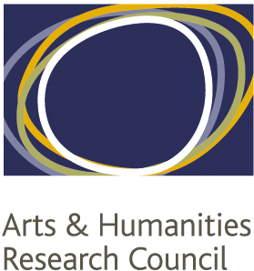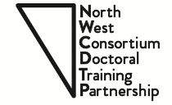

NORTH WEST CONSORTIUM
DOCTORAL TRAINING PARTNERSHIP
Standard Application form for students applying for a 1+3, +2 or +3 studentship in the Arts and Humanities

(September 2018 entry)

1. Studentship applied for (please tick):

1+3 (Masters + PhD)
+2 (PhD - current students)
+3 (PhD)

2. Institution in which you have been offered a place/or have applied to:

Lancaster University University of Liverpool University of Manchester
Manchester Metropolitan University Keele University University of Salford
Royal Northern College of Music

3. Candidate’s details:

Name:
Application / Registration number:
Address:
Town:
Postcode:
Country:
Telephone:
Email address:
Nationality/Resident Status: | UK National  UK Settled status  EU National not resident in the UK  EU National resident in the UK for the past three years  Other

4. Project details:

Award Type a. Full award b. Fees only

Mode of Attendance a. Full time b. Part time

Pathway:
Institution:

Proposed Masters Programme (1+3 only):

Project title (+2/+3):

5. PhD Proposal (to be completed by all students):

5a) Please provide between 6 and 10 keywords that describe your research

5b) Please describe the proposed research using up to 1,500 words, referring to the guidance. Include a word count.

6. Qualifications:

Year awarded | Qualification type | Qualification Subject | Awarding institution | Level | Class
Description:

7. Relevant Experience:

Description of relevant experience:

8. Supervision

Please propose up to 3 prospective supervisors for your PhD:

Institution | Supervisor

9. Research Training previously undertaken

9a) (+2 and +3 applicants only) Please give details of the Masters programme and research training undertaken:

9b) (+2 and +3 applicants only) Relevance of Masters and other previous training to your PhD project (up to 100 words):

9c) (1+3 applicants only) How will your proposed Masters training equip you with the skills necessary to undertake your PhD project? Refer to the guidance on eligibility for 1+3 awards (up to 250 words)

10. Research Training needs

Please give details of the anticipated research training needed for your PhD project:

Please give details of the kind of resources you will potentially need during your PhD. Please also indicate whether your research project will require you to undertake research abroad.

1. Additional Applications
11. Collaboration with External Partners

11a) Is this or does it have the potential to be a collaborative PhD? See the guidance for a definition. If so, give the name of the partner organisation, and describe the planned collaboration, following the guidance. Indicate what discussions you have so far had with the partner organisation. You must also attach a letter from the partner organisation indicating its support in principle.

11b) Other applicants: Please give details of any potential collaboration you may plan to develop with external organisations during your PhD programme (industry, cultural organisation, government bodies etc…).

12. Additional Applications

Have you been nominated for or applied for any other studentship this year?

If yes, please provide details:

13. References / Transcripts

Your institution will need to attach two references and your transcript(s) from your programme application to this application form.

14. How did you hear about us?

Please let us know how you have heard about the NWCDTP and its studentships:

15. Acknowledgement

I confirm that the information I have provided in this form is complete and accurate to the best of my knowledge at this date. I fully understand that it is my responsibility to ensure that the relevant forms are submitted to the relevant office in due time and that any missing information may render my application incomplete and ineligible. I authorise the North West Consortium DTP to disclose to the AHRC any information that is relevant to my application.

Signature:

(Type Name if submitted electronically)

Date:

