UMAC – Crewe
Room NG7
Electra House
Electra Way
Crewe Business Park
Crewe
Cheshire
CW1 6GL

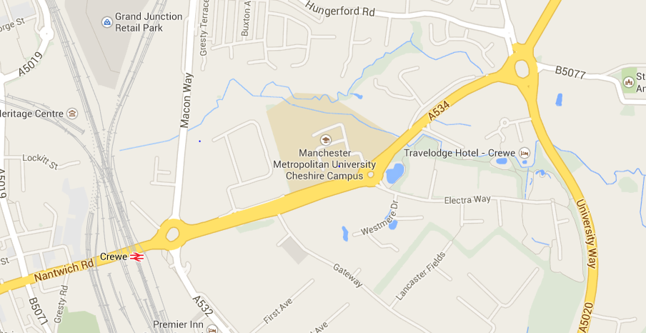

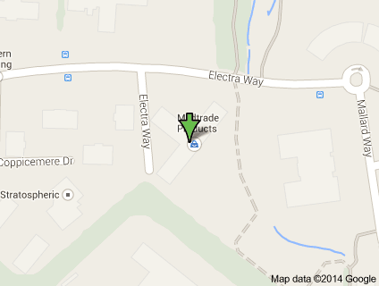

Free Parking is available, please ring the buzzer at the entrance barrier and inform reception you have an appointment with UMAC - Crewe

There are plenty of disabled parking bays next to the reception entrance.

