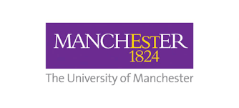
INTERNAL APPLICATION PROCESS:
UKRI Enhancing place-based partnerships in public engagement

Before completing this form please ensure you have reviewed the UKRI Call Guidance at:
https://www.ukri.org/news/enhancing-place-based-partnerships-in-public-engagement/

Delete as applicable:
- UoM is the lead research institution for the bid
- UoM is a partner in another research institutions bid (please specify):

Project Title:

Summary Project (need, rationale, activity, intended outcomes, sustainability) (200 - 400 words):

UoM Project Leads:

Collaborative partner(s) / Community group(s) / Proposed place(s):

Total Funding requested from UKRI (between £10,000 - £40,000):

Total Match Funding Commitment:

Cash: £

In Kind: £

