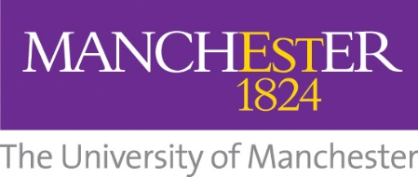
Periodic Review Agenda

Meeting with appropriate staff to discuss:

- Aims and context of programme(s) and intended learning outcomes
- Curricula – content and design
- Assessment and achievement of intended learning outcomes by Students

Meeting with students on the programme(s)

Meeting with appropriate staff to discuss

- Learning and teaching
- Student support and progression
- Learning Resources
- Quality management and enhancement systems

Panel to consider commendations and recommendations.

January 2021

