How to find Manchester Science Park
Reaching MSP is simply straightforward, whichever mode of transport you choose:
By public transport:

Train
Walking from Manchester Piccadilly will take around 30 minutes however, if you are not familiar with the city, we recommend you take a black cab from outside the station. A black cab to Manchester Science Park will cost around £8-10.
If your train stops at Manchester Oxford Road station, it’s a straightforward 20 minute walk to MSP. A map with walking can be found here: http://goo.gl/maps/sU1kl

Bus
There are many buses that stop near to Manchester Science Park from the city centre.
From Piccadilly Gardens: You can get the 41, 42, 43, 44, 48,142, 143 and 157 buses, all of which stop near or outside the Holy Name Church, opposite Manchester Academy. Ask the driver to let you know.
From Oxford Road Train Station: Leave the concourse, cross Oxford Road and at the bus stop outside the Palace Hotel take any of buses 15, 16, 41, 42, 43, 44, 48, 111, 142, 143 and 157, all of which stop near or outside the Holy Name Church, opposite Manchester Academy. Ask the driver to let you know.
For further information on public transport links, contact Greater Manchester Passenger Transport Executive on 0161 228 7811 (open 8am to 8pm). Alternatively, visit the GMPTE web site www.gmpte.com.

Walking from Oxford Rd
Walking directions from Oxford Road to MSP can be seen on this map:
Synergy
Skelton
Williams
Kilburn
Greenheys
Rutherford
Enterprise
Pencroft Way
Lloyd Street North
Oxford Road (B5117)

University walkway
John Rylands University Library
NatWest
KRO Bar
Red Chili Restaurant
McDonald’s
Subway
The Oxford Pub
Sainsbury’s
Costa
Manchester Royal Infirmary

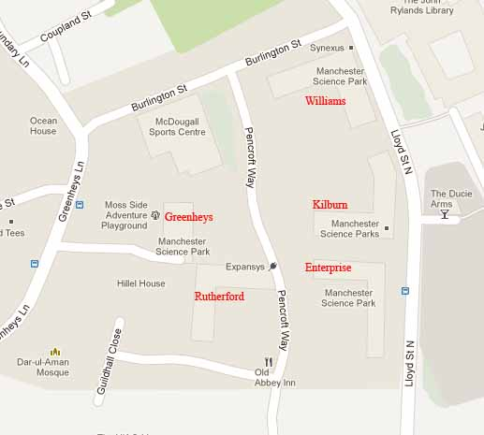
Site map

By car
From the East via M62
- Leave M62 at J12 and join M602 Salford for 4 miles
- Continue onto the A57, joining A57(M) after 1 mile
- Take the A5103 exit toward M’cr Airport
- At the roundabout take the 2nd exit onto Mancunian Way
- At the next roundabout take the 3rd exit onto Cambridge St.
- Take the fourth right onto Burlington Street
- Take your first left onto Pencroft Way
- Greenheys will be your first building on the right

From the South via M6
- Leave the M6 at J19 onto the A556
- Then join the M56 at J8 heading towards the Airport
- Continue along the M56, which will continue as the A5103 (Princess Road)
- Turn right into the B5219, Moss Lane
- Take the 3rd left onto Lloyd Street North
- Turn left onto Burlington Street
- Take your first left onto Pencroft Way
- Greenheys will be your first building on the right

From the South via M1
- From the M1 join the M6 at J19
- Then follow directions from M6 (South)

From the West via M61 & M62
- Leave the M62 at J12 and join the M602 toward Salford
- Continue onto the A57 (Manchester), becoming A57(M) after 1 mile
- Take the A5103 exit toward M’cr Airport
- At the roundabout take the 2nd exit onto Mancunian Way
- At the next roundabout take the 3rd exit onto Cambridge St.
- Then follow directions from M62 (East)

From M56
- At Junction 3 the M56 exits off on a slip road. Do not exit here
- Keep going onto the A5103 to Manchester for about 4 miles
- Turn right into the B5219, Moss Lane
- Then follow directions from M6 (South)

From M67
- Head east on the M67
- At the roundabout take the 5th exit and stay on the M67 heading to Oldham/Stockport/M’cr Airport/Manchester
- At Denton Island take the 2nd exit onto the A57
- At the next roundabout take the 3rd exit onto Ardwick Green
- Merge onto the A57 (M) and then take the A5103 exit
- At the next roundabout take the 1st exit onto Cambridge St.
- Then follow directions from M62 (East)

Please note unfortunately there is no visitor parking available at the venue. There is street parking in the vicinity of MSP but we cannot guarantee spaces.
Therefore we recommend you use a car park from the list provided below which are all within short walking distance of MSP.
Surrounding Car Parks
Grafton Street Car Park – Grafton Street, Manchester, M13 9WG
Free / 30 mins £2.50 / 3 hours £5.00 / 6 hours £15.00 / 24 hours
University of Manchester – Booth Street West, Manchester, M13 9GR
£3.00 / 3 hours £5.00 / 6 hours £8.00 / 10 hours £10.00 / 24 hours
NCP – Aquatic Centre, Booth Street East, Manchester, M13 9SS
£2.40 / 2 hours £4.10 / 4 hours £5.80 / 9 hours £8.60 / 24 hours
Wilmslow Park – Hathersage Road, Manchester, M13 0JJ
Free / 30 mins £2.50 / 3 hours £5.00 / 6 hours £15.00 / 24 hours
Hathersage Centre Car Park – Hathersage Road, Manchester, M13 9WL
Free / 30 mins £2.50 / 3 hours £5.00 / 6 hours £15.00 / 24 hours

Questions?
If you have any specific questions on how to get to MSP then please contact us:
Telephone: 0161 226 1000 Email: enquiries@mspl.co.uk
W: www.manchesterscienceparks.co.uk @McrSciParks

