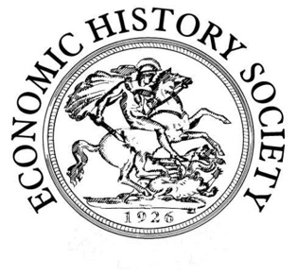
Economic History Society

Women’s Committee 30th Annual Workshop
Negotiating empire: women, economic practice and colonialism

Saturday, 23 November 2019
University of Manchester

Call for Papers

The thirtieth annual workshop of the Economic History Society Women's Committee, organised by Dr Misha Ewen and Dr Hannah Young, will take place at the University of Manchester on Saturday, 23 November 2019.

The 2019 workshop will explore women’s involvement in and negotiation of the economic practices that built, sustained and resisted empires across the globe from the seventeenth to the nineteenth centuries. It aims to examine the experiences of a wide range of women, colonisers and colonised, free and enslaved, interrogating the multiple axes of power that shaped the way these women thought and behaved. In doing so, it hopes to investigate new directions and approaches in the fields of economic and women’s history.

We invite proposals for 20 minute papers that address any aspect of women’s economic contribution to the making and remaking of, or resistance, to colonialism. We welcome proposals from postgraduate and early career researchers, independent scholars and local and community historians, as well as established scholars. Potential themes for papers might include, but are not limited to:

- Consumption
- Trade and commerce
- Investment
- Property-ownership and management
- Household economics
- Kinship and familial networks
- Economics and affect

Anyone interested in presenting their work is encouraged to submit an abstract of 250-300 words and a short biography to Hannah Young at hannah.young@hull.ac.uk. The deadline for submissions is 7 June 2019.

