The City Nature Challenge

Date sent: 09/04/2019

This year the City Nature Challenge comes to Greater Manchester. This is a worldwide biological recording event, organised globally by the Natural History Museum of Los Angeles County and the California Academy of Sciences.

Between 26th and 29th April, over 150 cities worldwide will be competing to find and record urban wildlife. We will be pitting our wildlife spotting skills against the likes of San Francisco, Rome, Lima, Hong Kong, Liverpool and London.

There are two ways to get involved in this fun and friendly competition. You can take part independently using the iNaturalist app to record any wildlife you spot over that weekend. You could record the ladybirds living on your balcony, the birds in your local park or the mushrooms you’ve seen on a walk in the countryside. The app is available to download at www.inaturalist.org.

You can also get involved by joining us at one of the many wildlife recording events taking place that weekend in parks and greenspaces across Greater Manchester; held by some of the region’s leading conservation organisations.

On Thursday 25th April, Manchester Museum will be holding a pre-challenge evening celebrating urban wildlife. On Friday 26th recording events will be held at Moston Fairway, Sandilands Wood, Smithills Estate and University of Manchester campus. On Saturday 27th there will be recording events at Blackley Forest, Sandilands Woods, Smithills Estate, Alexandra Park and Whitworth Park. On Sunday 28th recording events will be held at Fletcher Moss Park and Dove Stone reservoir. Finally on Monday 29th recording events will be held at University of Manchester campus and Chorlton Ees.

Anyone is welcome to come along and have a go. More information on events taking place that weekend can be found by heading to www.eventbrite.org and searching for 'Greater Manchester City Nature Challenge'.

Anyone who joins in will be helping to make a difference, mapping where wildlife lives in the city. The information from this weekend will be added to the UK’s biodiversity database, becoming part of the data used to protect nature.

Stuart Fraser, Environmental Records Officer for Greater Manchester Local Records Centre (GMLRC) said: “Recording your nature sightings is a great way for anyone to contribute to conservation. GMLRC uses records to highlight important areas for wildlife in the region; we produce protected/priority species reports for ecological consultants on Planning Applications, and they can help identify sites to be considered by GM districts for regional SBI status (Sites of Biological Importance).

Records also help owners and organisations manage land for all species, and track how climate change, habitat management and other changes affect biodiversity over time – locally and nationally, as our records feed into the national NBN database.”

Despite being a built-up, bustling city, there’s a surprising amount of wildlife living in the city alongside us. A number of organisations have come together to help people notice and protect the nature in Greater Manchester including: Greater Manchester Local Records Centre, Wildlife Trust for Lancashire, Manchester and North, Merseyside, City of Trees, RSPB, Salford Rangers, The Woodland Trust, Whitworth Art Gallery, Friends of Alexandra Park, Friends of Fletcher Moss, Mersey Valley Rangers, Friends of Chorlton Meadows and Manchester Museum.

***Ends***
Notes to editors
The City Nature Challenge
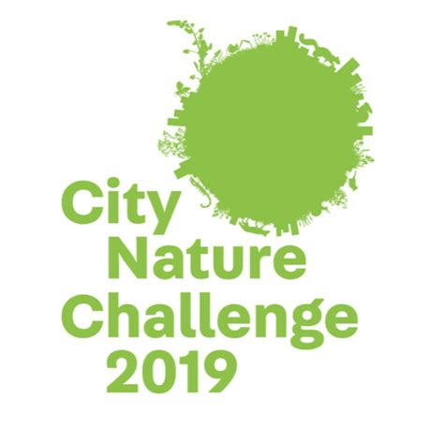
Started in 2016 for the first-ever Citizen Science Day, the citizen science teams at Natural History Museum of Los Angeles County and California Academy of Sciences dreamed up the City Nature Challenge as a fun way to capitalize on their home cities’ friendly rivalry and hold a citizen science event around urban biodiversity. The first City Nature Challenge was an eight-day competition between Los Angeles and San Francisco, engaging residents and visitors in documenting nature to better understand urban biodiversity. Over 20,000 observations were made by more than 1000 people in a one-week period, cataloguing approximately 1600 species in each location, including new records for both areas. During the 2016 CNC, we heard so much excitement and interest from people in other cities that we decided we couldn’t keep to the fun just to ourselves. In 2017 the City Nature Challenge went national, and in 2018, the CNC became an international event!
Find out more about the City Nature Challenge: www.citynaturechallenge.org
Find out more about iNaturalist: www.inaturalist.org
Eventbrite link to City Nature Challenge events in Greater Manchester: www.eventbrite.com/e/greater-manchester-city-nature-challenge-tickets-57795739613

Organisations involved

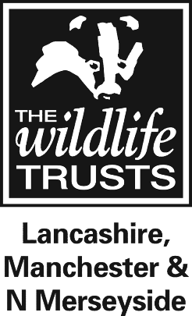
The Wildlife Trust for Lancashire, Manchester and North Merseyside is dedicated to the protection and promotion of the wildlife in Lancashire, seven boroughs of Greater Manchester and four of Merseyside, all lying north of the River Mersey. It manages around 40 nature reserves and 20 Local Nature Reserves covering acres of woodland, wetland, upland and meadow. The Trust has 27,000 members, and over 1,200 volunteers. To become a member of the Trust go to www.lancswt.org.uk or call 01772 324129.
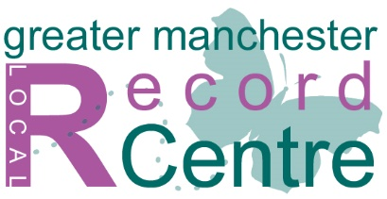
Greater Manchester Local Records Centre
Established in 2008 as part of the Greater Manchester Ecology Unit (GMEU), the Greater Manchester Local Record Centre (GMLRC) is part of a Local Records Centre network that spans the entire UK. LRCs are responsible for local ecological data. We collect, verify, safeguard and share records relating to species, habitats and sites designated as having local, national and international conservation value. www.gmwildlife.org.uk

Manchester City of Trees
City of Trees is an innovative and exciting movement set to re-invigorate Greater Manchester’s landscape by transforming underused, unloved woodland and planting a tree for every man, woman and child who lives there, within a generation. www.cityoftrees.org.uk
Manchester Museum
Manchester Museum, part of The University of Manchester, first opened in 1890. It is the UK's largest university museum with a collection of about 4.5 million items from every continent. Its combination of the academic and the popular is what makes the museum so distinctive and lies at the heart of its widespread appeal. The Museum’s vision is to promote understanding between cultures and work towards developing a sustainable world. In 2015, visitor numbers exceeded half a million visitors for the first time in its history, reflecting an institution that has become a leading visitor attraction. www.manchester.ac.uk/museum @mcrmuseum

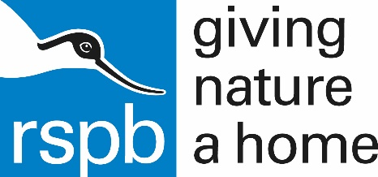
RSPB
The RSPB is the UK’s largest nature conservation charity, inspiring everyone to give nature a home. Together with our partners, we protect threatened birds and wildlife so our towns, coast and countryside will teem with life once again. We play a leading role in BirdLife International, a worldwide partnership of nature conservation organisations. In partnership with Manchester City Council we are developing an exciting new vision to connect people with nature in the Mersey Valley. The two organisations are working closely with local community groups, like the Friends of Fletcher Moss and Parsonage Gardens, to explore ways of encouraging people to do something positive for wildlife, reconnect with nature and help look after the Mersey Valley by getting actively involved. For more information, visit our website www.rspb.org.uk or email Mersey.Valley@rspb.org.uk

The Woodland Trust
The Woodland Trust is the UK's largest woodland conservation charity. Established from humble beginnings by our founder Kenneth Watkins OBE in 1972, we now have over 500,000 members and more than 1,000 sites covering over 26,000 hectares.
We protect and campaign on behalf of this country’s woods, plant trees, and restore ancient woodland for the benefit of wildlife and people. Our vision is a UK rich in native woods and trees, for people and wildlife.
The Smithills Estate is the largest site ever acquired in England by the Woodland Trust. Steeped in history and shadowed by the famous Winter Hill TV mast, it’s a rich mosaic of grassland, farmland, moorland, wooded cloughs and bog habitats, crisscrossed by dry stone walls, with panoramic views over Bolton to Manchester.
Salford Rangers and Peel Park
Opened in August 1846, Peel Park was one of the first public parks to be opened in the country "for the enjoyment and recreation of the public... without charge or restriction". For over 150 years, Peel Park was the city park for Salford, supporting concerts, school sports and flower shows in addition to more usual recreation. The park and its users were a favourite subject of LS Lowry.
Thanks to funding from the Heritage Lottery Fund and support from Friends of Peel Park and the surrounding community, Peel Park has been able to carry out £2.5 million restoration to the park and provide a park keeper. www.peelparksalford.info

