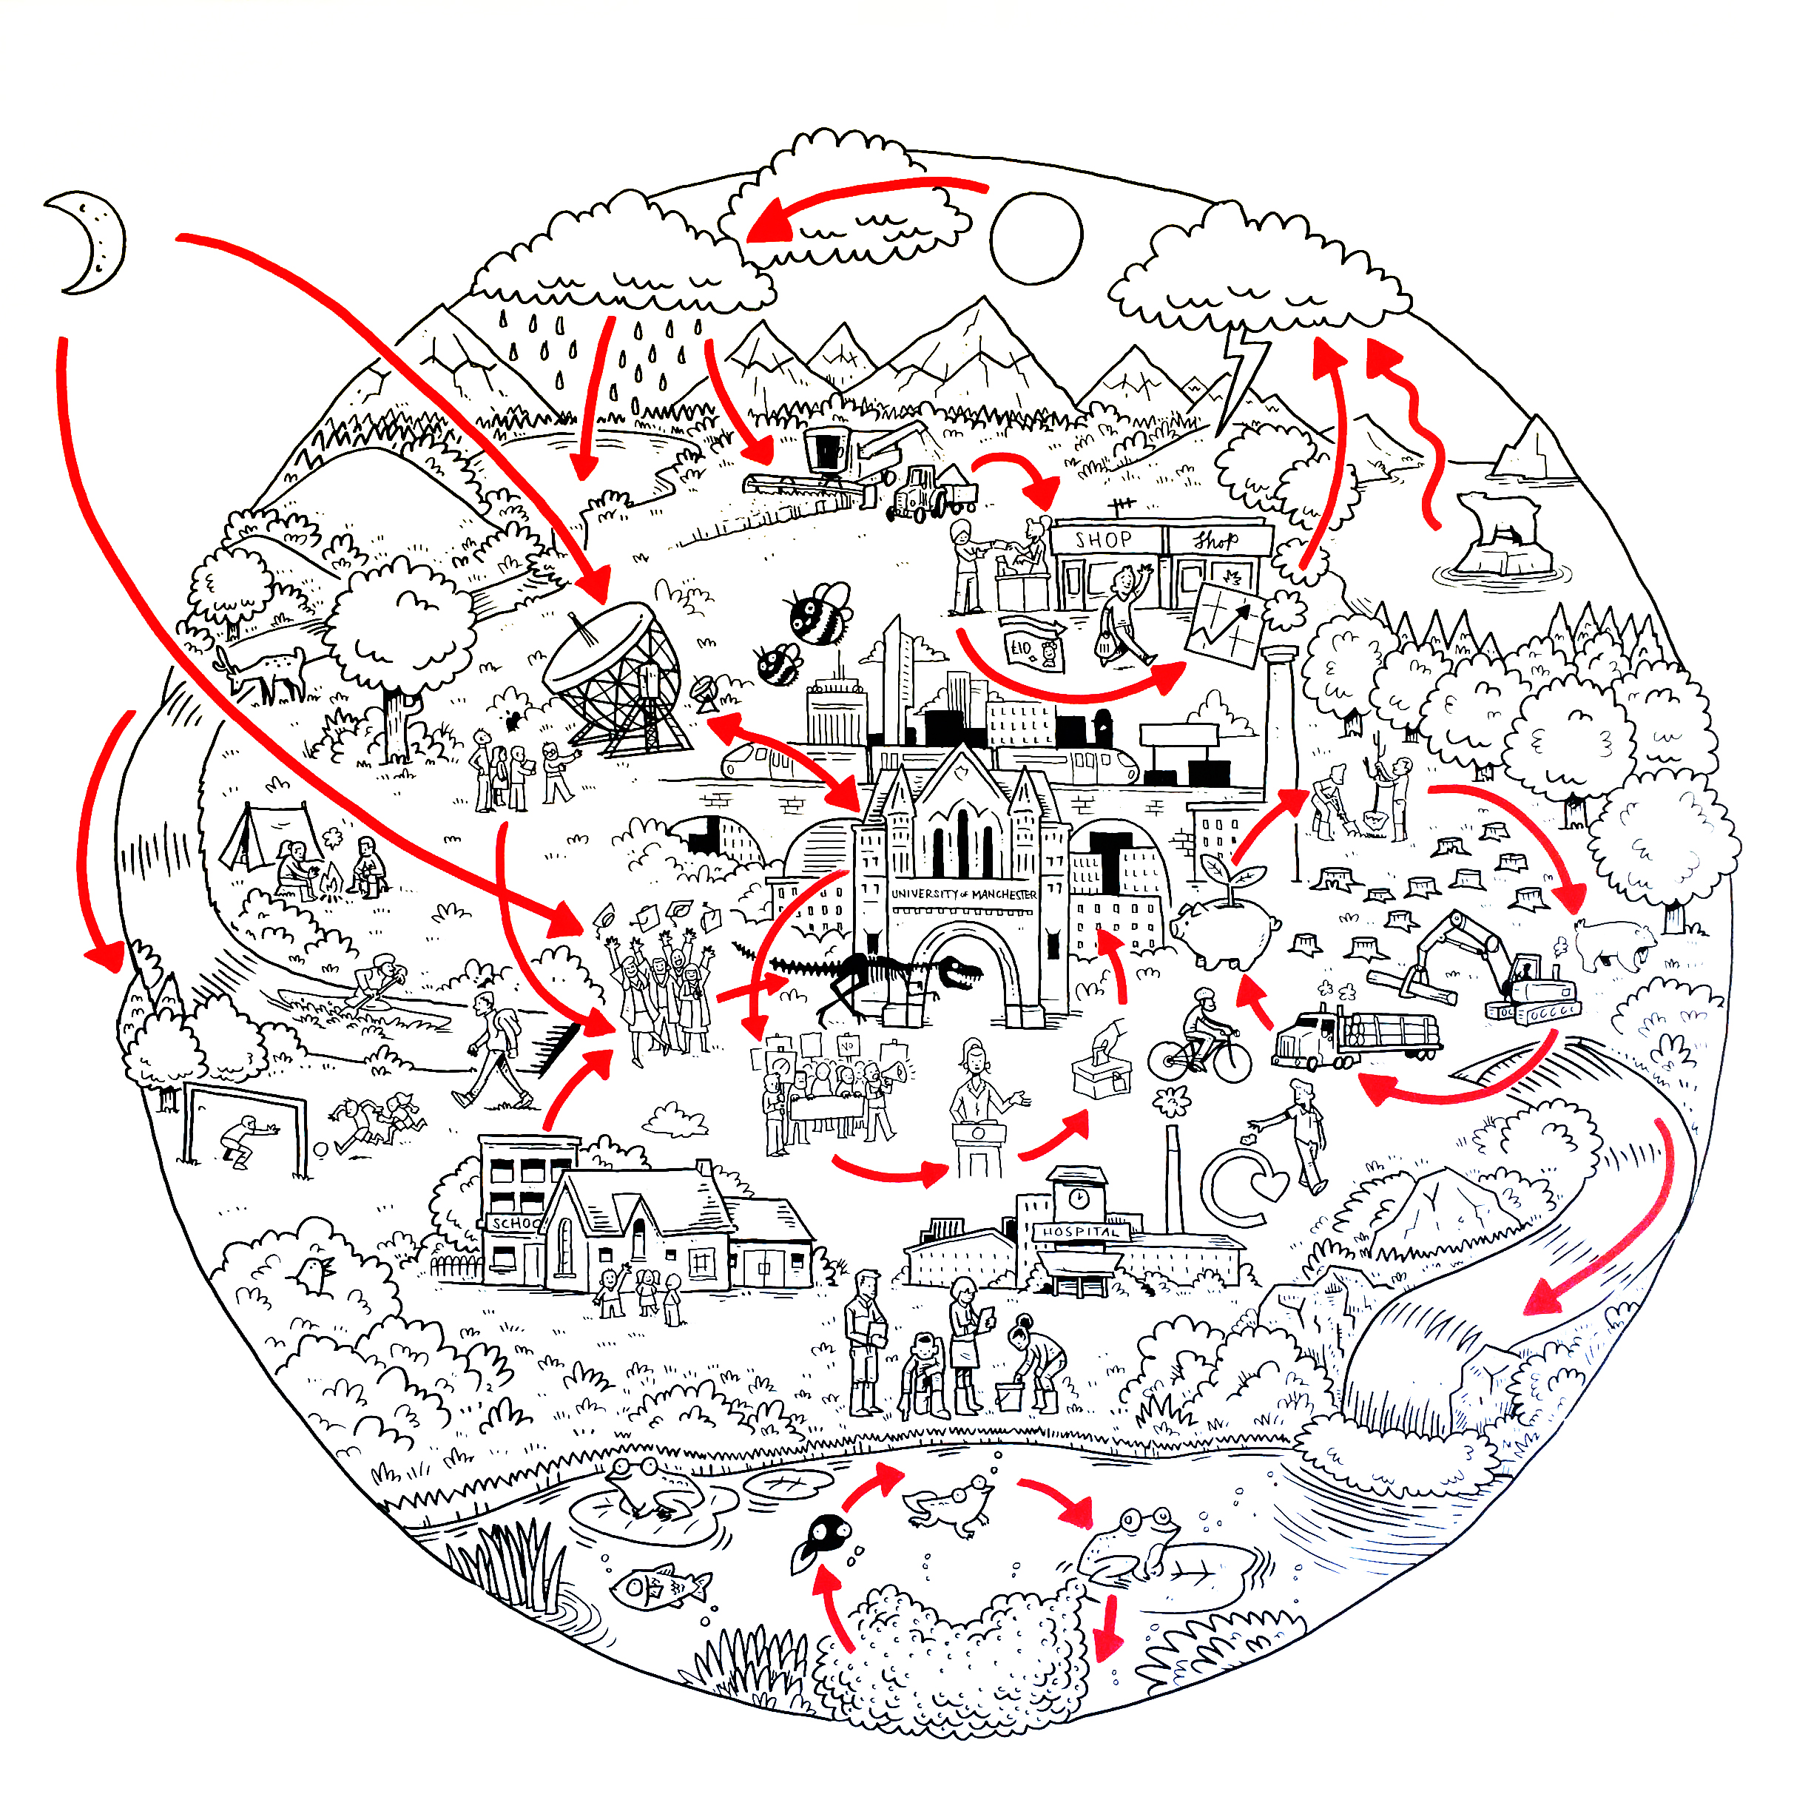

The University of Manchester: A review of ES performance
October 2020

1: Introduction

This academic year (2019/20) has presented many challenges for Environmental Sustainability (ES) however provides new opportunities to build back better. The devastating effects of COVID-19 have been felt globally and have resulted in many of the planned environmental sustainability initiatives being put on hold until resources become available. Despite this, our ranking in the 2020 Times Higher Education Impact Rankings remains high, we are placed first in the UK. We also committed to decarbonising our investment portfolio, announcing that we will go further than other fossil fuel divestment programmes.

The University of Manchester has announced that it will end investments in fossil fuel reserve and extraction companies by 2022, and ‘decarbonise’ all investments by 2038.

The changes to the University’s Socially Responsible Investment Policy go further than other fossil fuel divestment programmes as they include a commitment to reduce the carbon intensity of the overall investment portfolio by 30% by 2022, and then to move as quickly as possible to net zero by, at latest, 2038.

Pre-COVID the University piloted a BEIS funded carbon literacy programme and launched new team engagement programmes for staff, Team Actions and the Laboratory Efficiency Assessment Framework (LEAF).

Interest in Environmental Sustainability and positive action has remained high across the University and with external stakeholders. Internally, staff in the Faculty of Biology, Medicine and Health have continued rolling out the 6R plastic reduction programme, staff and students have formed a new Climate Network, and students provided feedback on our developing programmes through a series of focus groups.

To adapt to home working, the 10,000 Actions programmes was updated to include home-based actions and staff communications and engagement moved to the Yammer platform.

Despite the positive action around sustainability, there is a risk that the University will not meet its environmental commitments for zero carbon and eliminating avoidable single-use plastics. Both commitments require urgent action with the latter target date approaching (2022). Reduced resource (in the Environmental Sustainability Team and other teams across the University) amplifies this risk. This could be mitigated by strong Environmental Sustainability leadership and advocacy across the University, to build on successes such as the School of Biological Sciences 6R approach to reduce plastics in teaching labs and the roll out of video conferencing; and, prioritising zero carbon as we build back better. COVID-19 has disrupted the economy and society. Disruptions resulting from climate change will be (and in some countries already are) considerably worse than COVID-19. COVID-19 has also shown how habits can be disassembled, there is now opportunity to reassemble habits that support a transition to a zero carbon world.

2: ES Governance

Environmental Sustainability Committee (ESC): Professor Nalin Thakkar, Vice-President for Social Responsibility, chairs ESC, which advises the University on matters relating to environmental sustainability arising from its activities and recommends any action necessary to improve environmental performance. This includes advice to ensure our environmental sustainability commitments relating to zero carbon and eliminating avoidable single-use plastics are met.

ES governance includes a number of groups that report into ESC (Figure 1).

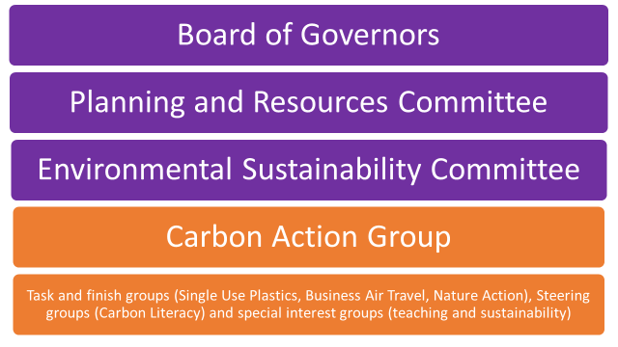
Figure 1: Environmental Sustainability Governance

Carbon action group (CAG): CAG is currently developing pathways in support of our zero carbon commitment. A series of energy audits resulted in more than 1,000 Energy Conservation Measures (ECM), which are being considered as part of the nascent zero carbon plan/programme. Discussions have progressed during 2019/20 to agree the process for further developing the carbon pathway.

Single-use plastic action group (SUP): Members of SUP have drafted an action plan that builds on work to date, including lab and catering audits. Work to eradicate avoidable single-use plastic continues alongside awareness raising amongst staff and students.

Business air travel group (BATG): BATG are now working towards updating the action plan and delivery initiatives to reflect the current circumstances.

Nature Action Group (NAG): It was agreed that NAG will replace the Living Campus Group to oversee the development and roll out of strategic partnerships to engage staff, students, alumni and other communities in responsible schemes to support proven natural solutions to capture carbon, restore the natural world and enhance environmental sustainability.The group will also provide advice to the University on issues relating to biodiversity and wellbeing and resilience to climate change. NAG held its inaugural meeting in October 2020.

All ES groups include professional services, academic and student representatives.

3. Zero Carbon

During 2018/19 the University signed up to Manchester City Council’s zero carbon by 2038 commitment. The University’s zero carbon baseline year is 2018, 54,389tCO₂, (for communications purposes this was stated as 54,000tCO₂). Data will be reported by calendar year annually.

Carbon emissions in 2019 were 52,202tCO₂ (Figure 2), a 4% reduction and a shortfall of 4,884tCO₂ from the zero carbon pathway (which targets a 13% annual reduction). Figures 2 and 3 show actual emissions from 2015, the year of the Paris Agreement. Urgent action to reduce carbon is required. If reductions are delayed, larger reductions will be required in the future (Figure 3). A delay to 2022 will result in an approximate 20% annual reduction and a delay to 2025 a 35% annual reduction.

The Carbon Action Group (CAG) drafted and proposed three principles to the Environmental Sustainability Committee (ESC), which were approved in May 2020.

Principle 1: We will make urgent reductions in the first five years, reducing carbon emissions from a 2018 baseline of 54,000 tCO₂ to at least 21,000 tCO₂ by 2025.
Principle 2: All members of the University of Manchester community will understand the problem of climate change in order to make better decisions in their working lives.
Principle 3: The carbon impact of University activities is part of all strategic decision making.

Each principle has a number of actions for delivery over the next five years, in support of the zero carbon pathway (Figure 2) and University Strategic Plan and Theme Plans (when approved). Work is underway to finalise these actions (although some actions are already underway), which will be presented to the ESC for approval in December 2020.

Actions underway:-
- To stabilise the climate, we need to stop transferring carbon from geological reservoirs to the atmosphere. We will therefore remove our equity investment from companies involved in fossil fuel extraction and production by 2022 and will redirect our other equity investments to favour companies that are more carbon efficient (emit less carbon for their level of activity), in a staged manner. (an action under Principle 1)
- We will launch an interdisciplinary platform connecting our research on climate change and environmental sustainability. (an action under Principle 2)
- We will be thoughtful in our use of air travel and adopt the Tyndall Centre’s decision tree for planning business travel, across the University. (an action under Principle 2)
- We will work together with Greater Manchester Combined Authority, Transport for Greater Manchester, Manchester City Council, Manchester Climate Change Agency, the Oxford Road Corridor and City of Trees to tackle the climate and ecological emergency. (an action under Principle 3)

Blue: Actual, Red: Pathway (~13% annual reduction), Green Manchester Climate Change Partnership milestones
Figure 2: The University of Manchester zero carbon pathway

Blue: Actual, Red: Pathway (~13% annual reduction), Purple: Delay to 2022 (~20% annual reduction), Light Blue: delay to 2025 (~35% annual reduction), Green: Manchester Climate Change Partnership milestones.
Figure 3: The University of Manchester zero carbon pathway with delay projections

4: Overview of ES performance: Carbon, energy, water and waste

Performance data have been aligned with the Higher Education Statistics Agency Estates Management Record March 2020 submission; therefore data presented in this section are for the 2018/19 academic year.

- Carbon, Scope 1, 2 and 3
The University’s carbon footprint for 2018/19 is 447,576tCO₂ (Table 1), an increase of 13% on the previous year due to increases in the Scope 3 area of procurement. However, waste has reduced significantly, by 59% due to reduced construction waste and reusing textiles. Scope 3 targets and metrics will be considered as part of the nascent ES strategy works.
Table 1: Carbon footprint
 | Scope | 2016/17 tCO₂ | % of overall footprint | 2017/18 tCO₂ | % of overall footprint | 2018/19 tCO₂ | % of overall footprint
Procurement | 3 | 229,021 | 70.19 | 307,852 | 77.39 | 367,050 | 82.09
Electricity | 2 | 35,610 | 10.91 | 28,471 | 7.16 | 25,982 | 5.8
Gas | 1 | 24,279 | 7.44 | 24,998 | 6.28 | 24,733 | 5.5
Air travel | 3 | 16,431 | 5.04 | 17,836 | 4.48 | 14,143 | 3.16
Commuter travel (staff and students) | 3 | 9,121 | 2.80 | 9,121 | 2.29 | 10,816 | 2.42
Waste | 3 | 9,552 | 2.93 | 6,819 | 1.71 | 2,764 | 0.62
Wastewater | 3 | 578 | 0.17 | 796.81 | 0.20 | 533 | 0.12
Road business | 3 | 510 | 0.16 | 579.15 | 0.15 | 580 | 0.13
Rail travel | 3 | 590 | 0.18 | 576 | 0.14 | 335 | 0.07
Water | 3 | 278 | 0.09 | 387.15 | 0.10 | 257 | 0.06
Oil | 1 | 197 | 0.06 | 228 | 0.06 | 242 | 0.05
Fleet vehicles | 1 | 146 | 0.04 | 139 | 0.03 | 141 | 0.03
 |  | 326,313 |  | 397,803 |  | 447,576

Scope 1 and 2 emissions account for roughly 11% of the total carbon footprint. Scope 3 emissions are 89% of the total carbon footprint; carbon emissions associated with procurement (calculated by spend) are 93% of Scope 3 emissions and 82% of total emissions. The Procurement Team within the Directorate of Finance use the Flexible Framework as a focus for their work, as it supports an approach to embedding sustainability, and through this they became the first University in the UK to attain the highest achievement of Level 5. They are working with NETpositive Futures to take the existing Framework even further, developing a NETpositive approach to responsible procurement for The University of Manchester context. This has meant that rather than concentrating solely on the negative impacts of our procurement activity we have actively sought to maximise opportunities to consider our positive impacts too. The Procurement Team have also been working across the sector to look at carbon emissions and are planning to produce guidance to help reduce carbon (easy actions and steps that can be taken now), as well as updating guidance on the calculation methodology.

For completeness, data pre-zero carbon commitment, the previous Manchester 2020 carbon KPI, is detailed in Table 2. Carbon emissions reduced by 38% on baseline and by 3% on the previous year. The 2020 target was 40% reduction, 48,330tCO₂, a shortfall of only 1,330tCO₂. Decarbonisation of the national grid alongside carbon reduction / energy efficiency interventions has supported this reduction. The impact of grid decarbonisation is evident from the 2019/20 carbon emissions for electricity (24,796tCO₂) that are the same as the carbon emissions for gas (24,594tCO₂), compared to 2007/08 electricity (53,496tCO₂) and gas (26,442tCO₂) emissions.

Table 2: Scope 1 and 2 carbon
 | 2007/08 | 2008/09 | 2009/10 | 2010/11 | 2011/12 | 2012/13 | 2013/14 | 2014/15 | 2015/16 | 2016/17 | 2017/18 | 2018/19 | 2019/20
Gas | 26,442 | 26,698 | 28,654 | 29,712 | 27,177 | 29,272 | 25,851 | 26,467 | 24,951 | 24,279 | 24,998 | 24,733 | 24,594
Electricity | 53,496 | 51,563 | 52,171 | 47,826 | 47,586 | 46,754 | 45,796 | 46,898 | 42,126 | 35,610 | 28,471 | 25,982 | 24,796
Oil | 272 | 178 | 497 | 185 | 246 | 621 | 142 | 170 | 189 | 197 | 228 | 242 | 166
Fleet Vehicles | 340 | 398 | 344 | 336 | 355 | 333 | 205 | 197 | 172 | 146 | 139 | 141 | 104
Total | 80,550 | 78,837 | 81,666 | 78,059 | 75,364 | 76,980 | 71,994 | 73,732 | 67,438 | 60,232 | 53,836 | 51,098 | 49,660
% change on baseline |  | -2.1 | 1.4 | -3.1 | -6.4 | -4.4 | -10.6 | -8.5 | -16.3 | -25.2 | -33.2 | -36.5 | -38.3
% change on previous year |  | -2.1 | 3.6 | -4.4 | -3.5 | 2.1 | -7 | 2.4 | -8.5 | -10.7 | -10.6 | -5.1 | -2.8

2020 target = 48,330tCO₂; a shortfall of only 1,330tCO₂

b) Energy
Energy consumption per m2 reduced from the previous year (Table 3), the trend is largely flat for the last 6 years.

Figure 4 illustrates the staff and student FTE numbers together with energy consumption, with a slight decrease in energy consumption per FTE.

Table 3: Energy consumption per m²
 | 2011/12 | 2012/13 | 2013/14 | 2014/15 | 2015/16 | 2016/17 | 2017/18 | 2018/19
Energy Consumption | 252,027,134 | 269,525,344 | 243,931,652 | 246,562,693 | 239,372,452 | 233,912,862 | 237,358,942 | 235,523,771
Gross internal Area | 827,312 | 832,131 | 886,134 | 887,531 | 887,532 | 887,985 | 878,432 | 884,088
Energy Consumption per GIA | 305 | 324 | 275 | 278 | 270 | 263 | 270 | 266

Figure 4: Staff, Student numbers and Energy Consumption

b) Water consumption

Water consumption data are sourced from Systems Link, which contains billing data from suppliers and is reported by the academic year. Work was planned to review data, however due to furlough and reduced resource in the ES and Energy teams this work has not yet commenced. Figure 5 presents data reported in the EMR March 2020.

Figure 5: Water Consumption (m³)

c) Waste
A new waste contract commenced in January 2019 which now includes pay-by-weight data. This should provide greater accuracy than the previous pay-by-lift contract and we saw a reduction in total waste produced in 2018/19. Waste to landfill has further decreased (Figure 6) since the commencement of the new contract, which stipulates that general waste will not be sent direct to landfill. However, reuse remains low and is a missed opportunity for a circular economy at the University.

Figure 6: Waste Tonnage

d) Air travel
In 2018/19, the quality and availability of air travel data was compromised due to the change in travel providers (Egencia to Key Travel) and we were unable to compare the data with previous years. Due to lockdown, 2019/20 air travel is not representative of business as usual and, again, cannot be compared with previous data sets.

Work to analyse 2019/20 air travel data had been scheduled prior to lockdown. However, the Sustainable Campus Officer was furloughed for three months and with no data analyst since mid-March 2020, there has been no resource in the ES Team to review the data for the last two quarters of 2019/20.

5: Overview of ES Engagement activities in 2019/20

As part of the nascent Agents of Change programme the University’s sustainability engagement activity was reviewed during 2019/20 with the following outcomes:

- 10,000 Actions: During lockdown the 10,000 Actions content was amended to reflect sustainability activities staff could take at home and the site was used to deliver campaigns for example, to promote World Environment Day and Plastic-Free July. Home-based actions will continue to be part of the environmental sustainability messaging moving forward.
- Team Actions: Team Actions was launched in January 2020, bringing team activity onto the 10,000 Actions platform (previously delivered via Green Impact). To date 43 teams have logged into the programme (compared to 39 teams certified in 2019) and 20 have started taking action. The first audit is scheduled for October 2021 to account for the impact of COVID-19. The content is currently under review to future-proof the scheme for any further periods of home working.
- Laboratory Efficiency Assessment Framework: The Laboratory Efficiency Assessment Framework (LEAF) was launched in January 2020, to date 18 teams have signed up to the programme. The programme was paused from March 2020 onwards due to COVID-19, however guidance has been produced which demonstrates actions that can be taken to improve laboratory sustainability remotely. The programme will re-launch during 2020/21.
- Sustainability Champions: From September 2020 champion activity will be folded into the 10,000 Actions programme. The content will be replicated through the platform, encouraging all staff to participate in sustainability activity as champions rather than running a separate programme.
- Carbon Literacy: In December 2019 the University ran a Carbon Literacy training programme for staff as part of a BEIS funded pilot, 16 members of staff attended. Work to build on this will commence in 2021, with a Carbon Literacy Steering Group (Figure 1) being established to lead this work.

6: Commuter travel

In April/May 2019 the biennial commuter survey of staff and students was conducted to establish the current travel behaviours and modes of choice of the University community and the associated carbon impact.

Figures 7 and 8 below show the main mode of student and staff travel to work.
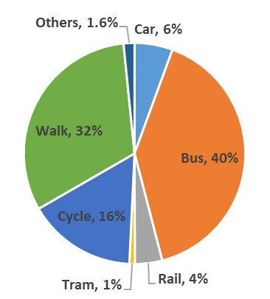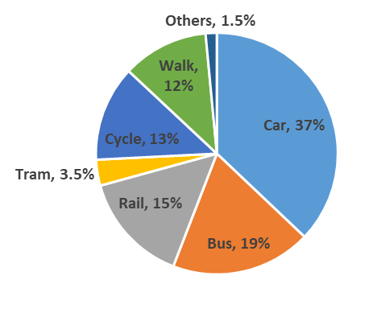

Figure 7: Student main mode of travel Figure 8: Staff main mode of travel

Student travel behaviours identify that sustainable options remain the most common. Staff travel behaviours identify that personal vehicle use is the most popular followed by public transport, although when accounting for all modes, the proportion using public transport is the same as personal vehicle use. Figure 9 more accurately reflects the total University commuting miles encompassing multimodal journeys and the relative distance travelled per mode.

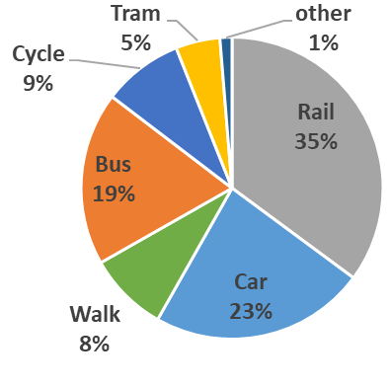
Figure 9: Total distance by mode

From this perspective
- 59% of all distance travelled is taken by public transport (rail, bus, tram, coach)
- 24% of all distance travelled is taken by personal vehicle (car, van, taxi)
- 17% of all distance travelled is active travel (walking or cycling).

7: Progress on Environmental Sustainability Strategy objectives 2016-2020

The University’s ES Strategy (2016-2020) includes a number of key performance measures. Table 4 concludes our progress in relation to this strategy, a new strategy is being drafted which builds on this.

Table 4: Progress against ES Objectives
Objective | Key performance measure | Progress | Status
Research with impact | Research with impact cases developed with environmental sustainability as focus. | We published a landmark report on the Sustainable Development Goals (SDGs) which has mapped all of our research and teaching against the SDGs.
Research with impact | Research projects having positive interactions with the campus/City. | Some of these projects were highlighted in the SDG report.
Socially responsible graduates | Student awareness of the complexity of sustainability issues after taking part in the Sustainability Challenge as part of the Ethical Grand Challenges. | 70% of students more aware of the complexity of sustainability issues after taking part.
Socially responsible graduates | Student engagement on environmental sustainability issues and projects. | Projects continued to run in the School of Environment, Education and Development. Work has been completed on a new UCIL module: Creating a Sustainable World: 21st Century Challenges and the Sustainable Development Goals, a taster session for the course is now available to all students.  Focus groups completed with students in 2020 to inform the Single Use Plastics Action Plan and the development of a student facing 10,000 Actions.
Responsible processes | Reduced consumption of natural resources, including the University’s KPI for 40% reduction in Scope 1 and 2 carbon emissions by 2020. | 2019/20 saw a 38% reduction in carbon emissions from a baseline year of 2007/08. This is a shortfall of 1,330tCO₂ against our target.
Responsible processes | Provision of quality and functional greenspace across the University estate. | A green roofs and wall review has been carried out to improve the biodiversity and green infrastructure of these spaces. A pollinator study has been completed of the main campus to establish the ecological impact of existing green spaces. Phase 2 of tree planting is complete.  A new green roof has been installed on the MECD campus and a green wall was installed on the Schuster building
Engaging our communities | Awareness of the complexity of sustainability issues after taking part in 10,000 Actions. | In January 2020 the Team Actions engagement programme was launched, allowing both individual and team-based activity to be completed through the 10,000 Actions platform.  From May 2020 onwards the 10,000 Actions programme was updated to promote actions that can be taken from home.
Engaging our communities | Engagement of staff, students and alumni on environmental sustainability issues and projects. | A BEIS funded trial of face-to-face Carbon Literacy training was delivered in December 2019. Due to the success of the trial a Carbon Literacy Steering Group will be established in 2020.  Sustainability champion activity has now been folded into the 10,000 Actions, making the platform the single point of contact for all sustainability activity at the University.  Work to build on this will be picked up in the new strategy.

8: Moving forward

Recruitment for the new Head of Environmental Sustainability (HoES) is underway. Once in post, the HoES will work with the soon to be appointed new Principal and Mechanical Energy Engineer, Academic Lead for Carbon, Academic Lead for ES, the ES Team and colleagues across the University to progress the following during 2020/21.

- New ES Strategy
- Zero carbon pathway

In addition, the new ES research platform and agents of change programme will be launched, and faculties will be asked to submit a zero carbon plan in support of our zero carbon commitment. It is envisaged that faculty plans will be reported to ESC.

Not including international student flights
calculated using spend data and defra conversion factors, sector work to update these factors is underway

