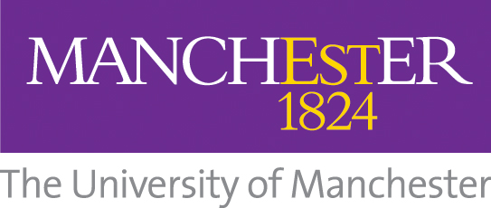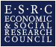

The University of Manchester
ESRC Impact Acceleration Account
Breakthrough Stream Expression of Interest

Please use this form to describe the nature of the project that you are considering and what support would be required from the ESRC IAA Breakthrough Stream fund to enable it. Details of the Breakthrough Stream can be found HERE.

Please contact the IAA team (ESRCIAA@manchester.ac.uk) for any queries relating to the application process.

Please note: The application should be written for a non-specialist audience and this section should provide a brief summary of the project

Applicant details | Name:  School/Directorate:  Email:  Phone:
Project summary (max 300 words to encompass the ways in which this project is innovative/risky.)
External partner details | Organisation Name:  Organisation Industry:  Organisation Contact Name:  Contact details:
Project aims
(max 200 words to describe briefly the history, nature, and scope of the project and its relevance to the university and external partner)
Desired impact (Max 200 words to describe the commercial or societal benefits of the idea? What impact will this project have?)

Previous impact related funding
(Max 150 words to highlight any previous impact related funding you have been awarded and give a brief explanation of the projects and their outcomes/output)

General information on partnership (tick box)
 | Yes | No
Are there any existing links between the external partner and the University of Manchester?

If yes, please provide details
Has the partnership applied for funding from another source, which is directly relevant to this proposal?
If yes, please provide details

Estimation of project budget
Please provide an estimation of the budget you will require to complete this project between £10 - £20k (nb a full FEC costing will be requested for successful projects following the Panel Meeting)
UoM Costs | Brief Description | Estimated Costs (£)
Staff costs | eg likely grade, FTE, duration
Travel and subsistence
Consumables
Other | Please specify
External Partner(s) Contributions
Direct
In Kind

This form should be submitted to esrciaa@manchester.ac.uk.

Next Stage:

The panel will assess and rank applications on the basis of the following criteria:

- How creative, innovative and risky the proposed pathway to impact or KE is, with reference to established modes of KE and pathways to impact;
- Clarity and feasibility of the proposed objectives;
- Clear links to existing and future work.

Shortlisted candidates will be invited to present their idea to the IAA Schemes Panel when the panel meets in April 2020 (exact date tbc). Candidates will be asked to give a 10 minute presentation followed by a 5 minute discussion with the panel. The panel will then deliberate and candidates will be notified within five working days of the outcome.

Successful candidates will be required to provide a business plan, Research Approval Form (RPA)*, a fEC report* and letter of support from their partner(s) prior to the project start date.

* Your local Research Support Service will assist with these

