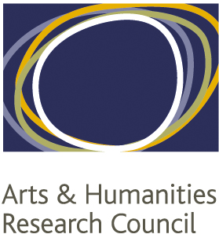


NORTH WEST CONSORTIUM
DOCTORAL TRAINING PARTNERSHIP
Guide for Applicants for AHRC North West Consortium Doctoral Awards

(September 2020 entry)

INTRODUCTION

These Notes of Guidance are intended for those who wish to apply to the Universities of Liverpool, Lancaster, Salford, Keele, Manchester, MMU and the Royal Northern College of Music for an Arts and Humanities Research (AHRC) postgraduate award under the AHRC North West Consortium Doctoral Training Partnership (NWCDTP) scheme to support doctoral study in the Arts and Humanities from September 2020. It sets out the types of awards provided, eligibility and the procedures for application.

It is therefore crucial that you read these carefully before making your application.

- THE FUNDING SCHEMES

The AHRC provides funding to enable students to study at Higher Education Institutions (HEIs) in the UK at doctoral level and their postgraduate awards programme is administered as follows:

+2 Scheme (Two years Doctoral Study – For current first year students only)
This scheme will provide support for up to two years of full time study, or four years of part-time study for students who are currently registered on the first year of a programme leading to the award of a doctoral degree. Students in their second or third year will not be eligible for funding.

+3 Scheme (Three years Doctoral Study)
This scheme will provide support for up to three years of full-time study, or six years of part-time study, on a programme leading to the award of a doctoral degree.

Note: In most cases studentships will be awarded for 3 years initially (or 6 years part-time), but applicants can apply to extend the funded period to 3.5 or 4 years (or part-time equivalent), if their project:

- Involves a period of intensive skills development (e.g. difficult language learning) identified at application or during the first year of funding (in discussion with the supervisory team)
- Involves additional or complex methodologies requiring additional training identified during the first year of funding (in discussion with the supervisory team)
- Includes a placement with a partner organisation applied for at any point during the funded period.

The Allocation Committee may decide to award a 3.5 studentship immediately if one (or more) of the above-mentioned training requirements have been already identified in the application.

- ELIGIBILITY

Applicants must be aware that the deadline for admissions under the NWCDTP funding scheme is Monday 13th January 2020. Applicants MUST have applied to their programme of study by this date or their funding application will not be eligible.

Academic eligibility:

- Candidates must have qualifications of the standard of a good honours degree at first or upper second class level, from a UK academic institution. Applicants for +2 and +3 awards should normally possess or be studying for a Master’s degree. In the majority of cases, candidates will have undertaken an undergraduate course and Master’s course at a recognised UK higher education institution. However, some may have qualifications from outside the UK, or be able to offer a combination of qualifications and/or experience. In both cases, it will be necessary to ascertain whether these qualifications can be equated to an honours degree, and at what level.
- The NWCDTP bases its assessments of qualifications attained outside the UK on the British Council’s NARIC guide.
- Candidates must be planning to study in a NWCDTP pathway (see appendix 1 for a list of pathways).
- Candidates who have already gained or completed the requirements for a doctoral degree in any subject, however funded, are not eligible to apply for NWCDTP funding.

- Candidates are required to declare whether they have already been enrolled on a PhD programme before and provide an explanation for not having completed it.

Residential eligibility:

- Candidates must have a relevant connection with the UK in order to qualify for a full award. This includes candidates who have been ordinarily resident in the UK throughout the 3-year period preceding the date of application and resident for this 3-year period for reasons other than education. Also candidates that have settled status in the UK within the meaning of the Immigration Act 1971.
- Candidates from EU countries other than the UK are now eligible for full awards maintenance and tuition fees if they have been resident in the UK for at least three years prior to the start of their programme.
- Candidates from EU countries who have not resided in the UK for three years prior to the start of their programme will be eligible for a fees-only award.

For further information on residential eligibility please refer to the AHRC webpage:
https://www.ukri.org/skills/funding-for-research-training/

3. THE FINANCIAL BASIS OF THE AWARD

A full postgraduate award for full-time study provides funds to meet:

- The payment of approved fees to the institution
- A maintenance grant
The level of the grant for the academic year 2019-20 is as follows (the level of the grant for 2020-21 and the following years is subject to confirmation from the AHRC):

Maintenance Grant £15,009

Students opting to study part time will receive a pro rata maintenance grant of the equivalent of a full time award.

Student will receive additional disability allowance where appropriate.

Fees Only Awards for eligible EU students provide the payment of tuition fees only. ‘Fees-only’ award holders are not eligible to receive a maintenance grant from AHRC funds.

4. THE APPLICATION PROCESS

Application Form and Transcripts

To apply for an award you must have applied for a place on a programme at one of the seven NWCDTP institutions by 13th January 2020. Please note that your application for admission onto your chosen programme must be complete (no missing documents) when submitted by this deadline.

You must also submit a NWCDTP Funding Application by 7th February 2020 (5pm) in order to be considered. Please note that the Funding Application form CANNOT be changed after submission.

Your application will be judged on the basis of your NWCDTP funding application form as well as your references, and your academic transcripts (submitted with your programme application on
13th January 2020). The references and transcripts will be matched to your funding application by the institution through which you are applying.

The references and transcripts submitted in support of your application for a place will suffice, but updated documents may be submitted if appropriate. This is advised if your new documents are able to provide information on your performance on a master’s degree currently in progress. If you are applying for a +2 (that is, you are a current PhD student) new reference letters should be submitted with comments on progress on your PhD to date.

If you decide to submit updated documents these must be received by the relevant admissions office by the deadline of 7th February 2020.

Closing Date

You should apply to one institution for admission onto your chosen postgraduate programme using the online application form:

Lancaster: http://www.lancaster.ac.uk/study/postgraduate/how-to-apply-for-postgraduate-study/
Liverpool: http://www.liv.ac.uk/study/postgraduate/applying/
Manchester: http://www.manchester.ac.uk/postgraduate/howtoapply/
MMU: http://www2.mmu.ac.uk/study/postgraduate/apply/postgraduate-research-course/
Keele: http://www.keele.ac.uk/pgresearch/howtoapply/
RNCM: http://rncm.ac.uk/research/programme/apply/
Salford: http://www.salford.ac.uk/study/postgraduate/applying/applying-for-research

Please note that candidates are allowed to apply to various institutions in the consortium for a place on a programme. However the candidates must choose only one institution through which they wish to apply for funding.

Please note that if an applicant submits more than one funding application in the Consortium, the NWCDTP reserves the right to withdraw the funding application.

Please note that in order to be eligible for NWCDTP funding you MUST have applied for a place on a programme at your institution by 13th January 2020.

You should complete the NWCDTP funding application form and send it to the relevant office (see Appendix 2 for contact details) at the institution in which you intend to register by 5.00pm on
7th February 2020.

There is only one closing date for funding applications each year and there is no flexibility on this date.

5. ASSESSMENT OF APPLICATIONS

a. The Pathway Panels
Your application will initially be assessed by the Institutional Pathway Panel. The panel consists of senior academics from within the relevant pathway within the Institution you intend to register at. Each application is judged on its own merits based on the information provided in the AHRC Application Form and your transcripts / references. The Panel agrees a mark for each application and applications are then ranked.

The Institutional Pathway Panels will then forward their selected applications for consideration by the NWCDTP Pathway Panel. This consists of one nominated pathway lead for each NWCDTP institution represented in this pathway. This panel will decide which applications will go through the final Studentship Committee.

Finally, the applications which have passed the previous two stages are presented to the NWCDTP Studentship Committee by the overall Pathway Lead. This Committee will then decide on studentship allocation across the NWCDTP. This NWCDTP Studentship Committee will take place on 27th March 2020.

b. Outcome of Application
Successful candidates will be notified by 6th April 2020. Candidates who are on the reserve list will also be notified, as will those who have been unsuccessful. If you are successful in being nominated for an award, you will be asked to confirm whether or not you wish to formally accept this.

c. Taking up an Award
Award holders are normally expected to begin their programme of study on, or around, 16th September 2020 and, providing we have received all necessary paperwork, holders of a full award will receive the first instalment of their maintenance grant in early October. In certain circumstances, such as illness, or where there is a need to give a period of notice to an employer, we will consider deferring the start date of a doctoral programme, normally by up to three months (with approval from the School/Faculty PG office). Any application for postponement must be made immediately through the Institution in which you intend to register. You should write to the Institution, in advance, including supporting letters from your potential supervisor.

If you are unable to take up your award in the year in which it was awarded, it will be rescinded and you will have to re-apply in the competition in the following year, should an award be available. You will need to inform us of your decision at the earliest possible stage, in writing, by letter or e-mail.

The continuation of doctoral awards is subject to the submission of a satisfactory annual report at the end of each year of the award and you are subject to the Institution and school/Faculty’s standard monitoring and progression processes.

Successful candidates are required to attend an induction session and a residential in the First Year of their programme (dates TBC)

d. Change in circumstances
Studentships are awarded for a particular programme of study at the Universities of Keele, Lancaster, Liverpool, Manchester, MMU, Salford, or at the RNCM. Therefore all requests to make changes to the awards are only considered by the NWCDTP studentship committee in very exceptional circumstances and only if the reasons are fully and clearly explained.

e. Resubmitting Applications
If you are unsuccessful in one year's competition you may apply in the next year's competition providing you continue to meet the eligibility criteria for the scheme.

f. Appeals Process
The competition is fierce and, inevitably, many highly qualified and strongly supported applicants do not get an award. Each application receives careful scrutiny by the assessors, and their decision is reached in the context of competing applications. Individual feedback on applications will not be available. The NWCDTP will be unable to notify unsuccessful candidates who did not make it as far as the NWCDTP Studentship Committee.

The Universities have complaints and appeals procedures, details of which can be found on our web sites at:

Lancaster: https://www.lancaster.ac.uk/strategic-planning-and-governance/student-complaints/
Liverpool: https://www.liverpool.ac.uk/student-administration/student-administration-centre/policies-procedures/
Manchester: http://www.manchester.ac.uk/study/postgraduate-research/admissions/policies-procedures/
MMU: http://www.mmu.ac.uk/academic/casqe/regulations/complaints.php
RNCM: https://www.rncm.ac.uk/about/college-information/complaints/
Keele: https://www.keele.ac.uk/sas/academicservices/studentappealscomplaintsandconduct/
Salford: http://www.salford.ac.uk/qeo/StudentPolicies/student-complaints-procedure

6. APPLICATION TIMETABLE

Monday 13th January 2020 | Admissions Deadline
Friday 7th February 2020 | Deadline for NWCDTP Funding applications to be submitted to relevant institution
Around 6th April 2020 | Successful and reserve candidates to be notified of the outcome
20th April 2020 | Deadline for successful candidates to confirm acceptance of the award.
From 16thSeptember 2020 | Start of the programme under the NWCDTP

7. APPLICATION GUIDANCE:

Please follow the instructions below to complete your application form.

- Studentships available:
Please tick the scheme you would like to apply for.

- Institution you have received an offer at/ have applied to
Please select the institution you have been accepted to study at.

- Name and address
We need to be able to contact you between April and September. Under ’Address' you should provide the address at which you can be contacted for the majority of this period, if this is different to the address you have given on the Institution application form. Should you be unavailable during this period, you may provide the name and address of someone who can correspond for you in your absence.

- Project details

- Award type: Fees only or full award
Please see residency eligibility under section 2 (page 2) for more details

- Mode of attendance
Part time students are only eligible for the maintenance grant on a pro-rata basis. Further information on awards and stipends can be found under section 3 (page 3).

- Programme/Pathway
Please indicate the pathway through which you have applied (further details of pathways can be found in Appendix 1).

- Project title
The title of the PhD project should be entered.

- PhD Proposal
  - Please summarise your proposed PhD research in up to ten keywords. This will enable us to create a searchable database of successful proposals.
  - Please give details of your PhD proposal in up to 1500 words. This limit includes any references and bibliography. Applications which do not follow this limit will be disqualified. Please provide a word count at the end of the proposal.

- Qualifications
Please enter your relevant qualifications (Post-Secondary and relevant professional qualifications). If you are currently undertaking a MA/MSc programme, please indicate which programme and indicate ‘pending’ under results.

- Relevant Experience (max 350 words)
The assessors will use this information to establish any experience you have gained that might contribute to the intended research topic. Please supply the kind and extent of any experience relevant to your proposed research.

- Supervision
Please state the names of your prospective supervisors according to your offer letter. If you have not yet received the offer letter, give the names of your intended supervisors. Please note that the NWCDTP provides the opportunity for you to have a supervisory team drawn from two or more of our constituent institutions, but your main supervisor should be from the institution at which you will be registered.

- Research training previously undertaken (max 250 words)
Please include a brief description of relevant research training previously undertaken.

- Research training needs (max 250 words)
Please give details of any identified training needs for your doctoral programme and state whether or not this has been discussed with your supervisors. Please also state whether your research project will require you to undertake research abroad or require additional resources (e.g. research/study abroad, language training, use of specialist equipment/facilities etc). Please note: the NWCDTP has resources for these purposes and an expensive project will not be disadvantaged. If you have identified training needs that require additional time on top of the normal three years, indicate this now and you will be eligible to apply for a studentship extension.

- Collaboration with External Partners (max 250 words)
  - Please indicate whether you think there is potential to work with an external partner, e.g. a cultural organisation, an industrial partner or a government body, during your PhD. Indicate on the form how this might take place: e.g. internship/placement or other type of collaboration. The external partner does not have to be part of the NWCDTP.

- Additional applications
Please indicate whether you have already applied for other funding for this forthcoming year. Please indicate if you have already been enrolled in a PhD programme. Please provide an explanation of why you haven’t completed it.

- References and transcripts
Your application will be judged on the basis of your application form, your references, and your academic transcripts. The references and transcripts will be attached to your application by the institution through which you are applying. These must be received by the relevant admissions office by the deadline of 7th February 2020. The references and transcripts submitted in support of your application for a place will suffice for this purpose; however updated documents may be submitted if appropriate. This is advised if your new documents are able to provide information on your performance on a master’s degree currently in progress. If you are applying for a +2 (that is, you are a current PhD student) new reference letters should be submitted with comments on progress on your PhD to date. It is your responsibility to contact and chase up relevant references in this case. Updated documents and references will need to be submitted by you to your institution by the deadline of
7th February 2020.

- How did you hear about us:
The DTP would be interested to hear how you have heard about the DTP and its studentships, whether it is via our website, external funding website, your institution etc.…

- Acknowledgement
Please sign and date the application form.

Equality and Diversity Form
Please ensure you do submit an E&D Form with your application form. Please be assured that the form will be anonymised and separated from your application form before the assessment stage process.

NORTH WEST CONSORTIUM DTP
APPENDIX 1 –LIST OF PATHWAYS

- Classics

- Creative Writing

- Dance, Drama and Performing Arts

- English

- Heritage

- History

- Language-Based Area Studies

- Law

- Linguistics

- Media and Cultural Studies

- Modern Languages and Translation

- Music

- Philosophy

- Religions and Theology

- Visual Arts: Arts and Design

APPENDIX 2

List of contact for each institution (General queries / Submission of funding applications)


Keele University: all funding applications to be sent to:

Helen Farrell
Postgraduate Research Administrator
humanities.phd@keele.ac.uk


Lancaster University: all funding applications to be sent to:

Sarah Purcell
fass-pg@lancaster.ac.uk


Manchester Metropolitan University: all funding applications to be sent to:

Katherine Walthall
Research Officer
adhlsspgadmissions@mmu.ac.uk

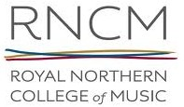
Royal Northern College of Music: all funding applications to be sent to:
Rachel Ware
Research Administrator
research@rncm.ac.uk

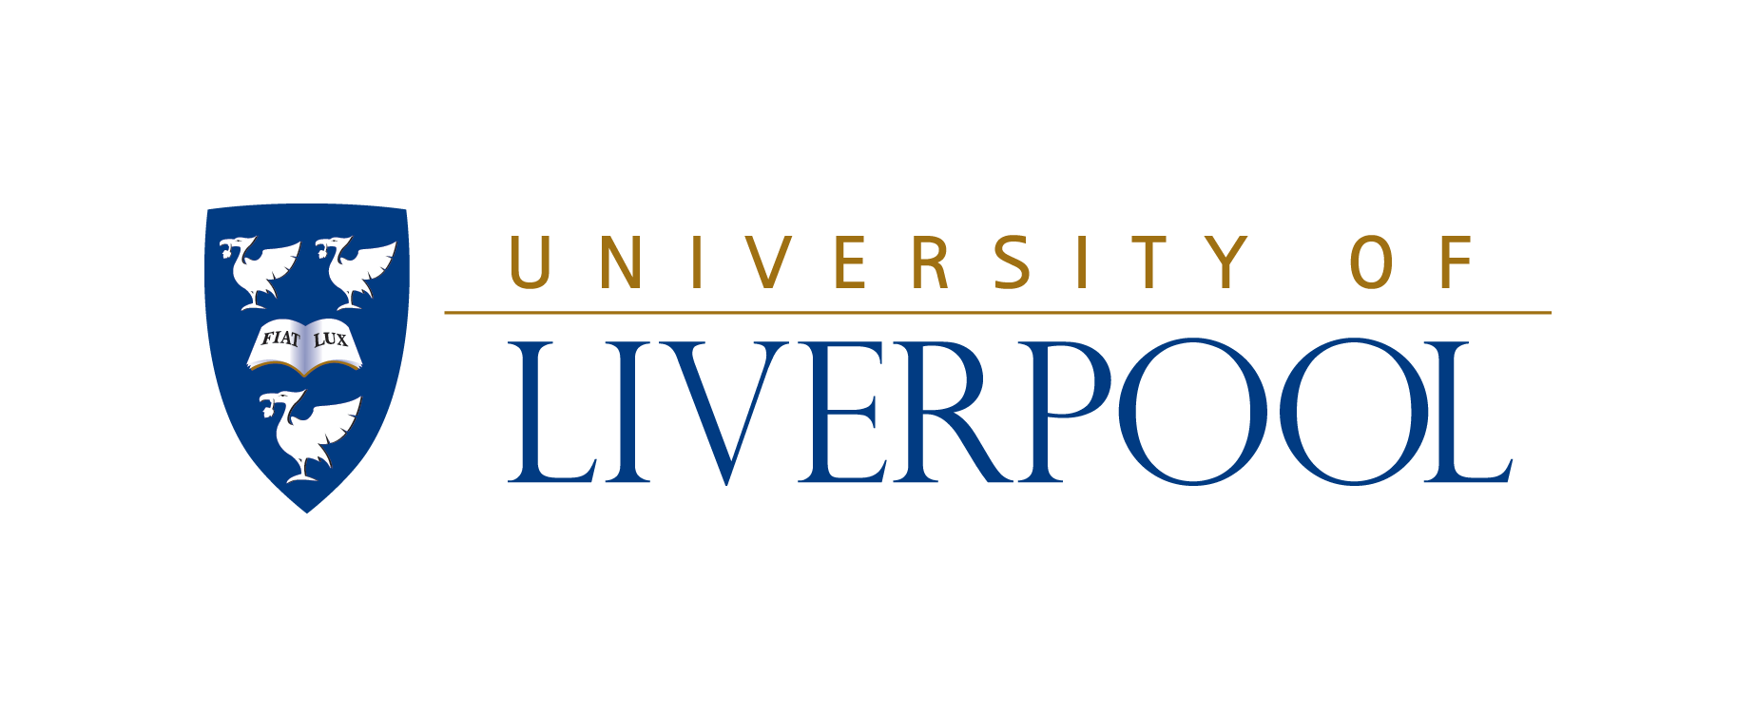
The University of Liverpool: all funding applications to be sent to:

Hayley Meloy
PGR Development Officer & NWSSDTP Manager
hsspgr@liv.ac.uk

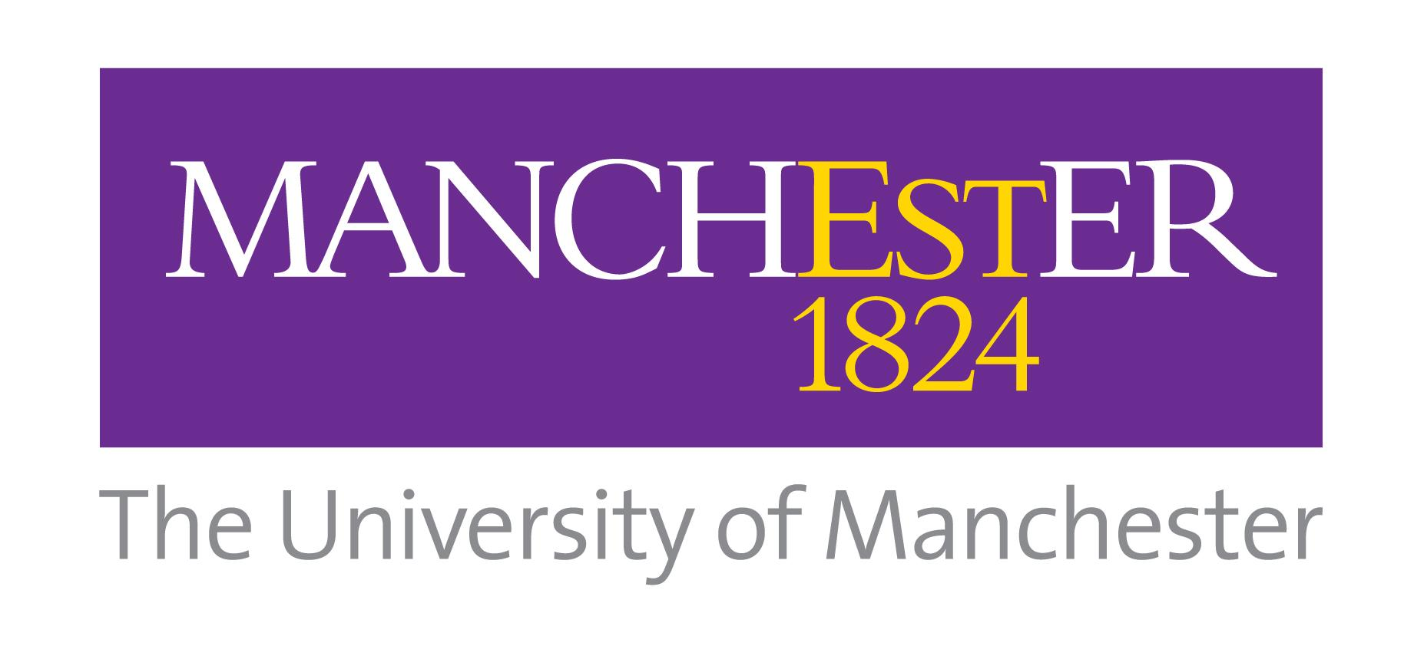
The University of Manchester: Funding applications for:

School of Arts, Languages and Cultures:

Joanne Marsh
SALC PGR Administrator phdfunding-salc@manchester.ac.uk

School of Law:

Law Admissions
law.scholarship@manchester.ac.uk

School of Social Sciences:

Vicky Barnes
SoSS Admissions Manager Vicky.barnes@manchester.ac.uk


University of Salford: all funding applications should be sent to:

College of Arts and Social Sciences
PGR Office
PGR-SupportSAM@salford.ac.uk

