Making the most of the Model
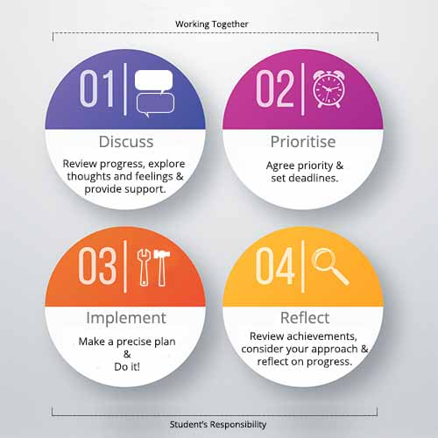
Using the model
The Academic Advising model aims to generate a constructive conversation which motivates and directs students to take action and encourages reflection on their development. The Discuss and Prioritise steps are completed by the student and advisor together, during a one-to-one advising meeting. The Implement and Reflect steps are undertaken by the student independently, and help to inform subsequent advising meetings. In this regard, the model is cyclical: following the first meeting and student actions, subsequent meetings will review and build upon progress made.
- Discuss
The purpose of the discussion is to identify any factors relating to the student’s academic progress, wellbeing and/or employability that the advisor and student agree as important priorities for development.
This discussion can also serve as an opportunity to address any issues around motivation and confidence which may act as barriers to progress.
The example Discuss sheet (download the Example Discuss sheet here) provides a list of prompts, as well as tips for successful conversations. At the initial meeting, the focus will be encouraging the student to reflect on how they view their current academic progress, future-readiness and wellbeing.
During follow-up meetings this discussion will be based on the actions and progress documented in the student’s Academic Advising Model Worksheet (download the Student Worksheet here); reflecting on successes, providing support and guidance in response to barriers encountered or lapses in motivation and confidence, as well as identifying future priorities. Some students will not engage with this process, failing to take any action in advance of follow-up meetings. This presents an opportunity to explore the reasons for lack of progress – there are many legitimate reasons including workload, assessment deadlines, the need to work to earn money, personal difficulties. In these cases, the discussion should provide reassurance or, where appropriate, signpost students to support services that can help.
Where a student seems to lack motivation, once significant difficulties have been ruled out, the discussion should emphasise the value of taking the time now make the most of the opportunities available to them, and to build the student’s confidence in their ability to do so. Feeling that you are interested and care about their progress will hopefully provide some impetus.
- Prioritise
Before closing the discussion, the advisor and student should agree a few priorities for development. The priorities may, but do not necessarily need to, cover each of the three areas: academic progress, employability and wellbeing. The priorities should be documented on the students’ Academic Advising Model Worksheet, along with a deadline set in advance of the next advising meeting (this is also a good time to set a date for the next meeting). The advisor should provide the student with a paper or electronic copy of the Worksheet and be clear that the expectation is that they should complete it and bring it to their next meeting, or email it to the adviser in advance. Advisers should also explain what is required in each section of the Worksheet. It is important to emphasise that completing the Worksheet is not just a box-ticking exercise; research shows that planning small, practical steps and reflecting on successes and obstacles helps to boost confidence and self-efficacy, both of which are key to successfully achieving broader goals. For students where more serious wellbeing issues are identified as a priority, it may not be appropriate to ask the student to document their actions or to provide a written reflection relating to these issues. It is still important to encourage such students to take steps to address any problems and to check that they are making progress, but you may agree that it is more appropriate to do this informally.
- Implement
This step should be carried out by the student independently. The aim is to encourage the student to break down the broad priorities, agreed during the discussion, into a series of practical actions. They should use this space in the Worksheet to document the actions they intend to take. It is important that students are given responsibility for identifying appropriate actions in order to build their self-efficacy. However, for students who have made little progress by the follow-up meeting, the discussion could review whether there were weaknesses or gaps in this implementation plan that could be addressed in the future.
- Reflect
This step encourages students to consciously evaluate what they have achieved, the success of their approach and the broader progress that they have made. If carried out well, reflective practice can motivate personal development, build self-efficacy and confidence, highlight barriers to success and help to modify future behaviour. However, it does take practise to develop this skill. During follow-up meetings, the advisor should encourage the student to provide more depth where the reflection provided is limited or superficial. Where this discussion highlights barriers to progress, the advisor and student should consider how these could be addressed in the future.

