
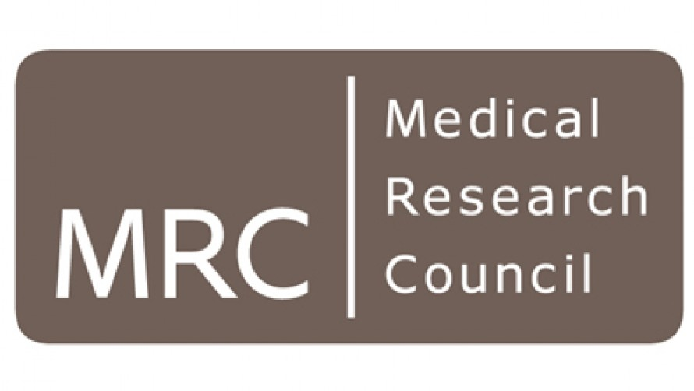

MRC P2D: Industry Secondment Scheme

Guidance Notes for Applicants

Overcoming the bottleneck to the establishment of new collaborations by supporting early interactions and knowledge exchange between industry and academic researchers

The Industry Secondment Scheme is targeted at academics who have already identified areas for potential collaboration with an industry partner(s), providing flexible support for staff secondments between organisations. Proposals should focus on the commercial/translational development of MRC-relevant research.

It is expected that academic staff time to support the project will be on a part-time basis, although each case will be considered on its merits. Secondments can last up to 6 months in total, of a maximum 9 month project duration. Funding will support interactions with single or multiple partners.

The aims of the scheme are:

- Develop collaborative project proposals (e.g. MRC CiC, MRC DPFS, Innovate UK KTP and Small Business Research Initiative, etc.)
- Generate data for proposals through collaborative research
- Identify areas that require specialist input e.g. medicinal chemistry, regulatory, access to specialist compound libraries
- Enable industry partners to conduct an extended review of the University’s portfolio of research with the aim of identifying exploitation/commercialisation opportunities
- Consolidate and extend existing relationships to work towards a strategic partnership

Anticipated outcomes:

- Increase in volume and quality of collaborative funding schemes project proposals (e.g. MRC CiC and DPFS, Innovate UK KTP and SBRI, etc.)
- Increased financial and long-term commitment from industrial partners
- Identification of novel models for industry-academia engagement e.g. Mannchester Connected Health Ecosytem, Centre for Applied Pharmacokinetic Research (CAPKR), North West Centre for Advanced Drug Delivery, Molecular Pathology Innovation Centre (MMPathIC), etc.
- Greater involvement in existing partners’ strategy and business models
- Formation of formal strategic partnerships

Eligibility

Applications are only permitted for projects focused on the exploitation/application of knowledge or technology within the scope of MRC funding. Please ensure an NDA is in place before disclosing any unpublished research to industry partners.

If you have any queries regarding user organisation eligibility, please contact Naomi Chandler (naomi.chandler@manchester.ac.uk). The funding is not intended to support staff exchange into a University of Manchester spin out company.

Funding Arrangements

Funding is intended for those projects where a company will contribute actively to the project through provision of resources (including finance, facilities, equipment, consumables and technical expertise). For Phase 4, funding can be used to cover both academic and industry costs for people exchange.

Industry partners will be expected to provide a letter of support with clarity on the next steps should the Industry Secondment project be successful, as well as direct financial and/or in-kind contribution to the project.

The MRC Proximity to Discovery panel expects University staff to negotiate with the partner organisation a deal which minimises the support necessary from the MRC P2D fund. The value to the partner and the University (in generating research publications, ongoing collaborations, IP etc.) shall be taken into account.

Spend Completion Date

The project period runs from 1st August 2018 to 31st August 2019; projects must begin and end within this timeframe. All project expenditure must be completed by the end date stated in the application form. Any unspent funds will be returned to the Business Engagement Team for reallocation.

Costing and eligible costs
Industry Secondments are expected to be costed on a full Economic Costing basis. The MRC P2D will provide funding for directly incurred costs only. Directly allocated and indirect projects costs will be covered by the PI’s School.

Eligible costs include:

Directly Incurred: staff costs
equipment and consumables
travel and subsistence (maximum £1k)
training and development (maximum £1k)
and in some cases (for example where market research is to be commissioned), the fees of an external supplier
Directly Allocated: maximum PI time 10% (suggested 3%)
indirect costs and estates

MRC P2D projects are exempt from the minimum PI contribution of 20%

The maximum P2D grant contribution will be £50k (DI costs).

Secondments in
For projects involving the secondment-in of a member of staff from an industry partner/s, eligible costs for the P2D funds include those such as provision of office and lab space for the secondee, staff time of University employees allocated to support the secondment, and in exceptional circumstances industry staff costs associated with the secondment. The PI’s School/Institute is responsible for providing appropriate office and lab space for the secondee.

Secondments out
For projects involving the secondment-out of a member of University staff, eligible costs for the P2D funds will include secondee staff costs (excluding indirect costs and estates) as well as travel and subsistence (up to £1k).

Project Budget: Project costs must be submitted to RSMs via the MAHSC costing form at least three weeks before the deadline. RSMs will provide PIs with a P2D project budget sheet to be submitted with the application form.
Total Project Costs: These are those costs directly associated with the project, in the eligible cost headings outlined above. These should include all staff costs, estates, indirect costs, travel and subsistence and consumables.
Company Contribution: These are the direct (invoiceable) company contributions to the total project.
In-kind Costs: These may include staff time, travel, access to equipment, provision of consumables.

Assessment of applications

Applications will be assessed by the University’s MRC Proximity to Discovery Schemes Panel. Applicants should remember to write their proposals for a non-specialist audience.

Assessment will take into account:

- The potential for impact and anticipated academic benefits
- The anticipated benefits for the company partner/s and the contribution the University is expected to make relative to the partner
- The likelihood that the project plans will deliver the expected outputs and benefits
- Consideration given to follow on activities

Application Submission

1st Call for Proposals: Opens on 1st May 2018, with a closing deadline of 30th June 2018, 12 noon.
2nd Call for Proposals: Opens on 1 Aug 2018, with a closing deadline of 30 Sept 2018, 12 noon.

Where possible you are encouraged to submit your proposal to the first call. Should all the funds be allocated in the first call, a second call for proposals will be cancelled.

Please note that applications will be evaluated by the BE team for content and eligibility before being sent to the P2D Schemes Panel for consideration. You are strongly advised to contact Naomi Chandler, for advice and guidance at least one month prior to submitting your application:

E: naomi.chandler@manchester.ac.uk / T: 0161 306 0554

All projects should be costed (100% fEC) and input onto the Research Management System (RMS). RSS will issue the RMS number to the BE Team for the purpose of tracking.

Once signed by Head of School and collaborating company(ies), completed applications should be submitted with the project budget sheet and letter(s) of support.

Electronic submissions are acceptable for application deadline purposes but a signed paper application and letter(s) of support should follow (signed and dated by all partners) no later than seven days after the deadline date.

