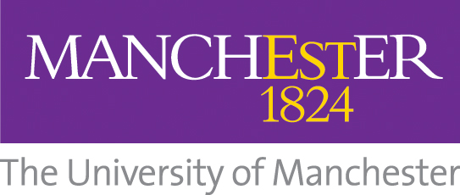
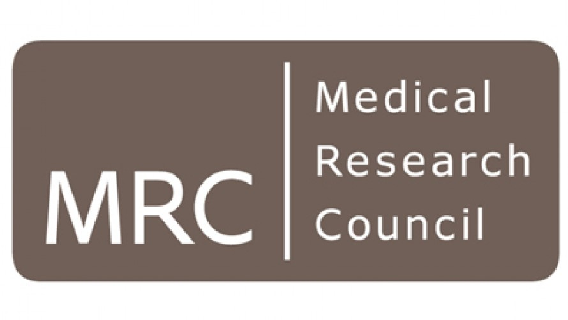

MRC P2D: Relationship Incubator Scheme

Guidance Notes for Applicants

Overcoming the bottleneck to the establishment of new collaborations by supporting early interactions and knowledge exchange between industry and academic researchers

The Relationship Incubator Scheme is targeted at academics with biomedical research of potential interest to industry, looking to identify new partners or build early stage relationships with existing partners, or develop greater understanding of industrial research priorities and models of engagement.

Funding will support interactions with single or multiple partners. Applicants are encouraged to approach a range of industrial partners from SMEs to large multi-national corporations.

It is expected that a Relationship Incubator project will be part-time, although each case will be considered on its merits. The maximum duration of a Relationship Incubator project will be up to 6 months.

The aims of the scheme are:

- Exploring exploitation opportunities for the University’s biomedical research portfolio to highlight areas for industry collaboration, such as MRC CiC projects
- Enabling academics to learn about industrial research priorities and models of engagement
- Highlight to industry the research expertise and facilities available to support collaborative/contract research, e.g. workshops and showcases

Anticipated outcomes:

- An increase in the number of new relationships with industry partners
- Greater understanding of industry research priorities and requirements for collaborations
- The identification of project partners for downstream funding schemes (e.g. MRC CiC, MRC DPFS, Innovate UK KTP, etc.)

Eligibility

If you have any queries regarding user organisation eligibility, please contact Naomi Chandler (naomi.chandler@manchester.ac.uk).

Funding Arrangements

Given that relationships are at inception, a direct financial contribution from industry partners is not required for Relationship Incubator projects. However, applications will be strengthened where a company is willing to commit a contribution at least through in-kind provision of resources (including facilities, equipment, consumables and technical expertise). Industry partners will be expected to provide a letter of support with clarity on the next steps should the Relationship Incubator be successful, as well as outlining any in-kind contribution to the project.

Spend Completion Date

The project period runs from 1st August 2018 to 31st August 2019; projects must begin and end within this timeframe. All project expenditure must be completed by the end date stated in the application form. Any unspent funds will be returned to the Business Engagement Team for reallocation.

Costing and eligible costs
Relationship incubators are expected to be costed on a full Economic Costing basis. The MRC P2D will provide funding for directly incurred costs only. Directly allocated and indirect projects costs will be covered by the PI’s School.

Eligible costs include:

Directly Incurred: staff costs
equipment and consumables
travel and subsistence (maximum £1k)
training and development (maximum £1k)
and in some cases (for example where market research is to be commissioned), the fees of an external supplier
Directly Allocated: maximum PI time 10% (suggested 3%)
indirect costs and estates

MRC P2D projects are exempt from the minimum PI contribution of 20%

The maximum P2D grant contribution will be £10k (DI costs).

Project Budget: Project costs must be submitted to RSMs via the MAHSC costing form at least three weeks before the deadline. RSMs will provide PIs with a P2D project budget sheet to be submitted with the application form.
Total Project Costs: These are those costs directly associated with the project, in the eligible cost headings outlined above. These should include all staff costs, estates, indirect costs, travel and subsistence and consumables.
In-kind Costs: These may include staff time, travel, access to equipment, provision of consumables.

Assessment of applications

Applications will be assessed by the University’s MRC Proximity to Discovery Schemes Panel. Applicants should remember to write their proposals for a non-specialist audience.

Assessment will take into account:

- The potential for impact and anticipated academic benefits
- The anticipated benefits for the company partner/s and the contribution the University is expected to make relative to the partner
- The likelihood that the project plans will deliver the expected outputs and benefits
- Consideration given to follow on activities

Application Submission

1st Call for Proposals: Opens on 1st May 2018, with a closing deadline of 30th June 2018, 12 noon.
2nd Call for Proposals: Opens on 1 Aug 2018, with a closing deadline of 30 Sept 2018, 12 noon.

Where possible you are encouraged to submit your proposal to the first call. Should all the funds be allocated in the first call, a second call for proposals will be cancelled.

Please note that applications will be evaluated by the BE team for content and eligibility before being sent to the P2D Schemes Panel for consideration. You are strongly advised to contact Naomi Chandler, for advice and guidance at least one month prior to submitting your application:

E: naomi.chandler@manchester.ac.uk / T: 0161 306 0554

All projects should be costed (100% fEC) and input onto the Research Management System (RMS). RSS will issue the RMS number to the BE Team for the purpose of tracking.

Once signed by Head of School and collaborating company(ies), completed applications should be submitted with the project budget sheet and letter(s) of support.

Electronic submissions are acceptable for application deadline purposes but a signed paper application and letter(s) of support should follow (signed and dated by all partners) no later than seven days after the deadline date.

