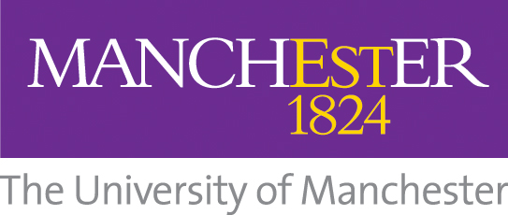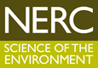

The University of Manchester
NERC Pilot Impact Acceleration Account
Call for Proposals

Closing Date: 4th December 2013

Summary
NERC has awarded The University of Manchester £200k to deliver a Pilot Impact Acceleration Account (IAA), building on the successful delivery of its Knowledge Exchange activities and support from other Research Councils.

Running until 31st March 2015, the £200k IAA will aim to ensure that the University fulfills its strategic Knowledge Exchange objectives in the domains covered by NERC research:

‘To maximise the University’s economic and social impact, by ensuring research and expertise/know-how are delivered in a timely and effective manner to relevant external partners so as to ensure impact, and in turn to inform and strengthen research activity by means of interaction with those partners.’

The IAA activities will aim to:

- develop early stage contact and strategic alignment between business and academics through Relationship Incubation
- bridge the gap in support for early stage commercialisation of ideas through Concept Development and Feasibility Studies

The University’s IAA Operations Board is pleased to announce a call for proposals for funding under the following mechanisms:

• Relationship Incubator Scheme
• Concept Development and Feasibility Study Scheme

The closing date for applications to this call is 4th December 2013, 12 noon.

Outline of IAA funding opportunities

Relationship Incubation
The scheme aims to overcome the ‘market understanding – technology awareness’ and relationship barriers by supporting the secondment-out of academics to organisation(s) to explore the exploitation opportunities for their NERC research, or enabling the secondment-in of users to explore opportunities offered by an identified range of NERC research. (£10k max)

Concept Development and Feasibility Studies
NERC research can remain unexploited because a greater evidential base is required before companies or academics are able to commit to its further development and application. Therefore, funding is available to support the development of an early evaluation prototype or ‘demonstrator’, initial trials in a particular field, or ‘scoping exercises’. (£30k max)

Eligibility
Applications are only permitted for projects focused on the exploitation or application of knowledge or technology generated through NERC-funded research. Eligible external collaborators are UK-based businesses, UK sites of international businesses, UK-based charities, and UK public sector organisations.

Application Process
Further information about the different IAA schemes, guidance notes and application forms are available online at www.staffnet.manchester.ac.uk/knowledge-exchange. Prior to submitting an application, academics are strongly advised to contact a member of the KE Team for support.

Assessment Criteria
Applicants should write their proposal for a non-specialist audience. The University’s Knowledge Exchange Schemes Panel will assess applications on a competitive basis; assessment of the various bids will take into account:

- the contribution the University is expected to make relative to the company (gearing).
- the benefits to industry, to the partner, to the University and to the Research Associate
- the likelihood that the project plans will deliver the expected outcomes and benefits

Further details
Please contact the KE Team on 0161 306 6815 or ke@manchester.ac.uk

Further information and case studies of completed projects can be found at www.manchester.ac.uk/business/ke/

